USER-FRIENDLY GUIDE: USING HOBOWARE AND THE WATERPROOF SHUTTLE TO DOWNLOAD AND UPLOAD TEMPERATURE DATA
Kirstin Underwood, USFWS

STEP 1 – DOWNLOAD THE SOFTWARE

To use the shuttle, you’ll need a computer with Hoboware software from Onset Company, version 2.2 or higher (www.onsetcomp.com). You can download a free version at http://www.onsetcomp.com/hoboware-free-download or purchase a license for the Pro version at http://www.onsetcomp.com/products/software/bhw-pro .

STEP 2 - LAUNCH THE SHUTTLE
Before you head into the field to collect data, you’ll need to launch your shuttle.
Open Hoboware Pro, and use the cable that came with the waterproof shuttle to connect it to a USB port. When the shuttle is detected, the lower right hand corner of the screen will say “1 device connected”.
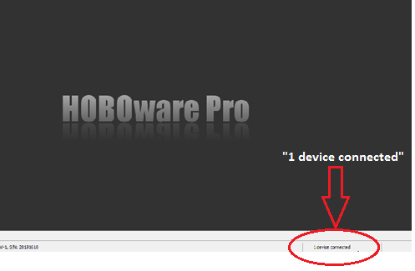
This usually happens quickly. If the program doesn’t detect the shuttle, try a different USB port, or disconnect and reconnect a few times.
Skip to the next step if an automatic popup window appears when the shuttle is detected. If no popup window appears, you’ll need to launch the shuttle manually. Find the “Device” tab at the top of the screen, and select “Launch” from the dropdown menu.
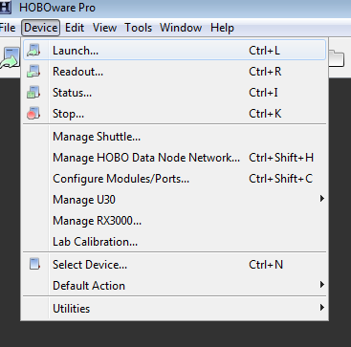
A popup window should appear, allowing communication with a connected device. Choose “HOBO Waterproof Shuttle” from the list and click “OK”.
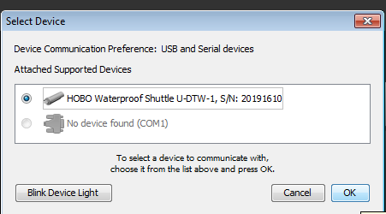

The shuttle management window will appear. As long as the shuttle is empty of files, it will launch automatically, and a confirmation message will appear.
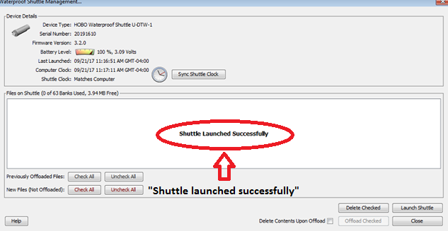

STEP 3 – SHUTTLE MANAGEMENT
While the shuttle window is open, ensure that the battery level is OK, and that the shuttle clock is synced to the computer clock. (You can also check this by selecting “Manage Shuttle” in the dropdown menu under the “Device” tab.) If everything looks good, close the window. You’re ready to go into the field.
If the shuttle clock doesn’t match with the computer clock, click “sync shuttle clock” at the top of the window, then launch the shuttle again by clicking “launch shuttle” in the bottom right corner of the window. If the battery level is less than 50%, CHANGE THE SHUTTLE BATTERIES, then go through the process again and re-launch the logger. (See “troubleshooting” to learn why this is important!)
The program will automatically warn you if the shuttle clock is off or if the battery level is low.

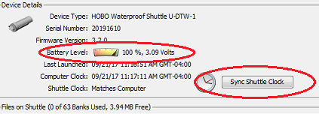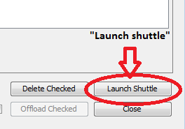

TROUBLESHOOTING

The shuttle can only be launched if it doesn’t contain any data files. If you click “launch shuttle” and get this message in a popup window:

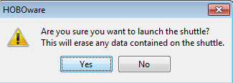

….then there are still some files stored on the shuttle.

If you’re sure that these files have been offloaded, delete them and launch the shuttle. If you’re not sure, offload all of the files first (explained in Step 4), then delete them and launch the shuttle. You shouldn’t run into this problem the first time the shuttle is launched.

A NOTE ABOUT BATTERIES

Never try to collect data with the shuttle if it has a low battery signal!

The shuttle clock will stop working when the batteries are low. It will not work correctly again until the batteries have been replaced and the shuttle has been re-launched with its clock synced to a computer clock.

The AA batteries that come with the shuttle should be good for at least a year, but be sure to keep an eye on the battery level when you launch the shuttle, and replace them when necessary. The shuttle should be re-launched with its clock synced to the computer clock every time that the batteries are changed.

The Tidbit loggers re-set themselves by syncing to the shuttle clock, so if they are paired with a bad clock, they will stop working. Timestamps from the logger data will not be able to align with the shuttle clock, and data will be erased.

It’s safe to download data if the Tidbit logger has a low battery.

STEP 4 – FIELD DATA COLLECTION

The waterproof shuttle has 60 banks, and each bank can store a large amount of data, so you can collect data from up to 60 loggers in a row before offloading data to a computer.
When heading into the field, make sure the shuttle’s cap is screwed on tight to create a waterproof seal. Put the black plastic coupler for TidbiT v2 on top of the shuttle.
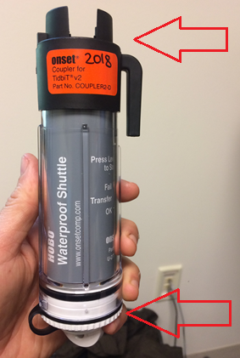

Take a midseason site check form and a thermometer into the field with you to keep track of site ID, time, date, and logger ID #, and to note any significant changes or vandalism at the site.
Measuring water temperature at the site with a thermometer and checking it against the logger readout will alert you to any malfunctioning devices.
Once you’ve located your logger in its PVC housing:
Unscrew the PVC cap (if tight, or epoxied shut, use large pipe wrench or jaw-gap pliers to gently twist open; be sure to have epoxy in case canister needs to be remounted). Cut the zip tie holding the logger to the PVC cap. Inspect the logger for any signs of damage, and make sure the logger’s red “ok” light is blinking.

If algae has grown over the logger’s sensor lights, scrub gently with a soft cloth or brush. Then place the logger in the coupler as shown below, sensor side down, flat side up.

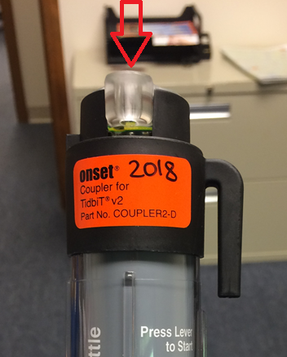

Really press down hard to mash the logger in there….it should be a very tight fit!

Now press and release the coupler lever.
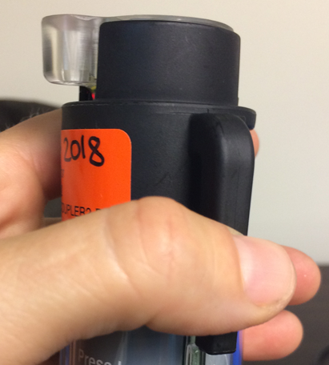

Wait for a moment. If the shuttle has successfully communicated with the logger, the amber “transfer” light will blink slowly. Data transfer can take a long time, so be patient. The light will blink faster and faster as download occurs. Hold still and wait until the green “OK” light flashes (below). (Note: if you push the coupler lever and nothing happens, see “TROUBLESHOOTING” at the end of this section. Usually there’s a simple solution – most often, the logger just needs to be pushed more firmly into the coupler to create a better fit.)

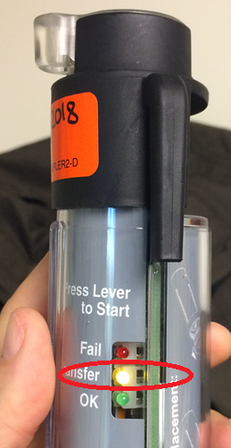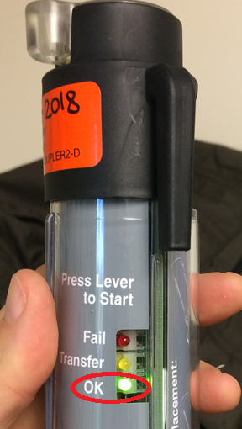

The green “OK” light signifies that data download is complete. The light shuts off automatically after a few minutes. Press the coupler lever to turn it off manually.
Be sure to record the logger ID#, site name, and time as you collect data at each site. This is crucial for data organization when multiple sites are visited in the same day.
You’re done! Make sure the logger’s red “OK” light is still blinking, use a new zip tie to re-attach it to the PVC cap, screw the cap back onto its anchor base.

TROUBLESHOOTING

If the shuttle doesn’t communicate with the logger, there is probably a simple solution. These are the 3 most common issues with shuttle/logger communication, and they all have a simple fix:
- Logger is seated in the coupler the wrong way.

The coupler has 2 notches, and there’s a “backward” and “forward” way for the logger to fit into it. Make sure the protruding end of the logger fits snugly into the front notch as shown below. If the protruding part of the coupler shifts around, take it out and spin it 180 degrees – it’s backwards.

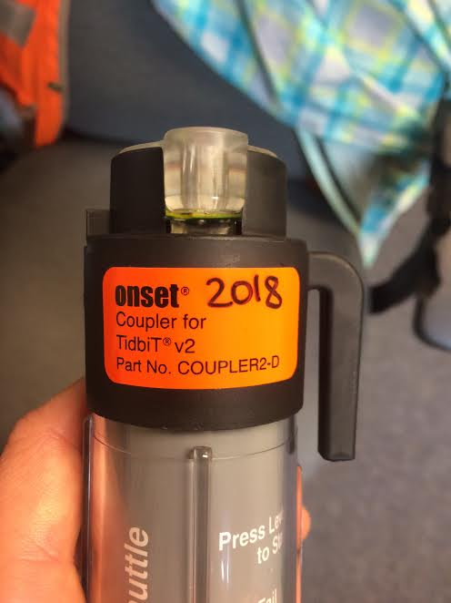

2 – Sensor lights are dirty.
Take the logger out of the coupler and carefully examine it. A light film of algae may have accumulated over the sensors. Use a soft brush (ie a toothbrush) or a cloth to gently wipe the sensors clean.

3 – Logger is not seated firmly in the coupler.
This is probably the most common problem. If the sensors are clean and the logger is seated the right way, take the coupler off (with logger attached), flip it upside down onto a flat surface, and really press down firmly to create a very tight fit. Don’t be afraid to mash the logger on there. Then put the coupler back on the shuttle and try again.
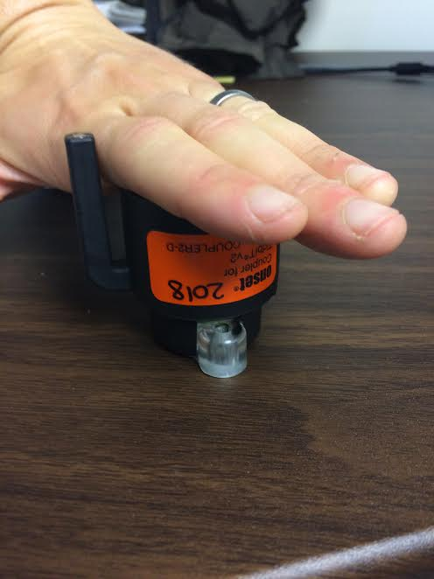

STEP 5 – DATA OFFLOAD

Now comes the more complicated part: offloading field data to HOBOware.
Open HOBOware, and connect the shuttle with the USB cord. HOBOware should detect the device automatically; if it doesn’t, try disconnecting and reconnecting the shuttle a few times, or using a different USB port.
Once the shuttle is connected, select “Readout” from the dropdown menu under the “Device” tab.

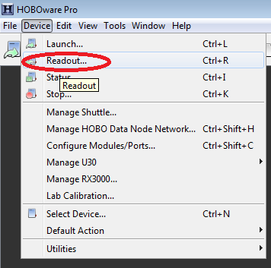

A popup window will appear asking which device you would like to connect to. Select “HOBO Waterproof Shuttle” and click “OK”.
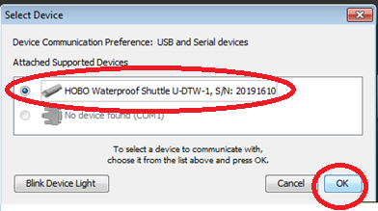

The Waterproof Shuttle Management window will open.

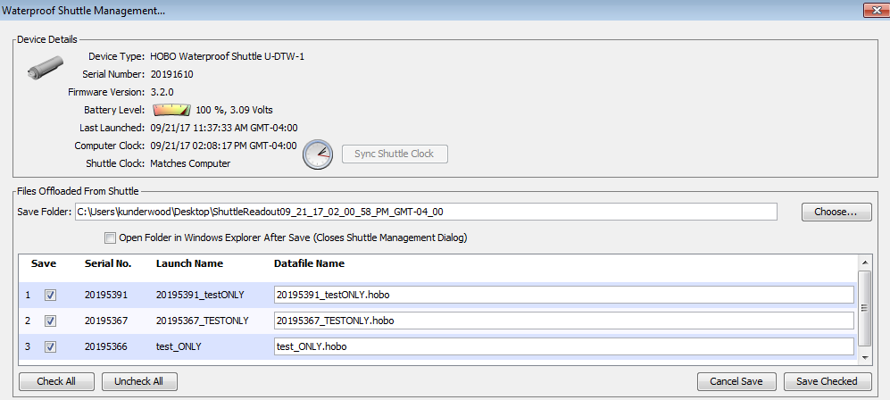

All of the data that you collected in the field will appear in a list, organized by logger serial number. This is where data organization is important – make sure you know which site each logger corresponds to, and that the Datafile name next to the logger serial number makes the file easily identifiable.
Note: the shuttle stores files in the order that the files were downloaded (ie, the first file is the first site visited, second file the second site visited, and so on.)

You can edit file names by clicking in the text boxes under “datafile name”.
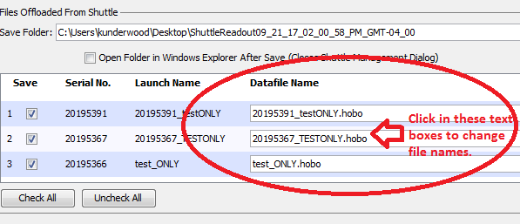
C:\Users\TU\Desktop\ShuttleReadout09_21_17_02_00_58_PM_GMT-0400

Above the list of files, you’ll see a text box marked “Save Folder”. This is the location where HOBOware will save your files after they’ve offloaded.

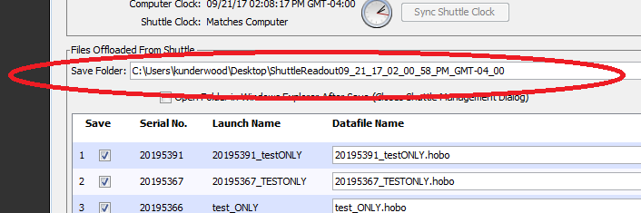
C:\Users\TU\Desktop\ShuttleReadout09_21_17_02_00_58_PM_GMT-0400

HOBOware will automatically save your files to a buried folder that is difficult to find. You’ll want to save your files to a location that will be easy to find. To change the destination folder, click the “choose” button to the right of the “Save Folder” text box.
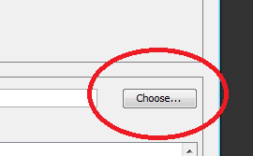

A popup window will appear. Choose the location where you would like to save your files in the dropdown menu next to “Look in:” at the top of the popup window. (If you want to save the files to your desktop, where they will be very easy to find, scroll all the way up until you see “Desktop”). Once you’ve selected the location that you want your files to be saved in, click “select”. The popup window will close.

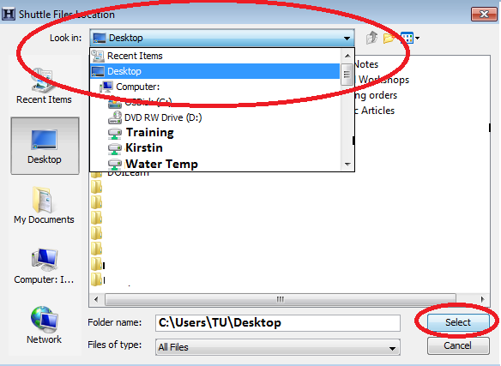
C:\Users\TU\Desktop

Check the “Save Folder” location again to make sure the files will save to the location that you want.

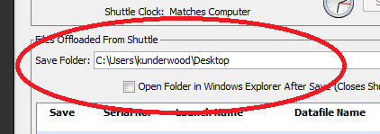
C:\Users\TU\Desktop
Now, it’s time to offload the data!

Make sure that all of the files in the list are selected.
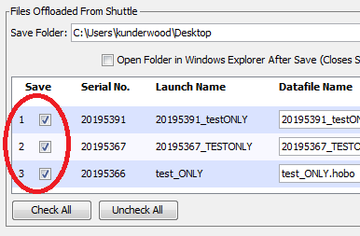
C:\Users\TU\Desktop
Then, click “save checked”.
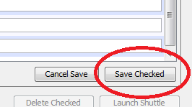

Once this is done, the status of the files in the list will change to “offloaded”.
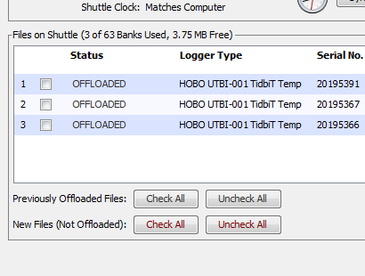
You could delete the files in the list now, but it’s a good idea to first close out of the shuttle management window and Hoboware, and check that your files have been saved to the correct location.

After you’ve seen that your files are OK, you can delete data from the shuttle. Failure to do so will complicate the next launching process. With the shuttle plugged in, open Hoboware and select “Manage Shuttle” from the dropdown menu.

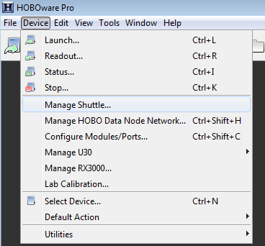

Check all of the boxes next to offloaded files.
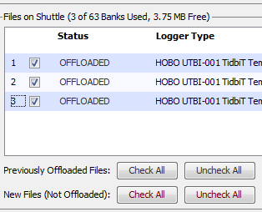

Then delete the checked files.
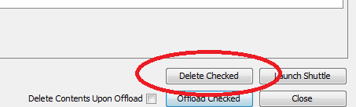

If you’re not sure whether or not the files have been saved, offload them before deleting. Select the box that says “Delete Contents Upon Offload”, then click “Offload Checked”.

When all of the files have been deleted from the shuttle, it can be re-launched.

TROUBLESHOOTING

The most common problem that happens with data offload is that the files become lost and buried in a hidden folder where HOBOware automatically saves them. If you know that the files have been offloaded, run a search for them on your computer by looking for a “.hobo” extension. If your computer locates the file, open the file location – all of the files are likely saved in the same folder. Then move the files to a more accessible location.
If you can’t find the files, or if you’re not sure whether or not they’ve been saved, just close out of Hoboware and re-start the process to save the files again. The only difference is that now you’ll be saving offloaded files. Files can only be erased from the shuttle manually – you can close out of Hoboware without saving as often as you need to to re-start the process.

STEP 6 – VIEWING AND EXPORTING YOUR DATA

Find the files that you offloaded from the shuttle, and double-click on one to open it. HOBOware should launch automatically. A popup window called “Plot Setup” should appear.
Check the temperature units in the popup window – you want everything to read in degrees Celsius, not degrees Fahrenheit. If the temperature is automatically set to “F”, change it by selecting “C” from the dropdown menu. Then, click “plot”.
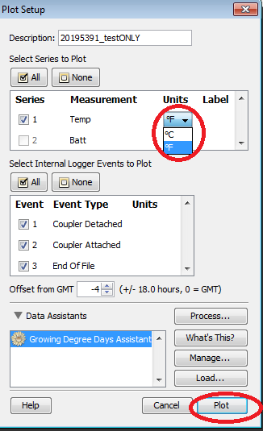

The data series will appear in a table at the top left corner of the window, and HOBOware will automatically plot out the data into a graph.
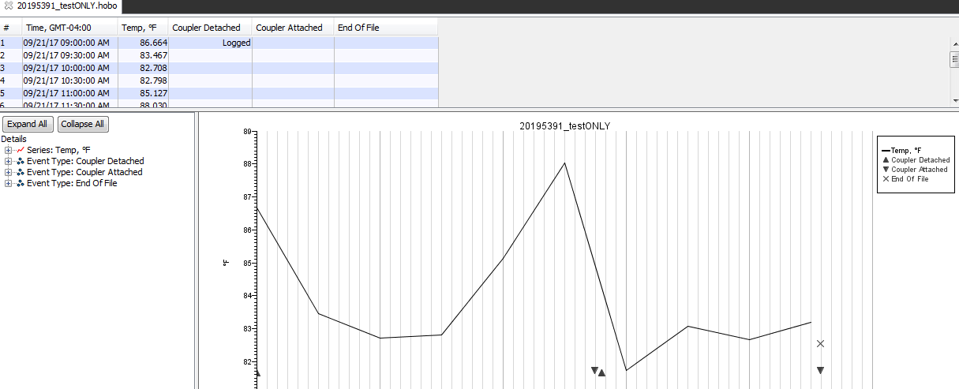

Now you need to transfer the data to an Excel file in order to upload it to SHEDS. The process is easy with the new version of Hoboware. Find and click on the Excel icon on the top of the screen.

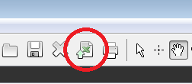

A popup window will open. Check to make sure that the units are in Celsius, then click the “export” button. (If the units aren’t in Celsius, just close out of Hoboware and go through the process again, this time making sure to select “C” from the dropdown temperature menu.)
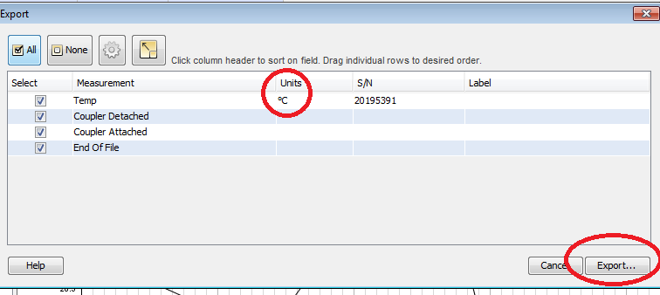

Another popup window will appear. Choose a location to save the file. You can rename it if you’d like, but keep the .csv extension.
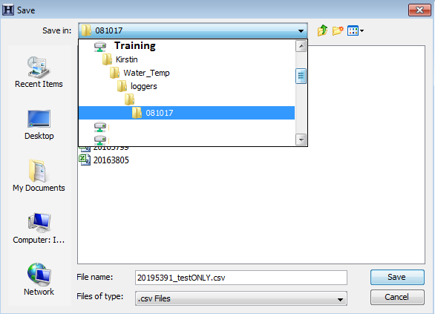
You can open and export multiple files in HOBOware.
Check to make sure that the file has saved in the correct location, and open it.

You can now view the temperature data in Excel as a csv file.

USER-FRIENDLY GUIDE: UPLOADING .CSV TEMPERATURE FILES TO SHEDS DATABASE
Kirstin Underwood, USFWS

PREPARING YOUR CSV FILE FOR UPLOAD TO THE SHEDS DATABASE
You’ll need to make some edits to prepare your .csv file for upload to the SHEDS database.
After you have successfully exported your temperature data from Hoboware to a .csv file, open the file in Excel. Your table should look something like this.
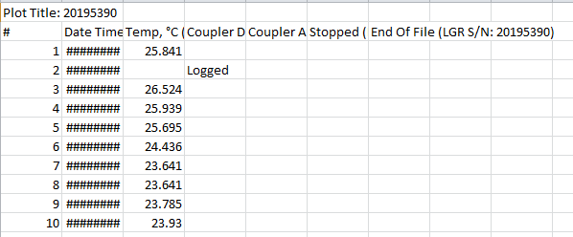

Expand the “Date Time” column so that you can see the date/time values. (Click on the dividing line between columns B and C, and drag the line over until the column expands enough for you to see the number values.)
SHEDS can only accept timestamps from a single timezone. If your file contains timestamps from both Eastern Standard Time (EST) and Daylight Savings Time (EDT), you will need to edit the file and manually subtract 1 hour from all timestamps in Daylight Savings time so that all timestamps will be in EST. (You could also change all of the timestamps to EDT.)

Clean up your table by getting rid of extra rows and columns. Highlight the first row (labelled “Plot Title”) by clicking on the number “1” on the left side of the chart. Then, right-click on the highlighted row, and select “delete” from the dropdown menu.

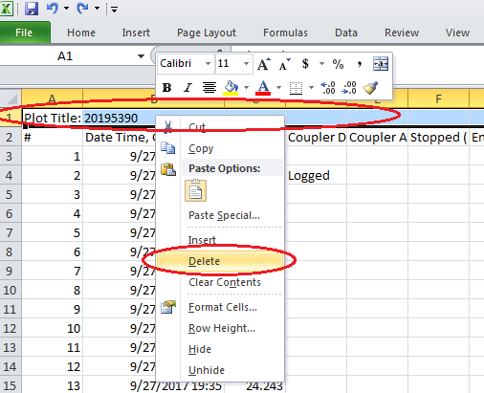

Next, delete the columns that lack corresponding data values (usually columns D-G, labelled “Coupler Detached”, “Coupler Attached”, “Stopped”, and “End of File”). Highlight the columns by clicking on the column letter label (ie, “D”) at the top of the chart and dragging the mouse over to the last column you’d like to highlight (ie, “G”). Once the columns have been selected, right-click on the selection, and choose “delete” from the dropdown menu.
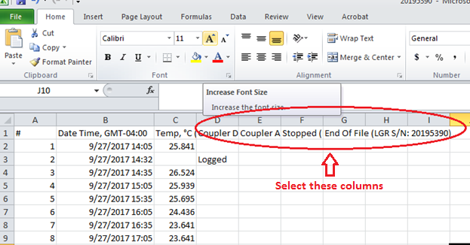

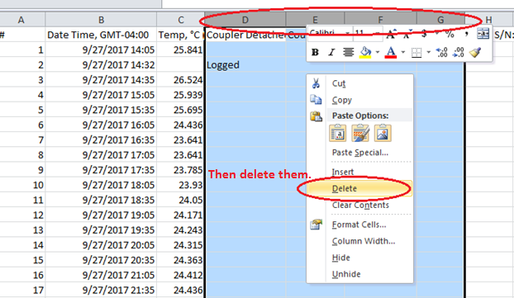

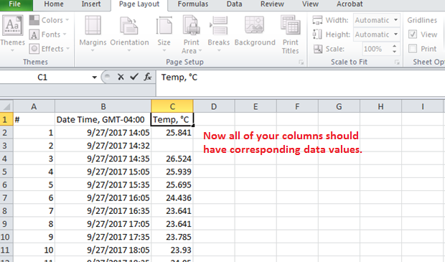

Look over your .csv table. All cells beneath the column labels should have numeric values. Look for blank spaces and cells containing the word “logged” instead of a numeric value at the beginning and end of the table – this occurs during data download or logger re-launch.
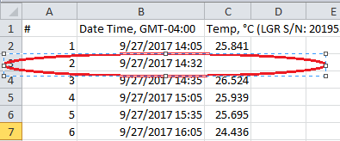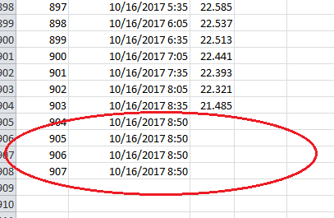
Or
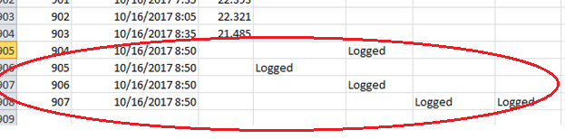

Delete these rows by clicking on the row numbers on the left side of the page, then right-clicking on the selection and choosing “delete” from the dropdown menu.

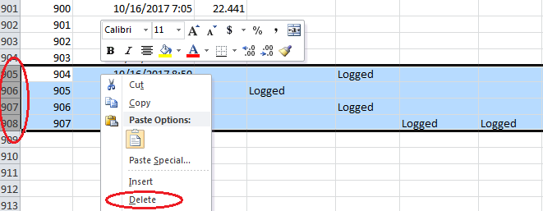

Now you should have a nice, clean table with numerical values under each labelled column all the way to the end of the data series, as shown in the image below.
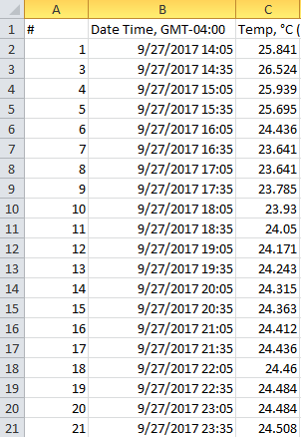

OPTIONAL: DATA QA/QC
You can either QA/QC your data now in Excel, or do it later in SHEDS. Skip this step and go onto the next section if you want to do this in SHEDS. Otherwise, scroll through your chart and look for any temperature values that stand out or seem abnormal. Delete any values that don’t make sense. If there was a known time period when the logger was out of the water, delete that data.
The benefit to doing this in SHEDS instead is that it is possible to compare air and water temperature using that platform, which can help you determine whether or not a set of abnormal readings (very high or very low temp values) makes sense.

SAVING THE FILE AS A CSV
Now save the file. Depending on the version of Excel that you have, you might run into some issues.
When you click “save”, you might receive an error message in a popup window which warns you that “new features are not compatible with CSV format”. Ignore this warning and click “yes” to keep the workbook in this format.

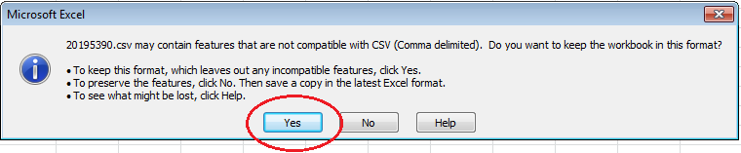
When you try to close out of Excel, you may be prompted to save the changes that you made in a new popup window. Click “save”.
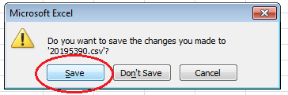
After you choose to save the file, another popup window may appear. The file may try to save itself as something other than a .csv file (ie “Unicode text”).
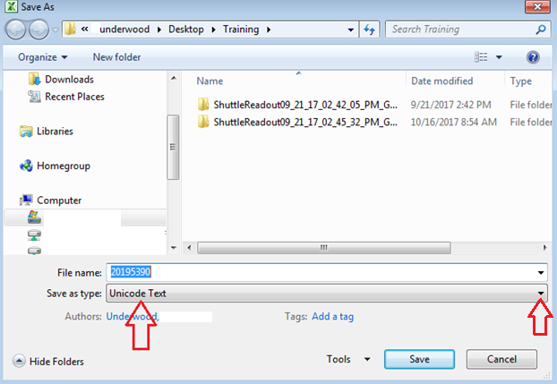

Whenever this window comes up, make sure the file saves as a CSV (Comma delimited) file! If you see any other type of file next to “Save as type” (as in the example above), click on the dropdown menu beneath the file name. Find “CSV (Comma delimited)” in the menu, select it, and then click “save”.
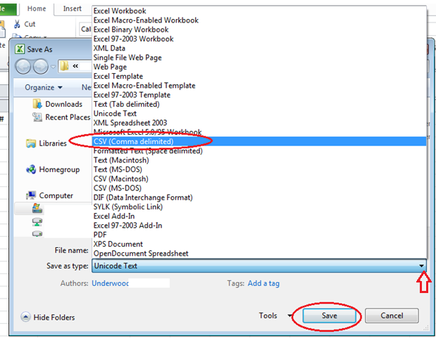

You may get another error message in a popup window. Select “yes” to replace the file.
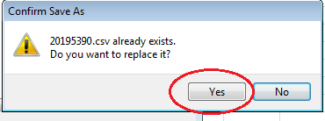
You may get another error message warning you of features incompatible with CSV format. Ignore the warnings and select “yes”.
The file should save with the new formats. You are ready to upload the data to SHEDS.

UPLOADING DATA TO SHEDS
Go to http://db.ecosheds.org and click the small “login” icon on the top right corner of the page to sign into your account. (If you don’t have one or if you forget your password, email Jeff walker at jeff@walkerenvres.com.) Once you’re logged in, you’ll be able to see the total number of all of your stations and time series (below). You will also see red boxes if you have set your stations to “private” and if your stations need QA/QC review (covered later).

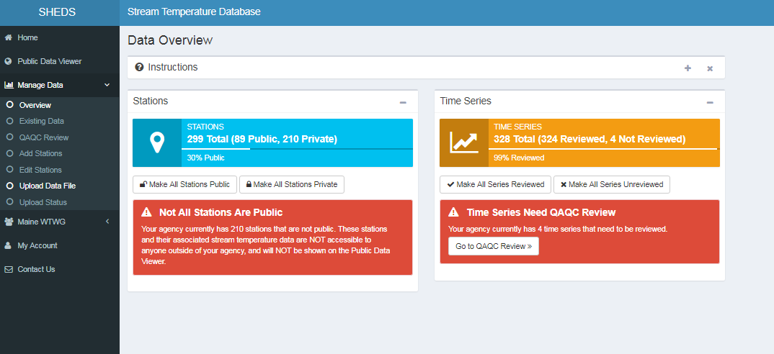
In the gray menu on the left, click on “Upload Data File”.
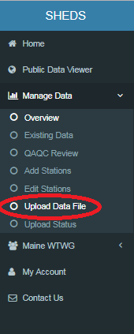

An upload form will appear. Scroll to “Select CSV File” and click on “choose file”.

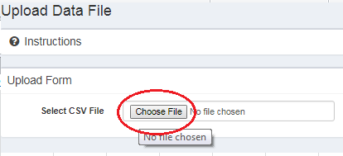

A popup window will appear, allowing you to navigate through your computer to select a file. Navigate to location of your .csv file, then double-click the file to select it.
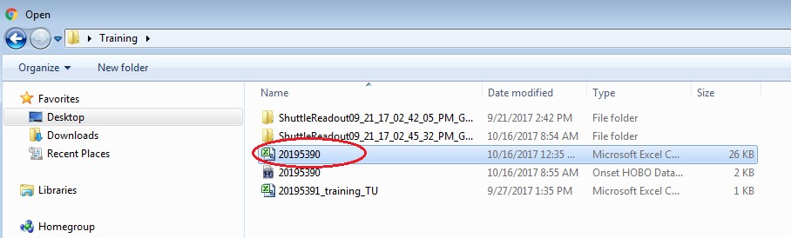

The popup window will close, and the file name will appear in the SHEDS upload form.

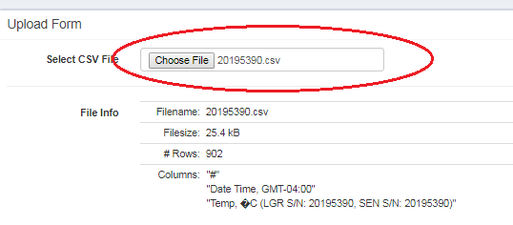
Go to the next blank space on the form (Datetime Column). Click on the arrow in the DateTime column box, and select “Date Time” from the dropdown menu.
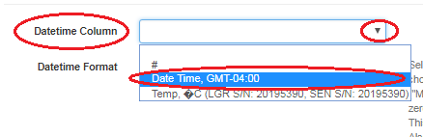

(NOTE: If “Plot Title” is the only option in the dropdown menu, you forgot to delete the first row of your .csv temperature file. Open the file, delete the first row, save it as a .csv, and repeat the upload process.)

Next, select the Datetime Format. This is the part of the form that can bring trouble.
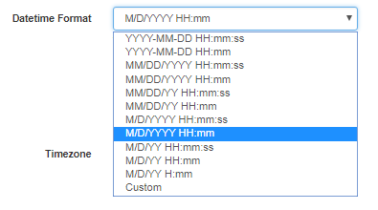
Here’s some advice on choosing the appropriate date/time format, taken directly from the SHEDS data upload page:
“Select the datetime format. If the datetime format used in the file is not listed then choose Custom. Note that the number of letters for each part of the datetime matters ("MM" is not the same as "M"). If the datetime stamps contain months with padded zeros (e.g. 03 for March) then use two letters (MM), otherwise use one letter (M). This applies to all parts of the datetime, not just the months (e.g. DD vs D for days). Also note that the default datetime format in Excel is (usually) "M/D/YY HH:mm". We recommend using 24-hour time instead of 12-hour time with AM/PM, however both are supported (see the link above for details).”
After you select the appropriate Date Time column, text will appear beneath the Datetime Format box.
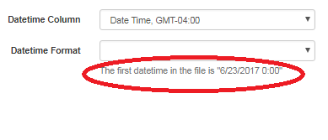
Use this text as guidance to select the appropriate date/time format. In the example above, the format is M/D/YYYY H:mm (for 6/23/2017 0:00). Note that the date/time format does not contain padded zeroes, indicating that the month (M), date (D) and hour (H) should be represented by a single letter. (If the date time/ was written as “06/23/2017 00:00”, the format would be “MM/DD/YYYY HH:mm”).
You can minimize the data upload form and open your .csv file for reference if necessary. Look at the Date Time column. Within each date listed, note the number of digits in the month (M), day (D) and year(Y); within each time, note the number of digits in the hour (H) and minutes (m). If any of the date or time values contain a single digit (ie, “3/3/2017” instead of “03/03/2017”, or 5:00 instead of 05:00), then the value is represented as a single letter in the format.
Ie, if a date/time stamp reads “3/3/2017 5:00”, the appropriate format is M/D/YYYY H:mm. If the date/time reads as “03/03/2017 05:00”, the appropriate format is MM/DD/YYYY HH:mm. 3/3/17 5:00 is M/D/YY H:mm….and so on.
Back in SHEDS, click on the arrow in the Date Time box and select the appropriate format from the dropdown menu.
If you do not see the appropriate date/time format on the dropdown menu, select “Custom” to enter the appropriate format manually.
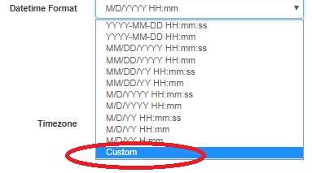

A blank text box will appear beneath the “DateTime” box. Click in the box to enter the appropriate format. Click anywhere outside of the box to save the change.
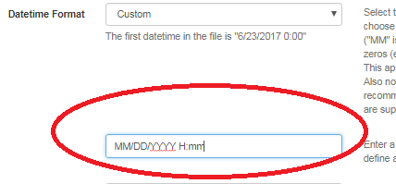

IMPORTANT: All letters entered in a custom format for month, day, year and hour should be CAPITALIZED! Minutes (“mm”) should be lowercase.
Once you’ve selected the correct date/time format, choose the appropriate timezone (EST - Eastern Standard Time or Daylight Savings Time – EDT). Remember that SHEDS can only accept timestamps in a single timezone. If a time series contains both EDT and EST, open your .csv file and edit the timestamps manually to reflect the same timezone. Then save the file and upload it to SHEDS a second time.
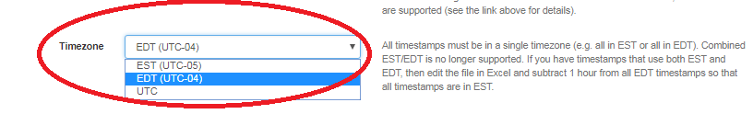

If you are uploading data from a single station, select “Single Station” from the Station Option. (You can upload multiple files to SHEDS if they are condensed into one .csv file and organized by column. I usually upload one file at a time.)

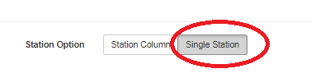

Next, select the appropriate station under “Station Name”. This is the site that the data corresponds to.
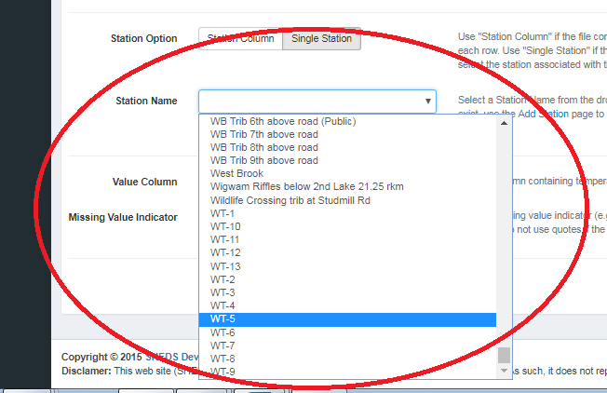

You’re almost done! Click in the box next to “Value Column” and select “Temp” as the value.
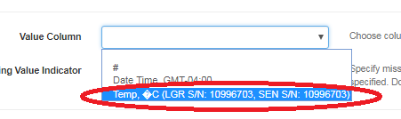
You can ignore the “Missing Value Indicator” box.

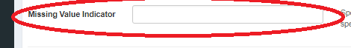

Glance over the form to make sure that all spaces are filled out correctly. If everything looks right, click “submit” at the bottom of the page.

If all went well, you will be sent to a new page with a success message.
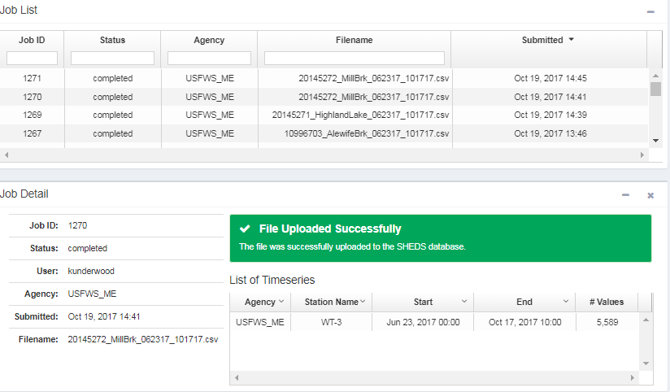

If you receive an error message that says “Unable to parse DateTime row at Row X. . . . . .”, then you did not select the correct DateTime format for your .csv file. If you entered a Custom format, ensure that all of your M’s for month, D’s for date, Y’s for year, and H’s for hour are capitalized, and that your m’s for minutes are in lowercase. Ensure that there is one space between the last Y and the first H, and that the time is properly represented as (#H’s):mm.
If you selected a DateTime from the dropdown menu, make sure that it represents the format in your.csv file. Double-check your file to determine the appropriate format.
A last resort is to format your DateTime row in Excel to match one of the DateTime formats in SHEDS.
If you have tried everything and still can’t figure out the issue, contact Jeff Walker at jeff@walkerenvres.com.

After the file has uploaded successfully, it needs to be checked for accuracy. From the menu on the left side of the page, click on “Manage Data”, then select “Overview” from the dropdown menu.
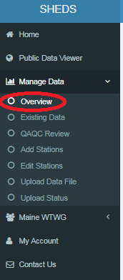

If you have files that have not been QA/QC’d in SHEDS, you’ll see a red message on the homescreen. Select “Go to QAQC Reciew”. (You’ll need to do this even if you have already finished QAQC in Excel.)
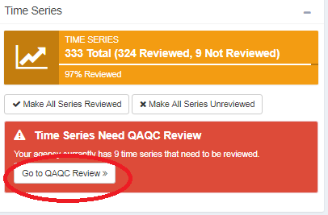
You will be sent to a new page with all of your data in a Time Series chart. Place your mouse pointer within the chart area to scroll through it. Look at the “Reviewed?” column. Time series that have not been reviewed in SHEDS will have a value of “false” in this column.
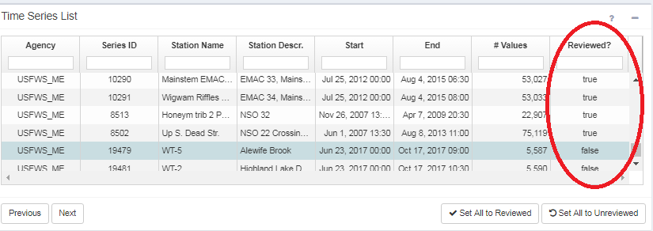
If you know that all of your files have already gone through QAQC in Excel, you can click on “Set All to Reviewed” in the bottom of the chart. Otherwise, click on the file that has not been reviewed to select it.
Data will appear beneath the chart in graph form.
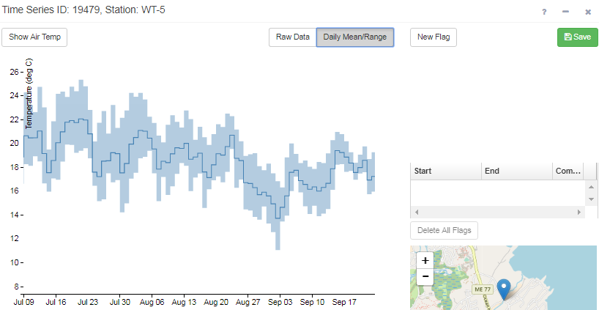

To view the data more closely, select “Raw Data”. Zoom in on the chart by placing your cursor anywhere in the graph and using your mouse’s scroll button to zoom in and out. This will allow you to view the data for each individual day.
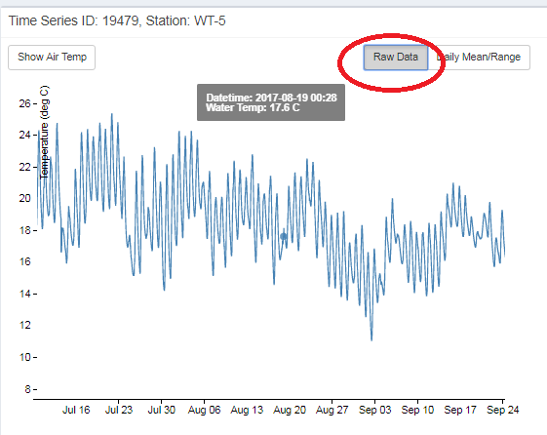
You can compare water temperature to air temperature values by clicking on “Show Air Temp” (this works best with older data series). Air temperature values will show up as a different color.
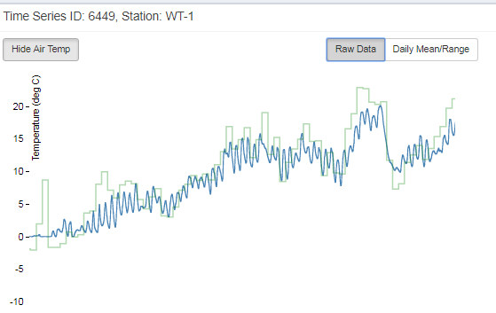
Look over your data carefully. If everything looks OK, skip to the next step. Otherwise, flag any suspect data: abnormal temperature values during a low flow period (logger might have been exposed), known time periods when the logger recorded data out of the water, etc.
To flag data, click on the “New Flag” button. You can select the suspect data series in the chart, or enter dates/times manually by clicking in the text boxes next to “Start” and “End”. Add a comment if you’d like (ie, “logger out of water”). When you’re done, click “Save”. Repeat this step for all suspect data within the series. You can skip this step if everything looks OK.

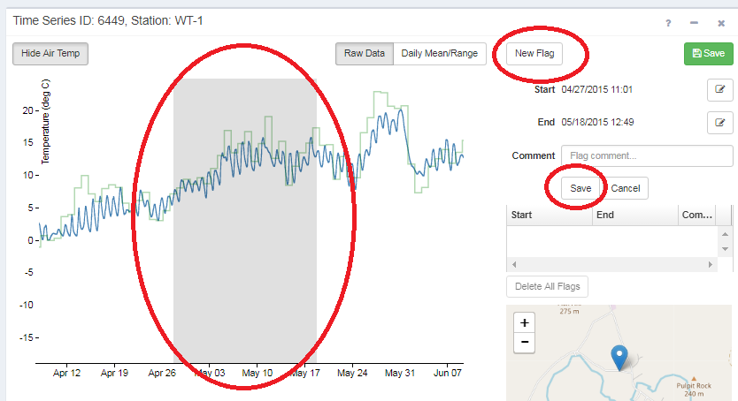

Once you have reviewed your data and added any necessary flags, click the green “Save” button.
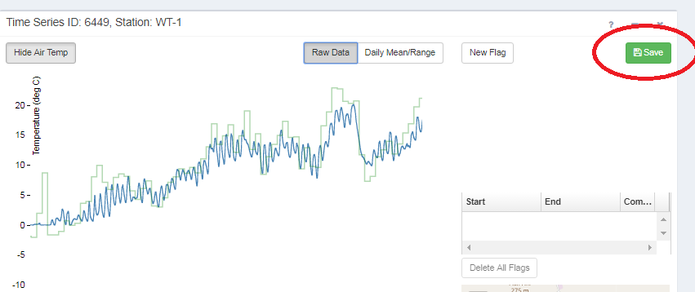

SHEDS will accept the data and save the series as “Reviewed”. Congratulations, you’re done! Your temperature data will be incorporated into the next model calibration.

