Maine Water Temperature Working Group Meeting Agenda

April 29, 2019
9:00 AM – 2:15 PM
Marquardt Building (DMR Headquarters), Large Conference Room
32 Blossom Lane, Augusta, Maine
Call-in Telephone Number (toll free): 1-877-952-2705
Participant Code: 74112339

******************************************************************************************

Purpose

To discuss current stream temperature work, increase coordination for future monitoring, learn about temperature model updates (SHEDS/ICE) and practical use of decision-making tools, and review obligations for grant reporting.

Agenda

9:00 – 9:30: Welcome/review of agenda & purpose
Round-table introductions and updates (all)
New equipment from Onset: Bluetooth loggers (Ernie Atkinson)

9:30 – 9:50: Maine Outdoor Heritage Fund Grant Update/Reporting Requirements (Merry Gallagher, MDIFW)

9:50 – 11:30: Spatial Hydro-Ecological Decision System (SHEDS) Updates, Tutorial, Q&A (Jeff Walker, SHEDS Database Designer)

10 minute break

11:30 – 12:00: Practical application of SHEDS & ICE (mixture of discussion & brief presentations)
Emily Zimmerman: SHEDS Data & Narraguagus River Temperature (5 min)
Kirstin Underwood: SHEDS, ICE & Temple Stream Temperature (5 min)
Scott Craig, Merry Gallagher (open to all): ICE/SHEDS Discussion
Who uses these tools? How do you use them? How can they be better utilized?

12:00 - 12:10: Outreach discussion (Kirstin Underwood, FWS)

12:10 – 12:40: Equipment signup and distribution
Wrap-up/adjourn for those not attending afternoon session
Lunch (bring your own)

12:40 – 1:20: WTWG Protocol Overview
Scott Craig: Chain anchor method
Kirstin Underwood: HOBOWare/calibration, epoxy method

FIELD TRAINING

1:20 – 1:30: Use SHEDS to pick field site, launch logger, pack up/travel to Bond Brook

1:30 – 2:15: Field Training!
Install logger at Bond Brook, below I-95 Bridge

Directions to Bond Brook site (44.338503, -69.808136) from 32 Blossom Lane in Augusta:
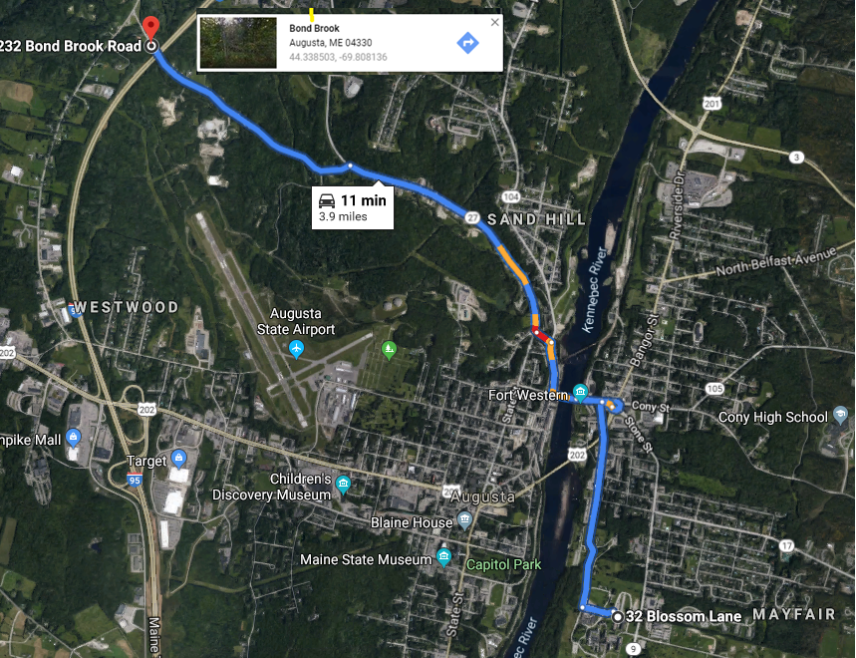

Drive along Arsenal St
- Head southwest on Blossom Ln toward Independence Dr. (.1 mi)
- Turn right onto Arsenal St (.9 mi)
Take Mt Vernon Ave to Bond Brook Rd
- Turn right at Cony St/Rte 27 (259 ft)
- At the traffic circle, take the 5th exit onto Cony St (.2 mi) and continue onto Bridge St (.1 mi)
- Turn right onto Water St (.2 mi)
- Turn left onto Bond St (394 ft)
- Bond St turns right and becomes Mt Vernon Ave (1.2 mi)
- Turn left onto Bond Brook Rd (1 mi) – destination will be on the left

