Stream Temperature Protocol Workshop
Gulf of Maine Coastal Program Office, 4 Fundy Rd, Falmouth, ME
7/10/2018
9:00 AM- 12:30 PM

9:00- 10:00: Opening & introductions
- Stream temperature project overview
- Protocol overview: anchor & epoxy Methods, data sheets, mid-season site checks
- Temperature logger deployment: HOBOware

10:00- 11:00: Introduction to SHEDS & online decision-making tools
- Data management
- Account overview
- Project site planning
- Interactive Catchment Explorer
- Questions?

11:00- 11:20: Travel to field site at Mill Brook logger
Meet at Summit Circle – park on street (43.702395, -70.342406)
Carry supplies & walk over to Mill Brook logger (43.701848, -70.340666)
Directions to Parking Area
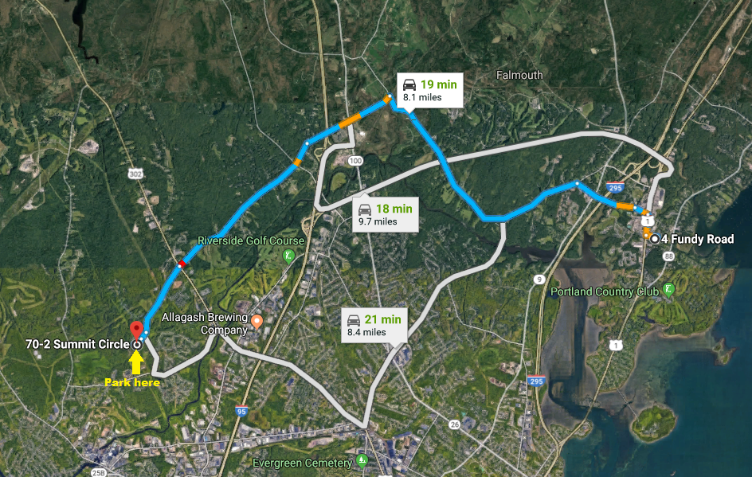
Directions to Site
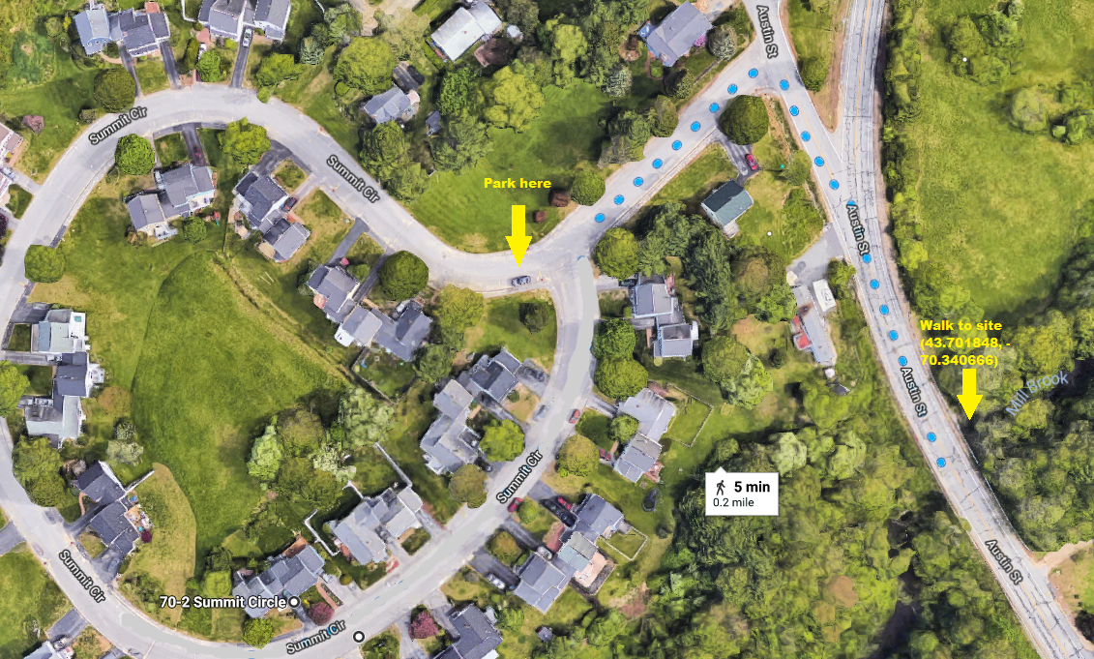

11:30 – 12:30: Field Training (bring waders, water, snacks, etc.)
- Equipment, Site Selection, Deployment
- Logger deployment w/ epoxy method (all participate)
- Mid-season site checks – overview
- Wrap-up, questions, closing

Travel home from field site

