Stream Temperature Protocol Workshop
Augusta DMR (Room #118), 32 Blossom Lane, Augusta, ME
5/1/2017
9:30 AM- 2:00 PM

9:30- 10:45: Review schedule, logistics, and introductions.
Protocol Overview
- 9:30-10:00: Anchor Method
- 10:00-10:30: Epoxy Method
- 10:30- 10:45: Pre-Deployment Steps
  - Launch the logger!

10:45- 11:05: Travel to Jamies Pond Wildlife Management Area in Manchester (see attached
map) for field training
- Coordinates of WMA parking lot: 44°17'8.50"N, 69°51'7.82"W
- Coordinate carpooling!

11:05- 12:15: Field Training (bring waders, water, snacks, etc.)
- Equipment, Site Selection, Deployment
- Epoxy vs anchor method
- Mid-season site checks

12: 15 – 12:45: Lunch (bring your own)

12:45 – 1:10: Travel back to DMR

1:10 – 1:30: Offloading logger data: Hoboware Pro

1:30 – 2:00: Uploading data to central database: SHEDS Tutorial

Directions to Field Site (44°17'8.50"N, 69°51'7.82"W - Jamies Pond Wildlife Management Area)

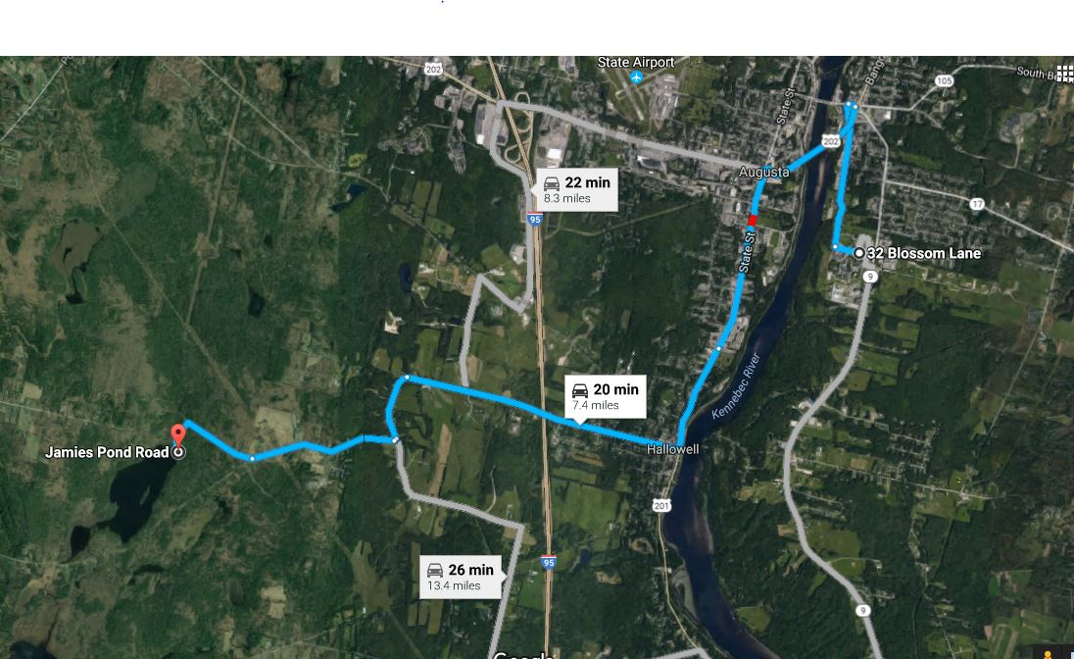

- Head southwest on Blossom Ln toward Independence Dr - 0.1 mi

- Turn right onto Arsenal St - 0.9 mi

- Follow US-201 S/US-202 W, State St and Water St to Central St in Hallowell - 6 min (2.6 mi)

- Turn right at Cony St/Rte 27 - 256 ft

- At the traffic circle, take the 1st exit onto US-201 S/US-202 W - 0.7 mi

- At the traffic circle, take the 3rd exit onto State St - 1.2 mi

- Continue onto Water St - 0.7 mi

- Continue on Central St. Take Outlet Rd to Jamies Pond Rd in Manchester - 10 min (3.7 mi)

- Turn right onto Central St - 1.7 mi

- Continue straight onto Shady Ln - 0.4 mi

- Turn right to stay on Shady Ln - 89 ft

- Turn right at the 1st cross street onto Outlet Rd - 0.9 mi

- Slight right onto Jamies Pond Rd - 0.7 mi
Destination will be on the right

