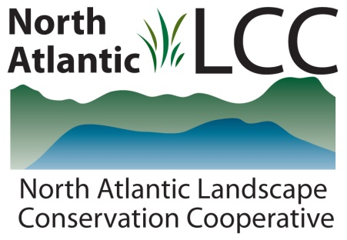

Connecticut River Watershed Landscape Conservation Design Pilot

Catalog (partial) of aquatic data and tools developed to support the work of the sub-team focusing on aquatic species, habitats, and associated ecology.
Project Name | Assessing Freshwater Ecosystems for their Resilience to Climate Change
Product Type | GIS data with attributes and ranks. Extensive report explaining goals, process, limitations, and ranks.
Product Description | Resilient stream systems are those that will support a full spectrum of biodiversity and maintain their functional integrity even as species compositions and hydrologic properties change in response to shifts in ambient conditions due to climate change.  The resilience analysis built on previously completed projects including a comprehensive stream classification system for the Northeastern US (Olivero and Anderson, 2008), and a spatial dataset of dams and unconstrained stream segments (Martin and Apse, 2011).  All connected stream networks were examined for seven characteristics correlated with resilience. These included four physical properties (network length, number of size classes, number of gradients classes and number of temperature classes), and three condition characteristics (risk of hydrologic alterations, natural cover in the floodplain, and amount of impervious surface in the watershed). A network was defined as a continuous system of connected streams bounded by dams or upper headwaters. For every network we calculated a complexity score that ranged from one to nine, and a combined relative score for physical properties and condition within the fish regions and freshwater ecoregions. Streams that scored above-average for their resilience characteristics are strongholds of current and future diversity, making them good places for conservation action. Lower scoring stream networks should be carefully evaluated with respect to their long term conservation goals.
Geographic Extent / Scale | 14 Northeast and Mid-Atlantic states including Ohio. Used the 1:100,000 scale National hydrography dataset.
Developer | The Nature Conservancy, Eastern Conservation Science office
Contact | Mark Anderson, Arlene Olivero Sheldon, Colin Apse
Completion | 2013

