Project Title:

**Mapping the Distribution, Abundance and Risk Assessment of Marine Birds in the Northwest Atlantic: Phase 1**

**Project Director:** Tim Jones, Science Coordinator, Atlantic Coast Joint Venture, 11510 American Holly Drive, Laurel, Maryland, 20708. Tel: 301-497-5674. Email: Tim_Jones@fws.gov

**Principal and Collaborating Investigators:** Because this project pulls together many different data sources and ongoing studies, there are numerous collaborating investigators who will be responsible for contributing the information from their areas of expertise and studies. To date, the Principal Investigator who will be responsible for overseeing the project in its entirety and to develop the risk maps using the results of the Structured Decision Making Workshop has not been identified. We will work via the partnership of the North Atlantic Landscape Conservation Cooperative (NALCC) and the Northwestern Atlantic Marine Bird Conservation Cooperative to identify the best lead for each project element. These are the collaborating investigators at this time.

**Principal Investigator –** to be selected by the partnerships

**Collaborating Investigators**

Dr. Iain Stenhouse Dr. Brian Kinlan

Director, Marine Bird Program Marine Spatial Ecologist

Biodiversity Research Institute NOAA National Ocean Service

652 Main Street NCCOS-CCMA-Biogeography Branch

Gorham, ME  04038, USA 1305 East-West Hwy

Tel: (207) 887-7160 ext. 210 Silver Spring, MD 20910-3281

[iain.stenhouse@briloon.org](mailto:iain.stenhouse@briloon.org) Tel: (301) 713-3028 ext. 157

[DOE-funded baseline studies [brian.kinlan@noaa.gov](mailto:brian.kinlan@noaa.gov)

on marine birds] [Statistical modeling work on predicting long-term distributional patterns of seabird

Ms. Melanie Steinkamp species]

Mid-Atlantic Coordinator

Atlantic Coast Joint Venture Dr. Richard Veit

11510 American Holly Drive Biology Department

Laurel, Maryland 20708 CSI/CUNY

Tel: (301) 497-5678 2800 Victory Boulevard

[Melanie_steinkamp@fws.gov](mailto:Melanie_steinkamp@fws.gov) Staten Island, NY 10314

[AMAPPS aerial and boat surveys] Tel: 718-982-4144

[veitrr2003@yahoo.com](mailto:veitrr2003@yahoo.com)

[Ships of Opportunity Studies and Foraging

Studies]

Mr. Scott Johnston Ms. Karen Bennett, Program Manager

Chief, Division of Migratory Bird Management Natural Heritage, Endangered Species &

US Fish and Wildlife Service Private Lands Programs

300 Westgate Center Drive DE Division of Fish and Wildlife, DNREC  
Hadley, MA 01036 89 Kings Highway

Tel: (413) 253-8557 Dover, DE 19901  
[scott_johnston@fws.gov](mailto:scott_johnston@fws.gov) Tel: (302) 739-9124

Individual Tracking Studies] [Karen.bennett@state.de.us](mailto:Karen.bennett@state.de.us)

[State Agency Liaison and Advisor]

Dr. Jarrod Santora

NOAA SW Science Fisheries Center Mr. Mark Wimer and Dr. Allan O’Connell

3333 North Torrey Pines Court USGS Patuxent Wildlife Research Center

La Jolla, CA 92037-1022. 12011 Beech Forest Road

Tel: (858) 546-7000. Laurel, Maryland 20708

[jsantora@noaa.gov](mailto:jsantora@noaa.gov) Tel: (301) 497-xxxx

[Predictive Modeling – Gaps] [mwimer@usgs.gov](mailto:mwimer@usgs.gov) and [aoconnell@usgs.gov](mailto:aoconnell@usgs.gov)

[Atlantic Seabird Compendium]

**Funds Requested: $175,000 (Phase One)**

**Project Summary**

This project will develop a series of maps depicting the distribution, abundance and areas of high, medium and low risk to marine birds from offshore activities (e.g., energy development) in the northwestern Atlantic Ocean. There are numerous efforts underway to identify marine habitats of importance to marine birds in the offshore environments of the eastern U.S. Many of these efforts are gathering similar types of information (i.e., baseline data) but are focusing on different regions and using different technologies. This project will bring together a unique partnership to pull together data from a variety of sources including: ships of opportunity, aerial surveys, species specific telemetry studies, and the historic (from the 1970s to present) marine bird database (Atlantic Seabird Compendium) maintained by the US Geological Survey (USGS). These data will be used to model distribution and abundance patterns of many species or species groups of seabirds and then combine them with species risk assessments to create a spatially explicit risk surface. The resulting “best darn bird map” can be can be used for informing decisions about siting offshore activities such as wind turbine installations, marine spatial planning efforts, or other uses requiring maps of seabird distributions such as identifying marine protected areas. Our goal in this effort is to document and predict areas of frequent use and aggregations of birds and the relative risk to marine birds within these areas. Interest in developing wind resources in the offshore waters of the Mid-Atlantic and New England is increasing rapidly and information is needed to help managers select sites for wind turbines and other offshore uses. The resulting risk surface can be used to inform offshore energy development and more generally, marine spatial planning efforts about the importance of the pelagic habitats to marine birds.

To accomplish this we need to identify seasonal distribution and abundance patterns, movement patterns, habitat-abundance associations (including prey), and the potential risk to a particular species based on life history traits, behaviors or species’ vulnerabilities. Currently, information on the spatial and temporal movement and occupancy patterns of wildlife resources in offshore habitats is lacking for much of the North and Mid-Atlantic Planning Regions. This project will integrate data from a number of ongoing marine bird survey efforts including but not limited to ships of opportunity surveys conducted by City University of New York, AMAPPS[1] aerial and ship-based surveys, ongoing telemetry studies of individual marine birds (sea ducks and seabirds) by a number of entities, state-funded studies gathering baseline information, the USFWS sea duck surveys and data from Canadian surveys in the Gulf of Maine. This project also will integrate with and inform work underway by NOAA’s Biogeography Division who are predicting seabird occurrences in the mid-Atlantic and New York Bight. This project will support work underway by The Nature Conservancy who is developing an estuarine and marine habitat classification system from Maine to Virginia using NOAA and NatureServe’s Coastal and Marine Ecological Classification Standard (CMECS) and the Nature Conservancy and NatureServe’s Northeast Regional Habitat Classification System (NRHCS). A workshop will be held to identify and quantify risk factors using a Structured Decision Making (SDM) process for marine birds in the Northwest Atlantic. The results from this workshop will be combined with data from the studies and surveys mentioned above, to create a map of relative risk to marine birds based on patterns of use, abundance and temporal variability that will inform current and future decisions by natural resource managers.

**Mapping the Distribution, Abundance and Risk Assessment of Marine Birds in the Northwest Atlantic**

**Product:** The primary product of this proposal is a series of maps depicting the distribution, abundance and spatio-temporal variability of seabirds in the Northwest Atlantic and of the risk to marine birds from offshore activities (e.g., wind power development) . The final product will include maps of species distributions and abundances including marine “hotspots” which will be based on a statistically supported measure of persistent of occurrence. Our analyses will make use of a variety of historic and extant surveys to model occurrence and abundance in a spatially-explicit framework. At this time we anticipate modeling the relative risk to marine birds categorically by areas of high, medium and low use; exact definitions will be developed during the Structured Decision Making (SDM) workshop. This effort will be a collaborative effort among scientists within the marine community and will include federal and state Fish and Wildlife agencies, academia, and private conservation organizations. Maps will be produced at different spatial resolutions to give marine spatial planners the ability to address planning and siting questions at both the regional and “local” scales. Phase I of this project will focus on the Mid-Atlantic region. Phases II and III, if funded, will expand the scope of this project to the rest of the North Atlantic Landscape Conservation Cooperative (NALCC) coastal waters. Products developed through this proposal will be used by partners of the Atlantic Coast Joint Venture (ACJV) and the NALCC to further conservation efforts directed at sustaining populations of seabirds in the northwest Atlantic.

**NALCC Relevance**: This project fulfills the purpose, vision and mission of the NALCC by bringing together data sources from multiple partners to create a comprehensive data and mapping product that will be used to assess risks posed by various stressors to marine avifauna and to inform decisions in offshore environments including, but not limited to, wind turbine installation, marine spatial planning, and identifying protected areas in the marine landscape within the boundaries of the NALCC. This proposal addresses **Ecological Planning** and **Conservation Design** actions identified in the *FINAL DRAFT North Atlantic Landscape Conservation Cooperative Conservation Science Strategic Plan* (NALCC 2011). This proposal also addresses the following Northeast Regional Conservation Needs (NEAFWA): **Priority Topic Area #1** *Develop Regional Base Maps for Analyses of Northeast (NE) Species of Greatest Conservation Need (SGCN) Data* and **Priority Topic Area # 7** *Identify and Assess Threats to NE SGCN*. Specifically, the results and products of this proposal will advance the NALCC mission by addressing the following actions:

|  |  |
| --- | --- |
| **Component and Objective** | **Actions** |
| **Ecological Planning**: Compile, organize and provide information from existing partners and partnerships on status, trends, current and emerging threats and limiting factors for priority fish, wildlife and plant species and cultural resources; agree on regional objectives for these species and resources; and assess their relationship to limiting factors, ecological processes, habitats and landscapes to provide a scientific basis for conservation actions. | **Action 4:** Compile best available information on threats and limiting factors constraining population size and distribution and management options to address these factors. |
| **Action 6:** Develop and apply models that related population to habitat, ecological processes and other limiting factors. |
| **Action 7**: Determine any immediate priorities based on emerging threats (triage). |
| **Conservation Design:** Develop, provide and translate maps, tools and information to guide decision makers and inform conservation actions to more effectively address threats, limiting factors and uncertainties and efficiently achieve objectives; ensure functional natural systems under current and predicted future conditions; and link site-scale actions to landscape and regional scale goals. | **Action 1:** Work with managers and conservation decision makers to assess what information and tools are needed to support their decision-making; |
| **Action 2:** Develop regional, consistent, spatial databases and maps to support conservation design at multiple spatial scales including consistent spatial data layers on habitat types and other key landscape attributes. |
| **Action 5:** Use predicted impacts of climate change, urban growth, and other stressors with population-habitat models to assess impacts to ecological processes, future capacity of habitats to support populations under different scenarios and adjust population objectives if needed based on current and likely future habitat capacity. |

**Geographic Extent:** The proposed area for the full project will include all Canadian Provinces and coastal states from New Brunswick to Virginia, extending from the intertidal zone to the base of the shelf-slope break as data allows. Reporting for Phase 1 will be limited to the Mid-Atlantic region; Virginia through New Jersey. Phases II and III will extend from New York to New Brunswick, Canada.

**Background**: In November 2010, Secretary of the Interior Ken Salazar launched a ‘Smart from the Start’ wind energy initiative for the Atlantic Outer Continental Shelf to facilitate siting, leasing and construction of new projects, spurring the rapid and responsible development of this renewable resource. As a result, interest in developing wind resources in the offshore waters of the Mid-Atlantic and New England is one of the fastest-growing segments of the energy market (American Wind Energy Association 2011). However, offshore wind facilities may have detrimental impacts on many marine bird species, exposing them to increased mortality through turbine collisions, altering behavior and flight pathways (Drewitt and Langston 2006), and altering the habitat upon which marine birds depend for foraging. Several wind energy facilities are currently being planned for offshore Atlantic waters of the United States. Under Federal and State laws, regulatory agencies, such as the Bureau of Ocean Energy Management (BOEM) the U.S. Fish and Wildlife Service (USFWS) and State Agencies have an obligation to protect populations of marine birds that frequent these areas (O’Connell et al. 2009). In addition to offshore energy developments, marine birds face many threats from anthropogenic activities. This project will create “the best darn bird map” for informing marine spatial planning efforts, such as offshore development and marine protected areas, about the importance of the pelagic habitats off the US Northeast and Mid-Atlantic coast to seabirds.

Relatively little is known about the distribution, abundance and spatio-temporal variability of marine birds in their offshore habitats. In response to the urgent need for this information, a number of aerial- and boat-based and individual tracking surveys have been performed in recent years or are underway to determine distribution and abundance of marine birds in both state and federal waters of the U.S. Atlantic Shelf, either in response to proposed offshore wind facilities or in anticipation of future development (e.g. NJ Department of Environmental Protection 2010, Atlantic Sea Duck Project/USGS and BDJV). Ongoing survey efforts, such as the Atlantic Marine Assessment Program for Protected Species (AMAPPS; NOAA 2011) aim to provide abundance and density estimates for marine birds over a wide geographical area during multiple years. While boat based and aerial surveys provide a “snapshot” of bird abundance and occurrence in time and space and can be used to model distribution, they do not help us understand seasonal, migratory, or daily use patterns. For this reason, a number of telemetry studies have been initiated or are planned to help us better understand concentrated migratory movements occurring over brief time periods and local within-season movements of seabirds. Finally, we will never have the monetary resources needed to survey the entire continental shelf multiple times a year to address the needs of resource managers so will have to supplement data from these efforts with statistically valid models that predict into areas not covered by historic or extant surveys. We will integrate and expand upon existing modeling efforts to predict the long-term distributional and abundance patterns of seabirds in the NY Bight and Mid-Atlantic areas. We propose to take the information from this combination of surveys and pull it together to produce the most comprehensive maps of marine bird use in the offshore environment. These surveys (aerial, boat, individual tracking, and predictive distributions), when analyzed together in a common framework, will provide the best understanding of how marine birds use or are expected to use waters of the U.S. Atlantic throughout the annual cycle. Phase I of this project will use existing data from the mid Atlantic. Phases II and III will incorporate data from new studies and surveys, such as DOE-funded studies and BOEM-funded telemetry studies, and similar extant efforts by the Canadian Fish and Wildlife Service and will expand to include the remainder of the northeast, including the Gulf of Maine in its entirety.

We also propose to conduct a marine bird risk assessment using a SDM process (Martin et al. 2009). Information on risk will be combined with the predicted distribution and abundance maps to highlight areas of low, medium and high risk to marine birds facing various forms of offshore development. Model validation will be accomplished through special survey efforts or by withholding a portion of the ongoing survey efforts to be used in cross-validation procedures. Information from this assessment can be used to help managers assess the potential for adverse interactions to offshore activities such as the installation of wind turbines. The products developed by this project will be able to be used by partners of the ACJV and NALCC to ensure that offshore developments are sited away from areas with high potential marine bird use.

**Project Description:**

The “Best Darn Bird Map” will be produced through a series of iterative activities.

The expected steps are:

1. Data collation of historical and extant survey efforts and analyses.
   1. Ships of Opportunity Studies

Collaborators have surveyed marine birds from ships and aircraft for thirty years in the Antarctic (Veit et al. 1993, 2008), California Current (Veit et al. 1996, 1997), Indian Ocean (Hyrenbach et al. 2007) and NW Atlantic (Veit 1978, Veit and Guris 2009). They have documented impacts of climate change (Veit et al 1996, 1997), found links between seabird distributions and those of their prey (Veit et al. 1993, 2008), and found statistical procedures for identifying Hotspots of abundance and species diversity (Santora 2010, and Santora and Veit in prep.). Current work involves surveying the US Atlantic continental shelf between Maine and North Carolina to map distribution and abundance of seabirds, using aircraft to survey the Atlantic Ocean off the coast of southeastern Massachusetts, and surveying by boat the Wind Energy Areas identified off the coasts of Delaware, Maryland and Virginia.

A combination of strip and line transects that have proven effective in the past (e.g. Clark et al. 2003) to map the distribution of birds on the US Atlantic coast. During these surveys, behavioral data on all birds is recorded to allow extraction of feeding birds after the fact. The intent of these surveys is to identify those parts of the ocean that are *important* (and indeed *persistently* important) so as to not draw attention to where transient aggregations may appear once and never again. Methods outlined by Santora et al. (2010, and Santora and Veit in prep.) will be used to identify areas of both persistently high abundance and persistently high species diversity of birds from survey data, plus the Atlantic Seabird Compendium database housed at USGS.

1. DOE funded baseline studies

These studies will draw upon historical and extant surveys while adding extensive boat and aerial surveys (including HD video) within the identified Wind Energy Areas (WEAs) to model the distribution and abundance of marine organisms in the Mid-Atlantic region (Virginia – New Jersey). The resulting data from their surveys will be used to help create the best maps and/or as validation data to help test outputs from our predictive modeling efforts.

1. AMAPPS surveys

Via an interagency effort among the US Fish and Wildlife Service, National Oceanic and Atmospheric Administration National Marine Fisheries Service, The Navy and Bureau of Ocean Energy Management, we are collecting broad-scale data over multiple years on the seasonal distribution and abundance of marine turtles, mammals and birds using direct aerial and shipboard surveys conducted by scientists from NOAA Fisheries and the US Fish and Wildlife Service. These data are providing information on distribution, abundance, related spatio-temporal variability, habitat associations, and are helping to identify important foraging and loafing sites for sea ducks and seabirds. During the summer of 2011, two NOAA cruise vessels had seabird observers. Aerial seabird surveys have been conducted during the summer and fall of 2010 and the summer of 2011.

1. Telemetry Studies

Satellite telemetry devices are being used to track the fine-scale occurrence and movement patterns of four species of diving birds, Red-throated Loon (*Gavia* *stellata*), Surf Scoter (*Melanitta perspicillata*), Black Scoter (*Melanitta nigra*), and Northern Gannet (*Morus bassana*), during winter and migration, when substantial proportions of their populations use waters of the Mid-Atlantic U.S. Satellite tracking studies are also underway for Great Shearwaters (*Puffinus gravis*) and other seabirds. Most of the PPTs transmit year-round providing location information in all seasons. Findings will complement other studies that are underway or being planned by BOEM and USFWS, as part of a comprehensive evaluation of the potential for interactions between wind energy facilities and wildlife within waters of the U.S. Atlantic. For the purposes of this project, this work will be used to ground truth predictive modeling efforts in the mid Atlantic and to identify areas of importance to marine birds not picked up by other survey methods.

1. New Jersey Wind Power Ecological Baseline Studies, Rhode Island SAMP and Massachusetts Cape Wind Studies

The State liaison will work to help facilitate incorporation, where publically available, data from state-funded baseline studies. These studies have been conducted to gather information for making sighting decisions in state waters and to help inform marine spatial planning efforts. The State liaison will also act as an advisor for the states to ensure that project objectives are meeting state needs.

1. Predictive Modeling

The NOAA Biogeography Branch (U.S. DOC/NOAA/NOS/NCCOS/CCMA/Biogeography Branch) is a group of marine ecologists, statisticians, and geo-spatial scientists who specialize in predictive spatial modeling of marine species and habitat distributions. Led by PI Dr. Brian Kinlan, NOAA Biogeography scientists recently completed a predictive modeling study of seabird species offshore of NY, specifically tailored to aid in offshore planning related to wind energy siting (Kinlan et al. 2011). With funding from BOEM and USGS, Kinlan and colleagues are extending their high-resolution predictive modeling work to the Mid-Atlantic region, using the Atlantic Seabird Compendium assembled by Allan O’Connell and Andrew Gilbert at USGS. Work on this funded project began in October 2011 and will be completed in 2013. In addition, Biogeography Branch is seeking funding to expand predictive models to include the Northeastern U.S. coastal and offshore waters starting in October of 2012.

With a relatively small expenditure the current study could promote synergies between the predictive modeling work of the NOAA Biogeography Branch and other efforts to synthesize information on seabirds for marine spatial planning purposes. Identification and ingestion of additional data into the Atlantic Seabird Compendium database will facilitate improved predictive models. The current proposal would establish this synergy by engaging NOAA Biogeography scientists and predictive modeling products in the risk assessment process. Also, because NOAA Biogeography Branch models predict the long-term average spatial pattern of seabird distribution, but do not capture variability at fine spatial and temporal scales, or nuances of behavior and ecology, validation and comparison with finer temporal-scale data is desirable. Funding from this proposal will facilitate comparison and integration of Biogeography predictive models with other sources of information on bird movements and habitat use, including individual telemetry using geo-locators and satellite tags, radar, and other technologies. The goal of these comparisons will be to develop an improved integrated framework for risk assessment that integrates long-term spatial patterns in seabird aggregation with short-term variability in distribution, behavior, and ecology.

1. Risk Assessment

A Structured Decision Making workshop will be implemented to identify and evaluate the potential risk posed by offshore development activities (e.g., wind farms) to marine birds. This workshop will develop a Bayesian Belief Network model to help identify species vulnerabilities and risks. Risk assessments often have difficulty separating risk assessment from risk management and fail the incorporate the connection between social values at stake (such as access to abundant alternative energy) and the scientific knowledge needed to predict the likely impact of management or planning decisions (Maguire 2004). Structured decision making is an organized approach to identify and evaluate alternatives and explicitly state model assumptions and factor weights. It focuses on engaging stakeholders, experts and decision makers in productive decision-oriented analysis and dialogue and deals proactively with complexity and judgment in decision making. It provides a framework that becomes a decision-focused roadmap for integrating activities related to planning, analysis and consultation. For marine birds, it will help define different conceptual models of risk to marine birds relative to species distribution and abundance patterns, predicted use patterns, and alternative offshore development scenarios.

Using outcomes from the risk assessment, our map of predicted occurrence will be weighted by relative risk. Areas of seabird use will be categorized into areas of high, medium and low risk to marine birds from offshore development activities. These outputs can be used by managers making decisions about siting offshore wind facilities.

1. Model Validation

We propose to validate low use/low risk areas of the map by either collecting new survey data or using alternative existing data for comparison with our modeled output. Those areas believed to be of less value to marine birds because of lower bird densities or lower occurrence would visited multiple times over time periods to determine whether they are truly “less important” to marine birds and would help us identify areas that we have high confidence are good lease sites. Information from telemetry studies of individual species can be used for in this effort as well.

**Timeline:**

January-June 2012 Phase I – Selection of PI and initial workshops to determine actions needed to collaborate on data and select pilot region (mid-Atlantic).

June – December 2012 Phase I –Structured Decision Making Workshop, individual tracking studies implemented, database gaps identified and data input into Atlantic Seabird Compendium

January - July 2013 Develop Distribution and Risk Maps and Test Outputs

Begin Phase II[2] (predicated on additional funds)

August-December 2013 Prepare Phase 1 Deliverables

**Deliverables:** A report, including spatially explicit maps predicting the risk to marine birds from wind development or other offshore activities at different spatial scales within the pilot region (mid-Atlantic?). The final product will include maps of species distributions and abundances including marine hotspots based on existing data and predicted occurrences, and will include the relative risk to marine birds within areas of high, medium and low use. Maps will be produced at different spatial resolutions to give marine spatial planners the ability to address questions at both the regional and “local” scales.

**Budget**

|  |  |  |
| --- | --- | --- |
|  | LCC Request | Match4 |
| **Data collation and Synthesis** | | |
| Salary1 | $ 45,000 | $ 1,500,000 |
| Data entry2 | $ 10,000 |  |
|  | | |
| **Travel3** | $ 20,000 |  |
|  | | |
| **Risk Assessment** | | |
| SDM Workshop | $ 10,000 |  |
| Risk surface layer | $ 25,000 |  |
|  | | |
| **Modeling Distributions** | | |
| Northeast Region | $ 25,000 | $ 150,000 |
|  | | |
| **Ground Truthing Surveys** | $ 15,000 |  |
|  | | |
| **Principle Investigator** | $ 25,000 |  |
|  |  |  |
| **Total** | $ 175,000 |  |

1To pay for approximately 2 weeks salary of each co-collaborator.

2Data entry of data not in USGS database, including tracking studies.

3Travel to two workshops/meetings of collaborators at $2500 per collaborator or $1250 per trip.

4There are millions of dollars of match associated with this project if all the co-collaborators ongoing studies are included. They are not all tallied here.

**References**

American Wind Energy Association (AWEA). 2011. [online]. Offshore wind.

< http://www.awea.org/learnabout/offshore/index.cfm> (25 August 2011).

Clarke, E.D., L.B. Spear, M.L. McCracken, F.F.C. Marques, D.L. Borchers, S.T. Buckland, and D.G. Ainley. 2003. Validating the use of generalized additive models and at-sea surveys to estimate size and temporal trends of seabird populations. Journal of Applied Ecology 40: 278-292.

Drewitt, A. L., and R. H. W. Langston. 2006. Assessing impacts of windfarms on birds. Ibis 148: 29-42.

Hyrenbach, K.D., R.R. Veit, H. Weimerskirch, N. Metzl and G.L. Hunt, Jr. 2007. Community structure across a large-scale ocean productivity gradient: Marine bird assemblages of the Southern Indian Ocean. Deep Sea Research I. 54: 1129-1145.

Maguire, Lynn A. 2004. What can decision analysis do for invasive species management? Risk Analysis, Vol 24, No. 4.

Martin, M.C. Runge, J.D. Nicholls, B.C. Lubow, and W.L. Kendall. 2009. Structured decision making as a conceptual framework to identify thresholds for conservation and management. Ecological Applications 19: 1079- 1090.

Northeast Association of Fish and Wildlife Agencies (NEAFWA). 2011. [online]. Regional Conservation Needs. <<http://rcngrants.org/priority-rcn-topics>> (1 January 2011).

New Jersey Department of Environmental Protection. 2010. [online]. Ocean wind power ecological baseline study, Vol. 2, avian studies, pp.C2-C9. Unpublished Report. State of New Jersey Department of Environmental Protection, Office of Science, Trenton NJ. < http://www.nj.gov/dep/dsr/ocean-wind/report.htm> (29 August 2011).

Niles, L. J., J. Burger, R. R. Porter, A. D. Dey, C. D. T. Minton, P. M. Gonzalez, A. J. Baker,

J. W. Fox, and C. Gordon. 2010. First results using light level geolocators to track Red Knots in the Western Hemisphere show rapid and long intercontinental flights and new details of migration pathways. International Wader Study Group Bulletin 117: 123-130.

North Atlantic Landscape Conservation Cooperative. 2011. FINAL DRAFT North Atlantic Landscape Conservation Cooperative Science Strategic Plan. U.S. Fish and Wildlife Service. 23pp.

O’Connell, A., B. Gardner, A. Gilbert, and K. Laurent. 2009. Compendium of avian occurrence information for the Continental Shelf waters along the Atlantic coast of the United States. Final report to the U.S. Fish and Wildlife Service and Mineral Management Service. Unpublished Report. U.S. Geological Survey, Patuxent Wildlife Research Ctr, Laurel, MD.

Veit, R.R. 1978. Some observations of South Polar Skuas (*Catharacta maccormickii*) on Georges Bank. American Birds 32: 300-302.

Santora, J.A., C.S. Reiss, V.J. Loeb, and R.R. Veit. 2010. Spatial association between hotspots of baleen whales and demographic patterns of Antarctic krill *Euphausia superba* suggests size-dependent predation. Marine Ecology Progress Series 405:255-269.

Santora, J.A. and R.R. Veit. In prep. Spatial persistence of top-predator hotspots near the South Shetland Islands.

Veit, R.R., E.D. Silverman, and I. Everson. 1993. Aggregation patterns of pelagic predators and their principal prey, Antarctic krill, near South Georgia. Journal of Animal Ecology 62: 551-564.

Veit, R.R., P. Pyle.and J.A. McGowan. 1996. Ocean warming and long-term change in pelagic bird abundance within the California Current System. Marine Ecology Progress Series 139: 11-18.

Veit, R.R., J.A. McGowan, D.G. Ainley, T.R. Wahl, and P. Pyle. 1997. Apex marine predator declines 90% in association with changing oceanic climate. Global Change Biology 3: 23-28.

Veit, R.R., J.A. Santora and H. Owen. 2008. Using a video camcorder to quantify spatial association between seabirds and their prey. Marine Ornithology 36: 145-151.

Veit, R.R. and P.A. Guris.  2009.  Recent increases in alcid abundance in the New York Bight and New England Waters.  New Jersey Birds 34: 83-87.

US Geological Survey. 2010. [online]. <http://www.pwrc.usgs.gov/resshow/perry/scoters/>

**Figures (examples of the types of data the project will pull together and overlay with risk.**

Figure 1. AMAPPS survey transects.

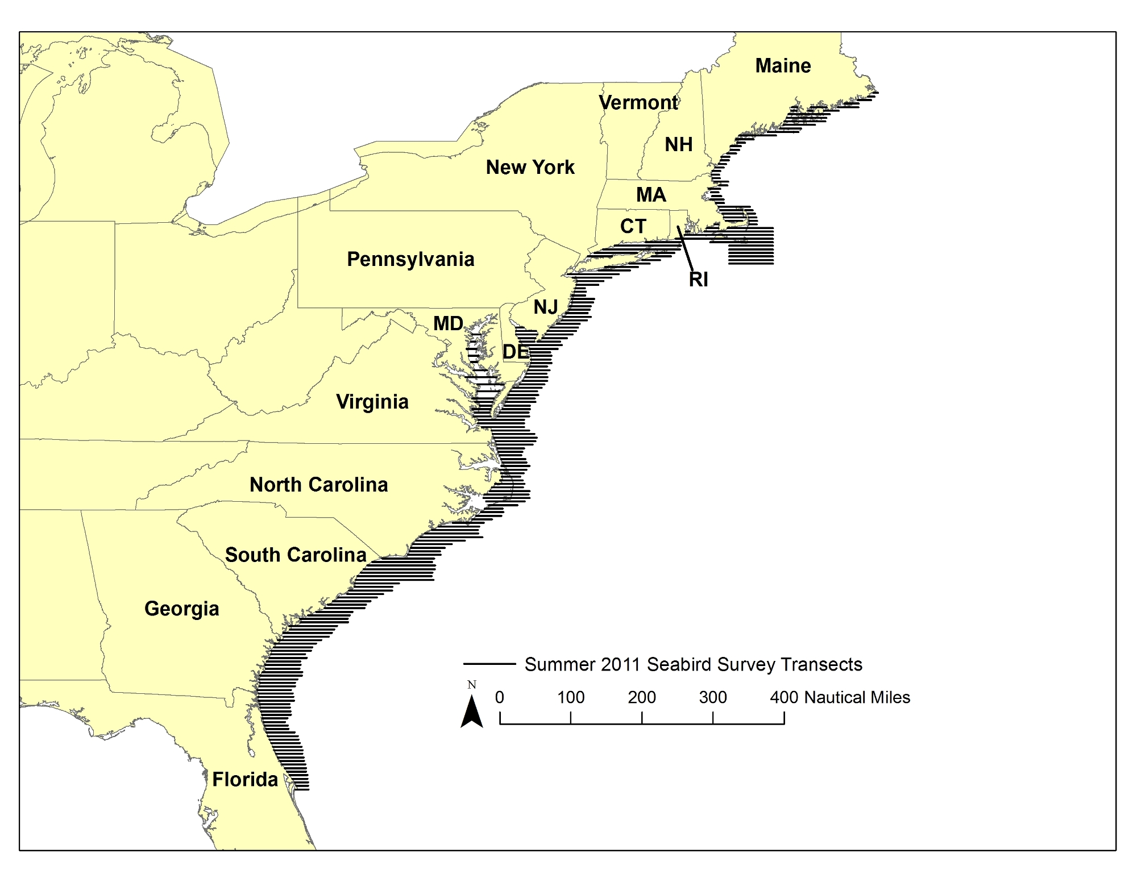

Figure 2. Ships of Opportunity Survey Data Example

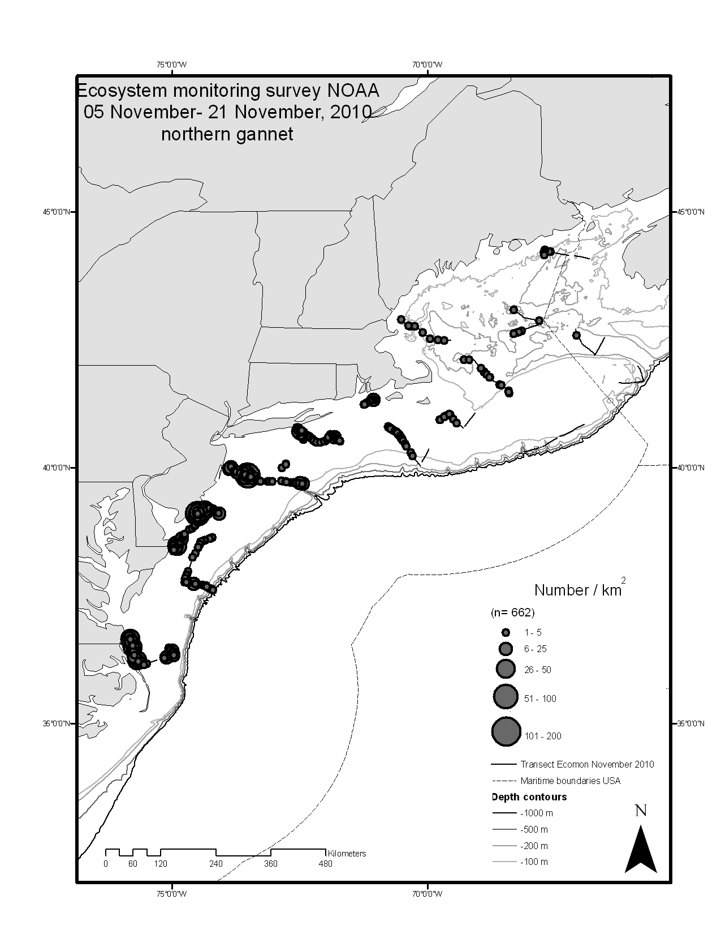

Figure 3. Example of results from Greater Shearwater tracking study (habitat use) (Courtesy of Rob Ronconi, Dalhousie University)



Figure 4. Predictions from modeling distributions of seabirds (hot spots ) in the New York Bight. (Courtesy of Brian Kinlan, NOAA/NMFS)

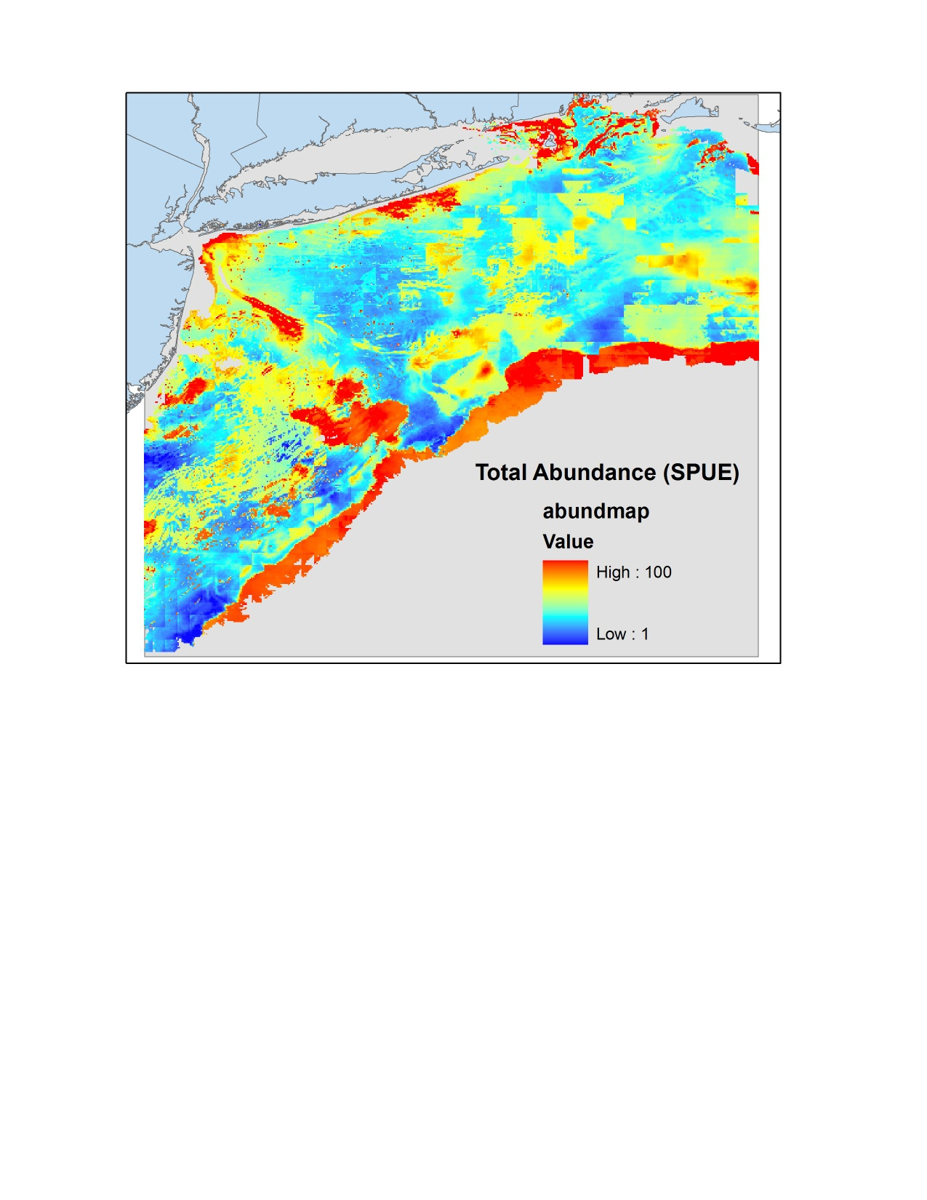

Figure 5. Atlantic Seabird Compendium Data Example

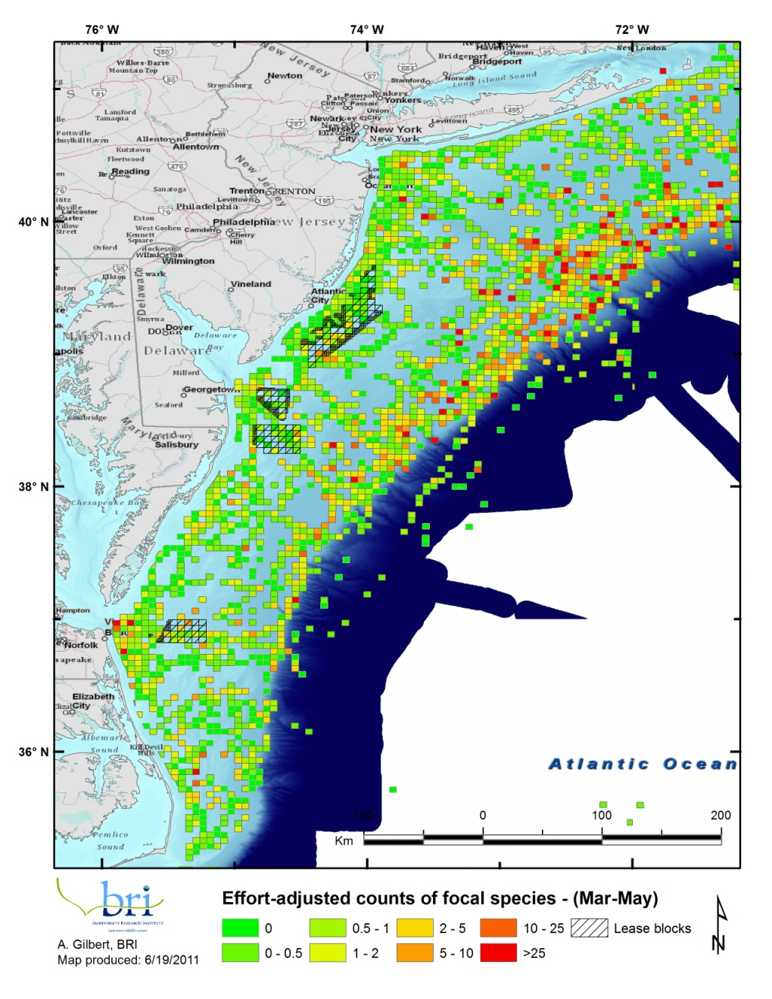

1. A coordinated effort among FWS, NOAA, BOEM, and The Navy to collect information on the distribution and abundance of marine mammals, turtles, and birds in the Atlantic.
2. Phase two of this project will be dependent upon additional funds of $125K per year for each of two years ($250K total) and would expand the work to the entire Northeast area. Phase 2 would be completed December 2014.