Version | Description | Changed By | Date
1.0 | First draft | L. Willey | 11/4/10
1.1 | Added draft to new template | L. Willey | 3/31/11
1.2 | Added assessment section and incorporated group comments | L. Willey | 5/27/11

Index

1 Index 1
2 Problem Statement 1
3 Solution Statement 2
4 Key Features 2
4.1 WRCP CMIP3 12km BCSD Data 3
4.2 PRISM 4
4.3 Data processing 5
4.4 Assessment 5
5 Detailed Description of Process 5
5.1 Assessment 8
6 Alternatives Considered and Rejected 10
7 Major Implementation Constraints 11
8 Major Risks and Dependencies 12
8.1 Major risks 12
8.2 Dependencies 13
9 Acknowledgments 14
10 Literature Cited 14
11 Appendix A – Diagrams/Figures 16
12 Appendix B – File Names and Brief Descriptions 26

Problem Statement
To evaluate the effects of climate change on ecological settings space, ecological integrity, and wildlife habitat over the next 100 years, it is necessary to develop climate projections under multiple emissions scenarios at a fine spatial resolution throughout the entire North Atlantic Landscape Conservation Cooperative (NALCC) region.
Global coupled atmospheric-ocean general circulation models (AOGCMs) are complex models used to produce long-term climate projections by integrating both oceanic and atmospheric processes and the interactions between them. As part of the Coupled Model Intercomparison Project, each of 16 AOGCMs have been standardized using standard historic data - the 20th Century in Coupled Models scenario (20C3M, Covey et al. 2003) and forced with standard emissions scenarios set by the Intergovernmental Panel on Climate Change (IPCC) Special Report on Emissions Scenarios (SRES, Nakicenovic et al. 2000). These simulations produced results comparable across models for each of the SRES scenarios. Output from these models is produced in large grid cells, up to 300km on a side. These cells are too coarse to incorporate the local variation (e.g., climate differences due to local topographic effects) that is an important driver of ecological processes. Consequently, it is necessary to downscale the AOGCM output to a finer cell size for use in the NALCC landscape change model.

Index

Solution Statement
We used publicly available AOGCM data that had been downscaled to 1/8 degree (approximately 12km) using the Bias Corrected Spatial Disaggregation (BCSD) downscaling approach (Wood et al. 2002). We averaged the results of 16 AOGCMs to create an ensemble average projection for each of 3 SRES scenarios, subtracted a baseline to create projected anomalies, and resampled these data at 800m cells. We then combined these data with 800m resolution, 30-year normal temperature and precipitation data (PRISM Climate Group, Oregon State University) using the “delta method”. These data were further resampled to 30m to match the other layers used in the NALCC landscape change model. The complete process is outlined in figure 1 and described in detail below. An animation illustrating the projected change in temperature over the simulation is located at: http://www.youtube.com/watch?v=tgfqq_sKlSs

Index

Key Features
In order to downscale the AOGCM climate projections, we utilized two major data sources: 1) World Climate Research Programme's (WCRP's) Coupled Model Intercomparison Project phase 3 (CMIP3) multi-model dataset, which had been downscaled to 12km, and 2) the 800m Parameter-elevation Relationships on Independent Slopes Model (PRISM) dataset developed by Oregon State University.

WRCP CMIP3 12km BCSD Data
The WRCP’s CMIP3 has made publicly available a database of output from a BCSD approach, consistently applied across 16 AOGCMs under 3 SRES scenarios projected to the year 2100. This dataset, derived from CMIP3 data and served at: http://gdo-dcp.ucllnl.org/downscaled_cmip3_projections/, was described by Maurer et al. (2007) and consists of monthly average precipitation and monthly average temperature projections at 1/8 degree (12km) resolution across the U.S. We have averaged results from all runs of the 16 AOGCMs to create an ensemble average AOGCM projection under each of 3 SRES scenarios (B1, A1B, and A2). Key features of the WRCP CMIP3 dataset include:

- 16 AOGCMs: The WRCP CMIP3 dataset uses results from 16 different AOGCMs, each run 1-4 times under each of the 3 SRES scenarios outlined below. We used an ensemble average of each AOGCM available under each scenario. The 16 models used, their sources and the number of runs under each scenario is presented in Table 1. The variability of each of these model runs was assessed for both temperature and precipitation. Under all emissions scenarios, the range in temperature increase between model projections was about 3 degrees. Under the highest SRES scenario (A1), the various models project an increase of 2 to 5 degrees C in the Kennebec watershed through 2080 (Fig. 2) and under the lowest emissions scenario (B1), the projected increase is 1 to 4 degrees (Fig. 3). The range of projections for precipitation under all scenarios is a decrease of 0.5 to an increase of 0.3 mm/day (Figs. 2 and 3). Because the model projections were fairly normally distributed with no real outliers, and the models did not consistently project high or low over multiple runs, an ensemble average of all model runs was used.
- 3 SRES scenarios: The four families of IPCC SRES scenarios were developed along two major axes: economic versus environmental focus, and regional versus global focus. All scenarios begin at the same point and slowly diverge with regard to population, economic growth, and energy policies over the coming century. While some scenarios emphasize sustainability and increased use of new technologies and clean energy, none of them explicitly incorporate policy changes from new climate initiatives. A detailed description of these four scenario families can be found in Nakicenovic et al. (2000). The three scenarios used in our analysis were A2, A1B, and B1.
  - A2 represents high population growth and regional, heterogeneous economic development. This scenario yields global CO₂ levels of about 900 ppm in year 2100, the highest of the three scenarios we examined. The processed data project an average increase in annual average temperature of 4.0 degrees C and an average increase in precipitation of 11% over the entire LCC under SRES A2 (Figs. 4 and 5).
  - A1B represents low population growth, rapid economic growth and technological advancement, and balanced (fossil fuels vs. clean) energy sources. This scenario yields global CO₂ levels of 700 ppm in year 2100, the mid range of the three scenarios we examined. The processed data project an average increase in annual temperature of 3.5 degrees C and an average increase in precipitation of 11% under SRES A1B over the entire NALCC (Figs. 4 and 5).
  - B1 represents low population growth with an emphasis on environmental sustainability and global economic equity. This scenario yields global CO₂ levels of 550 ppm in year 2100, the lowest levels of the three scenarios we examined. The processed data project an average increase in annual average temperature of 2.6 degrees C and an average increase of 8% in annual precipitation under SRES B1 (Figs. 4 and 5).
All 3 SRES scenarios project a similarly increasing trend in temperature through 2030, when they begin to diverge (Fig. 4). Precipitation projections are also very similar across at three scenarios through 2030, when SRES A2 and A1B begin to increase at a faster rate than B1 (Fig. 5). Differences in monthly projections for under the 3 scenarios are presented in Table 2.
- BCSD downscaling approach: This approach was initially developed to downscale climate data for hydrological applications (Wood et al. 2002), but since has been used for a number of applications including the Northeast Climate Impact Assessment (NECIA, Hayhoe et al. 2007). Maurer et al. (2007), in conjunction with the WRCP, has made this dataset readily available. When compared to other downscaling approaches, BCSD performs well (Wood et al. 2004). While regional climate models (RCM) may be better at projecting extreme events, particularly with regard to precipitation in the northeast, computational costs of RCMs are prohibitive, and the BCSD method has been shown to perform comparably well, especially for average temperatures in this region (Hayhoe et al. 2007). Validation performed by previous authors suggests that average simulated precipitation values downscaled using a BCSD method were within 10% of observed climatological data, better than the HadRM3 RCM studied by Tryhorn and Degaetano (2010).

PRISM
The Parameter-elevation Relationships on Independent Slopes Model (PRISM) dataset was developed by Oregon State University with support from the U.S. Department of Agriculture through the Natural Resources Conservation Service (USDA-NRCS). The model uses a weighted climate-elevation regression approach to model the temperature and precipitation in each digital elevation model (DEM) grid cell. To develop the regression model in each cell, the model considers the most similar of 10,000 and 13,000 stations (for temperature and precipitation, respectively) in physiographic space, including the factors: location, elevation, coastal proximity, aspect, vertical atmospheric layer, topographic position, and orographic effects. The PRISM data are available as 30-year normal grids of the entire U.S. consisting of 800m cells with monthly average precipitation and monthly average minimum and maximum temperatures averaged across the years 1971 – 2000. This climate modeling approach outperforms similar datasets such as WorldClim and Daymet (Daly et al. 2008).

Data processing
The process we used to convert the 12km data to 30m grid cells (detailed below in Section 5 and illustrated in Figure 1) consisted of:
- Downloading NetCDF files from the WRCP website
- Creating 30-year normal temperature and precipitation averages for each timestep using an ensemble average of the 16 AOGCMs under 3 SRES scenarios
- Subtracting temperature and dividing precipitation from a baseline to create delta (‘anomaly’) grids at the 12km cell size
- Resampling to 800m cells
- Combining the 800 m delta grids with the PRISM data
- Calculating growing degree days and minimum January temperature for each cell
- Resampling to 30m cells

Assessment
To evaluate the error associated with the AOGCM modelling and downscaling, we compared our downscaled and resampled grids to raw station data available from the U.S. Historical Climatology Network (USHCN). Similar to the approach used above for the model data, we downloaded spatially explicit, monthly temperature and precipitation data and averaged them across 30 year intervals for the 1970 and 1980 time-steps. We then compared these 30 year values with those obtained through the modelling and downscaling process outlined above.

Index

Detailed Description of Process
- Downloading NetCDF files from WRCP website:
Each individual AOGCM model run is stored as a separate netcdf in the ftp directory (ftp://gdo-dcp.ucllnl.org/pub/dcp/archive/1950-2099) on the WRCP website. Each netcdf file contains the dimensions: latitude (degrees), longitude (degrees), time (in days since 1950), and temperature (in degrees C) or precipitation (in mm/day). Using the R script “Z:\LCC\Code\Prep\Climate\Step1.download”, we downloaded the raw netcdf files from the WRCP website. The script downloads each netcdf file in turn, extracts the data with the appropriate coordinates (for the entire LCC region), and saves the result in .Rdata files. The .Rdata files consist of five of objects: lon, lat, time, metadata and either temperature or precip. Units are the same as those in the raw netcdf files, and are explained in the metadata object. Latitude and longitude are in decimal degrees, WGS1984.

- Creating 30-year averages for each timestep and scenario:
Once all .Rdata files were complete, we used the R script: “Z:\LCC\Code\Prep\Climate\Step2.transform” to create ensemble average 30-year normals for each NALCC timestep (e.g., 2000, 2010, 2020, etc.) for each SRES scenario. These were created as follows:
    - For each AOGCM result for a given scenario, we created monthly temperature projections for each NALCC timestep by averaging the 30 years surrounding each timestep year (e.g., 1986–2015 for timestep 2000) for each month. We created annual precipitation projections similarly, but averaging across all monthly precipitation projections.
    - For each scenario, we created an ensemble average temperature projection for each month of each timestep by averaging results from 5.2a for all 16 AOGCMs. For precipitation, this was done at the annual level.
    - This process was repeated for each of the 3 scenarios.
The output from this step was a temperature array for each scenario of dimensions: longitude, latitude, month, timestep; and a precipitation array of dimensions: longitude, latitude, timestep. These arrays, along with component objects (lon, lat, timestep, metadata) are saved in the Rdata files: a2.summary.data, b1.summary.data, a1b.summary.data.

- Subtracting/dividing a baseline to create delta grids at the 12km scale:
To develop the deltas for temperature, we subtracted a baseline from the 30-year ensemble average projection for each scenario, time-step, and month developed in step 5.2. For precipitation, we divided the results of 5.2 by a baseline. The baseline we used was the ensemble average AOGCM results from the 30-year period surrounding 1985 (i.e., the 30 year average from 1971-2000). We used this baseline because it was the same 30-year time period used to develop the 800m normal PRISM dataset.

- Resampling to 800m cells
  - Prior to resampling to 800m, we first filled holes (i.e., missing data) in the dataset using the weighted average of the eight nearest neighbors via the replace.nas function in E. Plunkett’s R package gridio. We also multiplied temperatures by 100 to correspond to the units in the PRISM dataset.
  - By calling the Arc Geoprocessor via the RPyGeo package in R, we resampled the 12km grids to 800m. We snapped to the PRISM grid in order to geographically align the two grids.
  - Lastly, we reprojected the data from WGS84 to NAD83 in this step.

- Combining delta grids with the PRISM data
By again calling the Arc Geoprocessor from R, we used Map Algebra to add the delta temperature grids and multiply the delta precipitation grids from step 5.4 to the PRISM data to create monthly average minimum and maximum temperatures and annual average precipitation projections.

- Calculating growing degree days (GDD)
To calculate growing degree days for each scenario and timestep, we combined the monthly minimum and maximum temperature projection grids for each month from step 5.5 using the formula:
(T_{max} – T_{min}) / 2 – 10⁰C
Values less than 0 were converted to 0. This result was multiplied by the number of days in that month, and combined with results for all other months to create a GDD grid for each timestep and scenario.

- Resampling to 30m cells
By once again calling the Arc Geoprocessor from R, we resampled the GDD grids and those from step 5.5 (minimum January temperature, and annual average precipitation) to 30m and snapped to the NLCD grid to match its geographic alignment and projection (Albers NAD83).

Assessment
We repeated steps 1 – 7 for the 1970 and 1980 timesteps to compare with raw observation data from United States Historical Climatology Network (USHCN) weather stations. We then downloaded the full monthly temperature and precipitation records for 174 stations in the NALCC that are available in the USHCN v.2 database (Menne et al. 2010; available at the site: ftp://ftp.ncdc.noaa.gov/pub/data/ushcn/v2/monthly/). We used the data adjusted for Time of Observation Bias (TOB), but with no other adjustments (i.e. unadjusted for homogenization or urbanization effects).

Using the epi.ccc function in the R package epiR (Stevenson 2011), we calculated the concordance correlation coefficient (R_{c}, Lin 1989) for average annual precipitation and average monthly temperature for the 1970 and 1980 timesteps. Because results were very similar for the three SRES scenarios (B1, A1B and A2), we report results from the A2 dataset here. Temperature R_{c} values were between 0.97 and 0.99 for all months in both timesteps, suggesting strong agreement between the downscaled modelled temperatures and observed station temperatures. R_{c} values for precipitation were 0.83 in 1970 and 0.92 in 1980.

We also evaluated potential bias in the downscaled estimates by calculating the residual difference in temperature and precipitation values between the observed and modelled datasets. On average, the observed station data was lower in temperature and precipitation than the downscaled climate data, suggesting a slight positive bias in the downscaled projections.

One station located at 515m in elevation at Stillwater reservoir in the Adirondacks, NY (Station ID # 308248), measured an average of 4 degrees C lower than the modelled values. Upon further investigation, the latitude and longitude of this station were incorrect in the USHCN database, so this point was dropped from subsequent comparisons. All other stations were within 2 degrees C for all months, and the average difference, excluding the outlier, was 0.15 degrees C in 1970 and 0.125 in 1980, suggesting a slight positive bias in the modelled temperature data. Similarly, the two stations with the greatest differences in observed and modelled precipitation values (Station # 308248, Stillwater Reservoir and Station #301401, Chazy, NY) were located at incorrect coordinates in the USHCN database, and they were dropped from subsequent comparisons. Downscaled precipitation projections for all other stations were within 13% of observed values and were on average 2.7% higher in 1980 and 5.1% higher in 1970 than the observed station data. A similar bias in downscaled precipitation projections was observed by Hayhoe et al. (2007) who also noted that BCSD projected precipitation rates were too high in the northeastern U.S. Overall, given the unanticipated locational errors in the USHCN database, it is quite likely that additional stations were incorrectly located. Thus, our estimates of accuracy of our downscaled climate estimates are probably conservative (i.e., the true discrepancy between observed weather station data and our downscaled model estimates are probably slightly less than we report here).

To further evaluate the source and nature of the bias, we examined the residual difference between the PRISM dataset and the station data, as well as the residual difference between the raw downscaled AOGCM ensemble output for the year 1985 and the station data. The PRISM data, excluding the Stillwater, NY outlier were on average 0.13 degrees C higher than the station data. The raw downscaled AOGCM ensemble data were on average 0.04 degrees higher than the observed station data, suggesting a positive bias from both data sources. The spatial and temporal variation in the bias was also visually inspected. The bias in the AOGCM data was much more variable by month, while the PRISM data were consistently higher over all months (Fig. 6). In summer months, the magnitude and direction of the error between modelled and observed temperature data were interspersed throughout the NALCC, with no regions modelling consistently higher or lower than other regions (Fig. 7). In the winter months, however, there was a gradient, with northern areas modelling cooler than observed and southern areas modelling warmer (Fig. 8). Precipitation projections were consistently higher than observed across the NALCC (Fig. 9)

This bias is difficult to correct without incorporating additional error from other sources. Overall, although there is a slight positive bias in the downscaled temperature and precipitation values, it is quantifiable, the modelled and observed data are highly correlated, and for the temperature, the bias is small compared to the projected increase in temperature expected over the course of the 80 year simulation. For precipitation, the bias is larger and slightly more problematic. However, for both temperature and precipitation, we will be using a similarly biased dataset to create the initial habitat models and derive starting ecological settings variables at timestep 0 in the simulation, so the bias should not influence the projected trends over time.

Index

Alternatives Considered and Rejected
Prior to selecting the BCSD data source, we evaluated alternative methods for downscaling AOGCM data, including: 1) dynamical downscaling (regional climate models), 2) regression-based statistical downscaling approaches, and 3) the delta approach.

- Dynamical downscaling (regional climate models). These models use regional topography and local weather patterns to model future climate with AOGCM data input as “boundary conditions”. This method is sometimes described as a model nested within a model. Though more accurate in modelling extremes in some cases (e.g., Hayhoe et al. 2006), they have also been shown to model average precipitation with less skill (Tryhorn and Degaetano 2010) in the northeast. These models are much more computationally intensive, and applying such a model to the entire NALCC for multiple scenarios and nine timesteps from 2000-2080 would have been prohibitive.
- Regression-based statistical downscaling approaches. While these methods have been shown to be more accurate in some instances (Tryhorn and Degaetano 2010), they are not as readily available as the BCSD data, and would require an extensive modelling effort in order to develop projections. The widely used SDSM software available to downscale station data operates on only one station at a time, and would have been prohibitive to implement over the entire NALCC. Other approaches to developing the regression models would also have been difficult, as the statistical relationships between broad- and fine-scale climate are likely to vary widely across the NALCC region. In addition, this method is not as conducive to developing long-term ensemble AOGCM averages. Regression-based approaches also have the same limitations as the BCSD approach (discussed below in Section 8); they assume stationarity and are limited by the availability of AOGCM data.
- Delta approach: The delta approach, also known as the change factor approach (Wilby and Wigley 1997), is the most straightforward means of downscaling climate data from AOGCMs. This method involves subtracting the AOGCM projection for a time in the future from a baseline time in order to develop a “delta” to add to current climate data obtained from station data or other present-day climate models. We used this approach when combining the 12km data with the PRISM data in order to obtain higher resolution climate projections at future timesteps.
Given these factors, the BCSD is the best and most available data source for AOGCM data. The BCSD has been shown to be effective for downscaling data in the northeast region. No other approach has been applied over such a large area for so many timesteps. It does have several assumptions and limitations, but these are not unique to the BCSD approach. See section 8 for additional information.

Index

Major Implementation Constraints
One of the major reasons for choosing this method was the relative simplicity of its implementation. The BCSD dataset was already available at the 12km scale. Each netcdf contained data for the entire U.S., creating files over 800 MB in size. Because there are 112 distinct AOGCM/scenario combinations for both temperature and precipitation, there were 224 files to download from the WRCP website. File storage space became a major constraint, and rather than store the entire netcdf file, we implemented a script (described in step 5.1, above) to download each file, extract the necessary information, save it as an .Rdata file, and delete the netcdf from our local computer cluster. This process resulted in 112 files for temperature and 112 files for precipitation.

One additional constraint was the time required to download each of the netcdf files. This process took almost one month of download time. If new data become available, necessitating that this process be repeated, this time constraint should be factored into the planning.

Index

Major Risks and Dependencies

Major risks
The WRCP CMIP3 12km BCSD dataset has several assumptions and limitations, most of which are true of all AOGCM data and downscaling approaches.
- Assumptions
  - Stationarity: the BCSD approach assumes that the relationship between the distributions of broad- and fine-scale temperature and precipitation in the future will be similar to the relationship historically. This assumption is not unique to the BCSD, but is a basic assumption of all other downscaling approaches that use historical climate data.
  - The BCSD approach also assumes that the biases of the AOGCM models will be the same in the future as they have been in the past. Again, this assumption is not unique to this modelling approach.
- Limitations
  - The BCSD approach models data at the monthly timescale; daily temperature and precipitation projections are not available using this approach. This is a disadvantage for two reasons. First, extreme data points (high and low temperatures and extreme precipitation events) are not included in the projections and therefore cannot be used in the landscape change model. We projected average minimum January temperature by adding the projected January anomaly at each timestep to the average minimum January temperature from the PRISM data. This assumes that the anomalies we calculated apply similarly to minimums and means. Second, typical growing degree day calculations require daily minimum and maximum temperature data, which were not available using this approach. We were able to modify the equation in order to estimate GDD using monthly data, but this is probably not as accurate as a daily calculation would be.
  - The WRCP CMIP3 12km BCSD dataset is only available to the year 2100. Because we are using 30 year projections, this allows a projection only to the year 2080. Many of the AOGCM models were only run to the year 2100 under several of the SRES scenarios, so the temporal limitation is not unique to this dataset. It does, however, limit our ability to project a full 100 years into the future.

As described in section 5.1, we have attempted to evaluate and quantify the error and potential bias in the projections by comparing the downscaled projections to data observed at weather stations throughout the NALCC. The downscaled temperature data were within 2 degrees C of observed station data in all cases in each month, and on average are 0.15 degrees warmer. Downscaled precipitation data were within 13% of observed station data in all cases, and were an average 2.7% and 5.1% higher than observed station data in the 1980 and 1970 timesteps.

In addition to the limitations of the input data (above), our approach for processing the data imposes additional limitations on the interpretation of the results. Due to the inherent uncertainty in climate change projections, we opted to utilize an ensemble average AOGCM approach, so that our model would not be driven by outliers. In addition, we opted to utilize 30-year average projections for temperature and precipitation data, to match the PRISM dataset that we used as a baseline, and to more realistically project trends in climate, rather than the inherent variability in annual weather patterns. This approach safeguards the landscape change model from being overly influenced by outliers and annual variations in weather patterns. However, by averaging away extremes and variability, we may miss the most extreme changes that will occur as a result of climate change. These extremes are inherently difficult to predict, and may be more easily incorporated into the landscape change model as scenarios in a later phase of the project.

Finally, it is important to note that these data have not been downscaled to the 30m grid cell level; rather, they have been resampled to this cell resolution. The 800m cell projections have been developed using the PRISM data, which incorporates variation as a result of topography, but the process of converting the projections from 12km to 800m and from 800m to 30m involved only bilinear interpolation. This process assumes that temperature and precipitation vary linearly between the center points of the cells, and that the cell values of the larger grid cells (12km and 800m) were representative of the value at the center point of each cell. This is clearly not entirely true, as the 12km BCSD values (and the larger AOGCM values) represent an average value over the entire cell, rather than the value at the center point of that cell. We chose to resample to match the 30m cell size used for other NALCC grids using bilinear interpolation in order to prevent sharp boundaries between larger cells and potential resulting artifacts in the ecological models, but we recognize that these data are artificially smooth.

Dependencies
Because we are relying on data from outside sources (WRCP and PRISM), the accuracy of our projections are directly dependent upon the accuracy of the data from these outside sources. In addition, the accuracy of our assessment is dependent upon the quality of the USHCN database.

Index

Acknowledgments
We acknowledge the modelling groups, the Program for Climate Model Diagnosis and Intercomparison (PCMDI) and the WCRP's Working Group on Coupled Modelling (WGCM) for their roles in making available the WCRP CMIP3 multi-model dataset. Support of this dataset is provided by the Office of Science, U.S. Department of Energy.

Index

Literature Cited
Covey, C., K.M. AchutaRao, U. Cubasch, P. Jones, S.J. Lambert, M.E. Mann, T.J. Phillips, and K.E. Taylor. 2003. An overview of results from the Coupled Model Intercomparison Project. Global and Planetary Change 37: 103–133.

Daly, C., M. Halbleib, J. I. Smith,W. P. Gibson, M. K. Doggett, G. H. Taylor, J. Curtis and P. P. Pasteris. 2008. Physiographically sensitive mapping of climatological temperature and precipitation across the conterminous United States. International Journal of Climatology 28: 2031–2064.

Hayhoe, K., C.P. Wake, T.G. Huntington, L. Luo, M. Schwartz, J. Sheffield, E. Wood, B. Anderson, J. Bradbury, A. DeGaetano, T. Troy, and D. Wolfe. 2007. Past and future changes in climate and hydrological indicators in the US Northeast. Climate Dynamics 28:381–407.

Hayhoe, K., C.Wake, B. Anderson, X. Liang, E. Maurer, J. Zhu, J. Bradbury, A. DeGaetano, A. Stoner, and D. Wuebbles 2008. Regional Climate Projections for the Northeast. U. S. Mitigation and Adaptation Strategies for Global Change 13: 425-436.

Lin, L.I. 1989. A concordance correlation coefficient to evaluate reproducibility. Biometrics 45 (1): 255–268.

Maurer, E. P., L. Brekke, T. Pruitt, and P. B. Duffy. 2007. Fine-resolution climate projections enhance regional climate change impact studies. Eos Transactions of the America Geophysical Union 88(47): 504.

Menne, M.J., C. N. Williams, Jr., and R. S. Vose. 2010. United States Historical Climatology Network (USHCN) Version 2 Serial Monthly Dataset. Carbon Dioxide Information Analysis Center, Oak Ridge National Laboratory, Oak Ridge, Tennessee.

Nakićenović , N., J. Alcamo, G. Davis, B. de Vries, J. Fenhann, S. Gaffin, K. Gregory, A. Grübler, T. Yong Jung, T. Kram, E. L. La Rovere, L. Michaelis, S. Mori, T. Morita, W. Pepper, H. Pitcher, L. Price, K. Riahi, A. Roehrl, H. Rogner, A. Sankovski, M. Schlesinger, P. Shukla, S. Smith, R. Swart, S. van Rooijen, N. Victor, and Z. Dadi. 2000. IPCC special report on emissions scenarios. Cambridge University Press, Cambridge, UK and New York, NY.

Stevenson, M. with contributions from T. Nunes, J. Sanchez, and R. Thornton. 2011. epiR: Functions for analysing epidemiological data. R package version 0.9-32. http://CRAN.R-project.org/package=epiR

Tryhorn, L. and A. Degaetano 2010. A comparison of techniques for downscaling extreme precipitation over the Northeastern United States. International Journal of Climatology, n/a. doi: 10.1002/joc.2208

Wilby, R.L., and T.M.L. Wigley. 1997. Downscaling general circulation model output: a review of methods and limitations. Progress in Physical Geography 21: 530-548.

Wood, A.W., E.P. Maurer, A. Kumar, and D.P. Lettenmaier. 2002. Long-range experimental hydrologic forecasting for the eastern United States. Journal of Geophysical Research-Atmospheres 107: 4429.

Wood , A., L.R. Leung, V. Sridhar, and D. Lettenmaier. 2004. Hydrologic implications of dynamical and statistical approaches to downscaling climate model surface temperature and precipitation fields. Climate Change 62:189–216.

Index

Appendix A – Diagrams/Figures

Figure 1. NALCC Climate Change Data Processing Diagram

File Reference: NALCC_Climate_change_data_processing.pptx

Date created/copied into this file: 3/30/11

Figure 2. Projected change in annual temperature and precipitation between 2080 and “1985” for each AOGCM run under the A2 SRES Scenario. Data are from the Kennebec region, Maine.

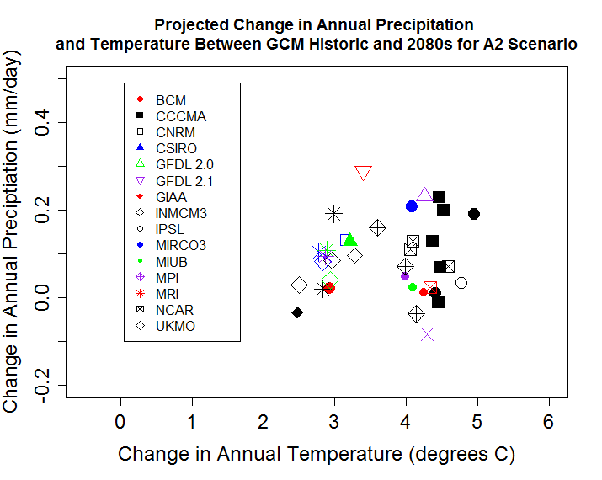

Figure 3. Projected change in annual temperature and precipitation between 2080 and “1985” for each AOGCM run under the B1 SRES Scenario. Data are from the Kennebec region, Maine.

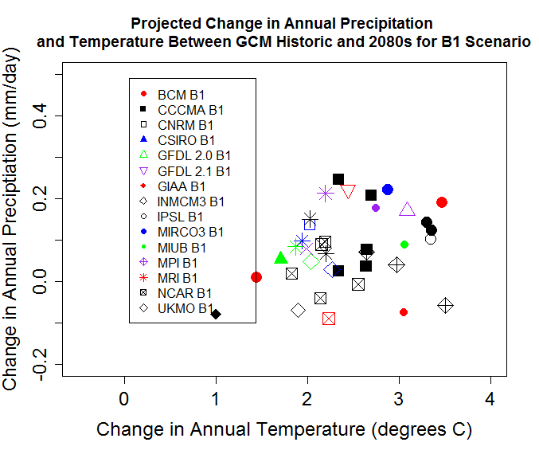

Figure 4. Projected change in annual average temperature throughout the NALCC from 2000 to 2080 under 3 SRES scenarios. 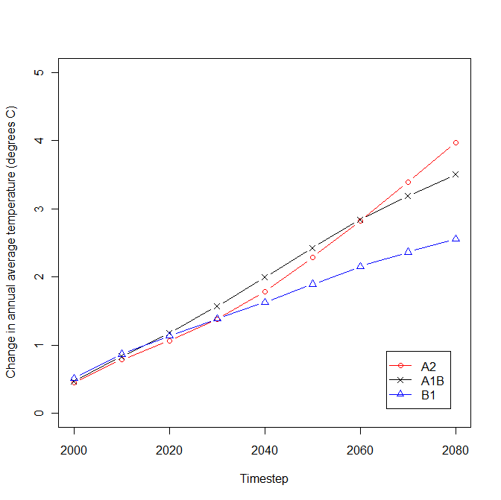
Figure 5. Projected change in annual average precipitation throughout the NALCC from 2000 to 2080 under 3 SRES scenarios.
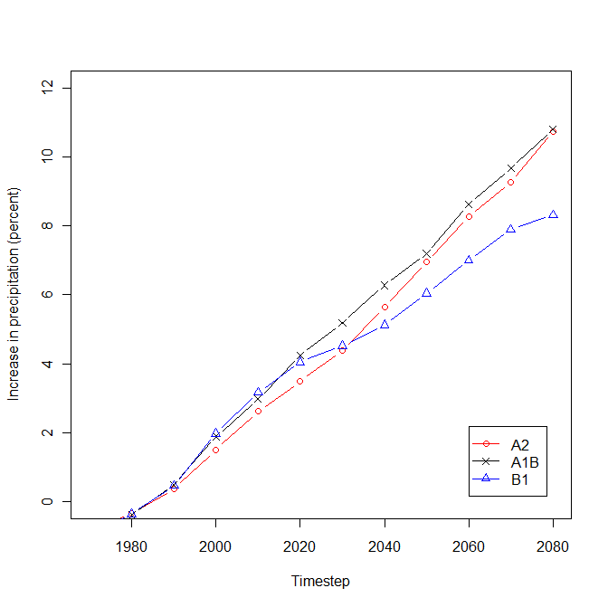
Figure 6. Residual difference between modelled average monthly temperature data and temperature observations at 174 weather stations throughout the NALCC. The 1980 downscaled data (green X’s) are the difference between the completely processed downscaled projections for the 1980 timestep and the weather station data. This dataset has an average bias of 0.15 degrees C (i.e., the projections are on average 0.15 degrees C higher than the observed values), though it varies greatly by month. These projections are built from the other two datasets presented in the figure. The AOGCM data (blue triangles) are the differences between the raw ensemble AOGCM projections and the weather station data. The residual error in this dataset also varies greatly by month. The PRISM (red squares) data are the differences between the raw PRISM data and the weather station data, which has a consistently positive bias.

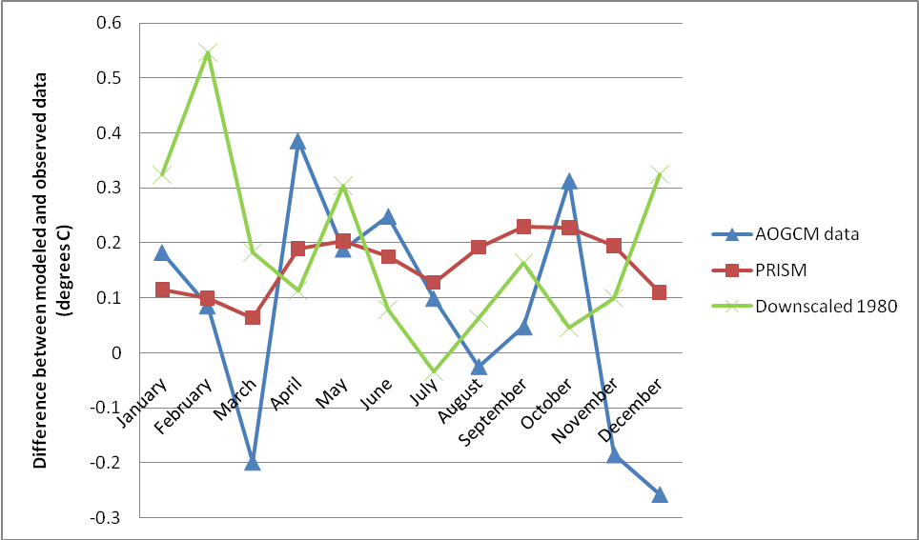

Figure 7. Spatial distribution of residual differences between downscaled temperature projections in July for the 1970 timestep and observed weather station data across the NALCC. Larger dots indicate larger differences between modelled vs. observed. Red dots indicate stations that modelled higher than observed, blue modelled lower.

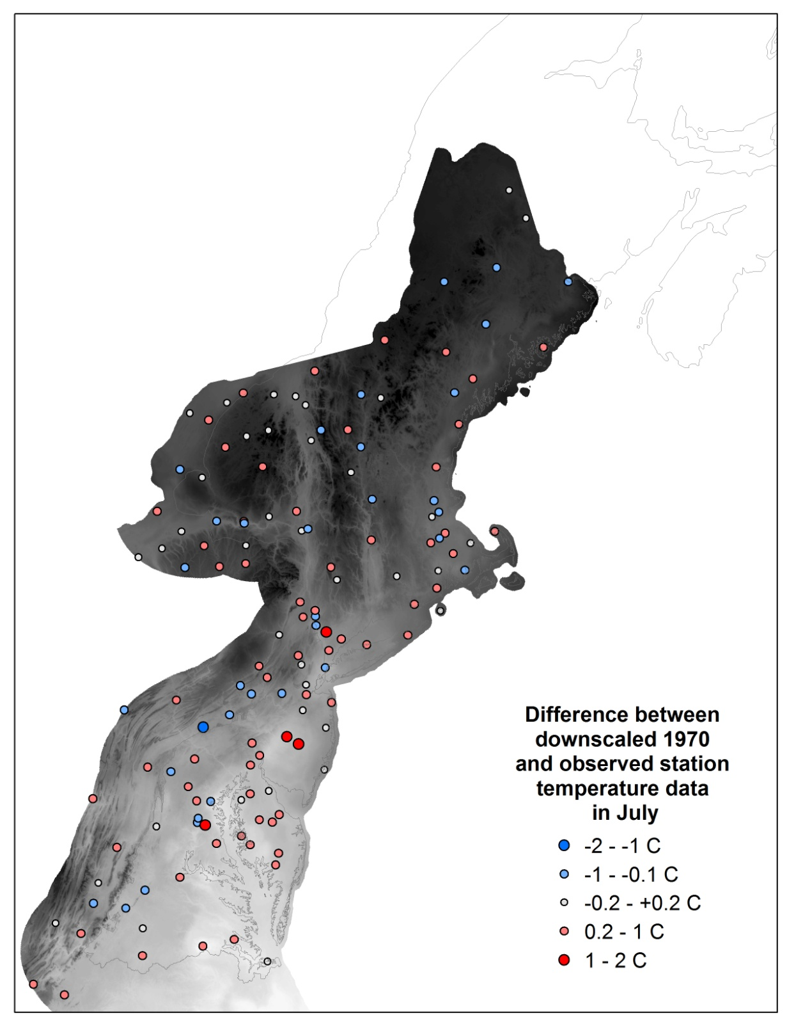

Figure 8. Spatial distribution of residual differences between downscaled temperature projections in January for the 1970 timestep and observed weather station data across the NALCC. Larger dots indicate larger differences between modelled vs. observed. Red dots indicate stations that modelled higher than observed, blue modelled lower. There is a gradient from north to south of temperatures that modelled increasingly warmer than observed.

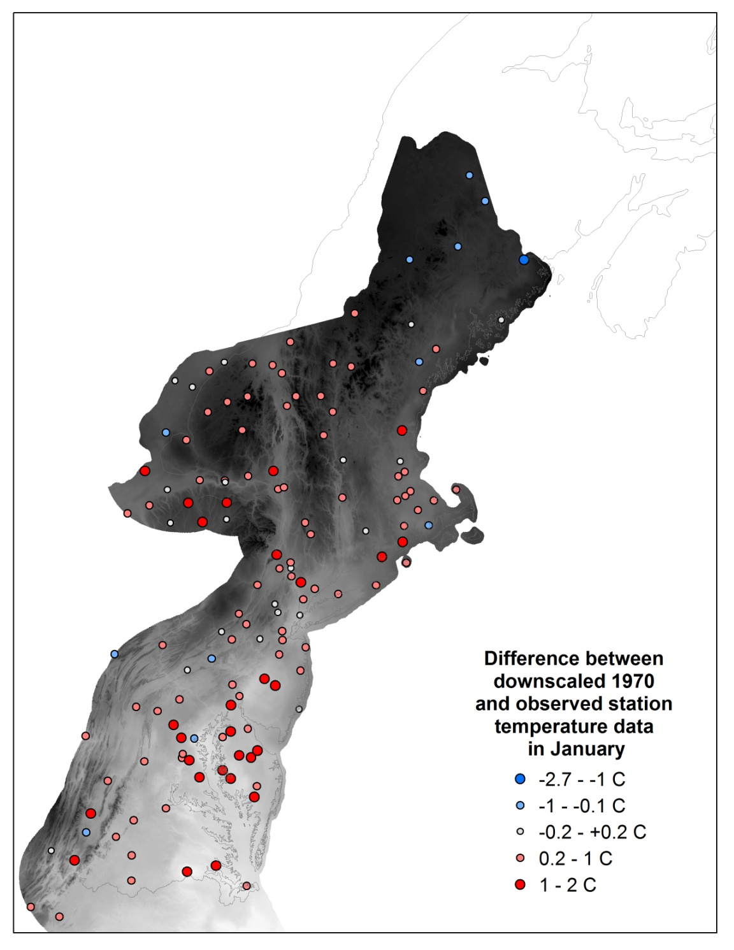
Figure 9. Spatial distribution of residual differences between downscaled annual precipitation projections for the 1970 timestep and observed weather station data across the NALCC. Larger dots indicate larger differences between modelled vs. observed. Red dots indicate stations that modelled higher than observed, blue modelled lower. Precipitation projections are consistently higher than observed throughout the NALCC.

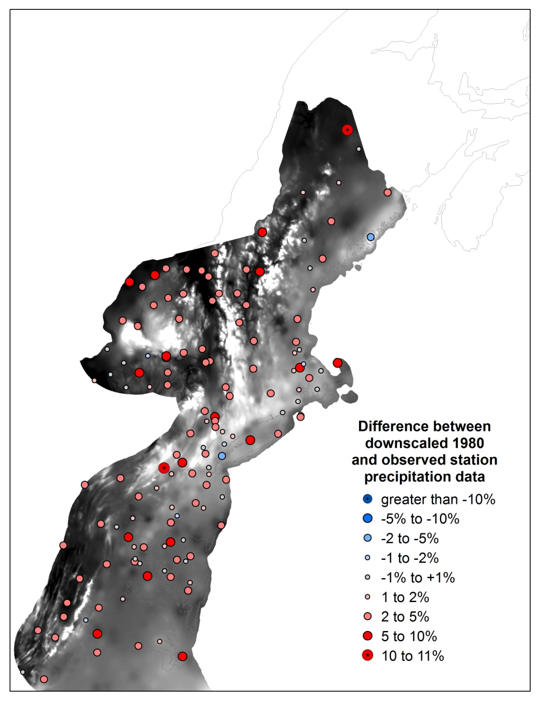
Table 1. AOGCM model runs used in climate projections.

Modeling Group, Country | WCRP CMIP3 I.D. | SRES A2 runs | SRES A1b runs | SRES B1 runs | Primary Reference
Bjerknes Centre for Climate Research | BCCR-BCM2.0 | 1 | 1 | 1 | Furevik et al., 2003
Canadian Centre for Climate Modeling & Analysis | CGCM3.1 (T47) | 1...5 | 1...5 | 1...5 | Flato and Boer, 2001
Meteo-France / Centre National de Recherches Meteorologiques, France | CNRM-CM3 | 1 | 1 | 1 | Salas-Melia et al., 2005
CSIRO Atmospheric Research, Australia | CSIRO-Mk3.0 | 1 | 1 | 1 | Gordon et al., 2002
US Dept. of Commerce / NOAA / Geophysical Fluid Dynamics Laboratory, USA | GFDL-CM2.0 | 1 | 1 | 1 | Delworth et al., 2006
US Dept. of Commerce / NOAA / Geophysical Fluid Dynamics Laboratory, USA | GFDL-CM2.1 | 1 | 1 | 1 | Delworth et al., 2006
NASA / Goddard Institute for Space Studies, USA | GISS-ER | 1 | 2, 4 | 1 | Russell et al., 2000
Institute for Numerical Mathematics, Russia | INM-CM3.0 | 1 | 1 | 1 | Diansky and Volodin, 2002
Institut Pierre Simon Laplace, France | IPSL-CM4 | 1 | 1 | 1 | IPSL, 2005
Center for Climate System Research (The University of Tokyo), National Institute for Environmental Studies, and Frontier Research Center for Global Change (JAMSTEC), Japan | MIROC3.2 (medres) | 1...3 | 1...3 | 1...3 | K-1 model developers, 2004
Meteorological Institute of the University of Bonn, Meteorological Research Institute of KMA | ECHO-G | 1...3 | 1...3 | 1...3 | Legutke and Voss, 1999
Max Planck Institute for Meteorology, Germany | ECHAM5/ MPI-OM | 1...3 | 1...3 | 1...3 | Jungclaus et al., 2006
Meteorological Research Institute, Japan | MRI-CGCM2.3.2 | 1...5 | 1...5 | 1...5 | Yukimoto et al., 2001
National Center for Atmospheric Research, USA | CCSM3 | 1...4 | 1...3, 5...7 | 1...7 | Collins et al., 2006
National Center for Atmospheric Research, USA | PCM | 1...4 | 1...4 | 2...3 | Washington et al., 2000
Hadley Centre for Climate Prediction and Research / Met Office, UK | UKMO-HadCM3 | 1 | 1 | 1 | Gordon et al., 2000

Table 2. Change in monthly temperature (degrees C) from 2000 to 2080 for three SRES scenarios.

 | A2 | A1B | B1
January | 4.78 | 4.35 | 3.21
February | 4.48 | 3.93 | 2.78
March | 3.92 | 3.36 | 2.41
April | 3.53 | 3.10 | 2.34
May | 3.49 | 3.11 | 2.24
June | 3.49 | 3.03 | 2.19
July | 3.74 | 3.27 | 2.39
August | 4.03 | 3.53 | 2.53
September | 3.88 | 3.39 | 2.42
October | 3.91 | 3.36 | 2.50
November | 3.87 | 3.41 | 2.54
December | 4.53 | 4.16 | 3.13

Appendix B – File Names and Brief Descriptions
An animation of projected change in temperature over the simulations can be found at the following link: ‘http://www.youtube.com/watch?v=tgfqq_sKlSs

R code is located in:
Z:\LCC\Code\Prep\Climate\Step1.download
Z:\LCC\Code\Prep\Climate\Step2.transform
Z:\LCC\Code\Prep\Climate\Step3.reproject
These files implement the code described in Section 5 above.
The .Rdata files that consist of the WRCP files clipped to the LCC (as described in Step 5.1) are located in three separate folders, one for each SRES scenario:
Z:/LCC/GISData/DataWorking/TempPrecip/WRCP/sresa2
Z:/LCC/GISData/DataWorking/TempPrecip/WRCP/sresb1
Z:/LCC/GISData/DataWorking/TempPrecip/WRCP/sresa1b
These files contain the objects: lon, lat, time, temperature OR precip. They are geographic (WGS1984).

All of the gcms for the scenario are then averaged and subtracted from the baseline date (which runs from 1971-2000, the same as the PRISM data), to create "deltas" for each month, for each timestep, as described in Section 5, Step 2 above. The final output is an array of dimensions: lon, lat, month, timestep. This array, along with component objects (lon, lat, timestep, metadata) are saved in the Rdata files:

a2.summary.Rdata
b1.summary.Rdata
a1b.summary.Rdata

The intermediate 800 meter temperature and precipitation grids (the product of step 5.5) are saved in the folder:
Z:/LCC/GISData/DataWorking/TempPrecip/800m

Final climate grids (with cell size of 30m in Albers NAD83 projection) will be stored in the folder:
Z:/LCC/GISData/DataWorking/TempPrecip/Final

Index

