July 1, 2011

Assessment of Landscape Changes in the North Atlantic Landscape Conservation Cooperative: Decision-Support Tools for Conservation (Phase 1)

This document is intended to serve as a general description of this project and, more specifically, provide an overview of our approach to meeting the goals and objectives. This working document is directed to our Scientific Steering Committee, but should be useful to anyone interested in learning more about this project. This document is something of an executive summary of the project in its current state and makes reference to other documents (some complete, but mostly under development) that provide the technical details of the approach.

1. Goals and objectives

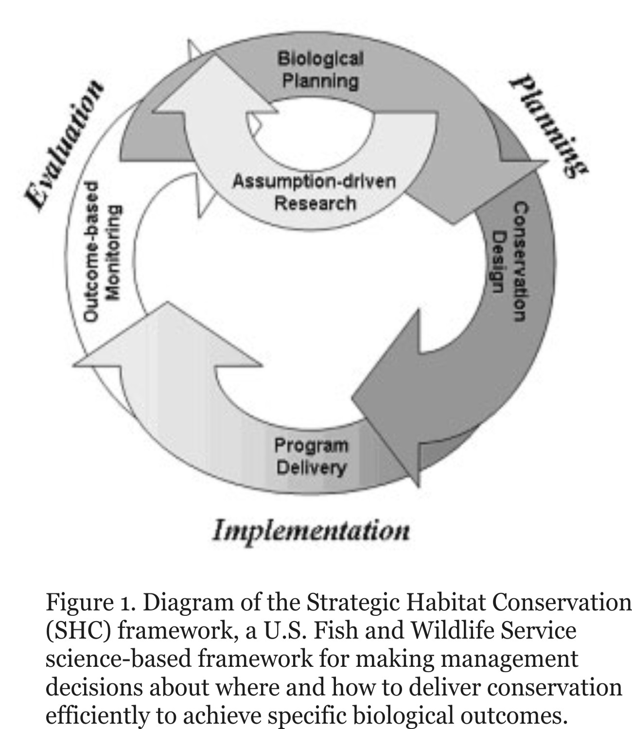
﻿Our primary mission as conservationists and public stewards of fish and wildlife resources is to ensure the conservation of biological diversity. ﻿Thus, our primary over-arching goal is to maintain well-distributed viable populations of all native species and the ecosystem processes they perform and depend on. To achieve this goal, however, we face many serious challenges associated with human population growth, such as habitat loss and fragmentation, disruption of ecological processes, spread of invasive non-native species, and human disturbance, all of which are being overlain and exacerbated by global climate change. ﻿In the face of these serious challenges, our conservation objective is to maximize the quantity, quality, and connectivity of habitats and ecological systems, subject to the real world socio-economic constraints of development. More specifically, our conservation objective is to protect, manage and restore as much habitat as possible, minimize the forces of habitat degradation, and design landscapes to ensure habitat connectivity within the limits imposed by the socio-economic realities of human population growth.

To achieve this conservation objective, the USFWS developed the Strategic Habitat Conservation (SHC) approach, which incorporates five key principles in an ongoing process that changes and evolves in an adaptive framework (Fig. 1):

- Biological Planning (setting targets)
- Conservation Design (developing a plan to meet the goals)
- Conservation Delivery (implementing the plan)
- Monitoring and Adaptive Management (measuring success and improving results)
- Research (increasing our understanding)

To implement the SHC approach, the USFWS created a geographic network of ecologically-based Landscape Conservation Cooperatives (LCCs)(Fig. 2). The North Atlantic LCC (NALCC) was established in 2010 and encompasses the mid and north Atlantic coast, including all or part of 12 states from Virginia to Main (Fig. 3). The specific goals of the NALCC are as follows:
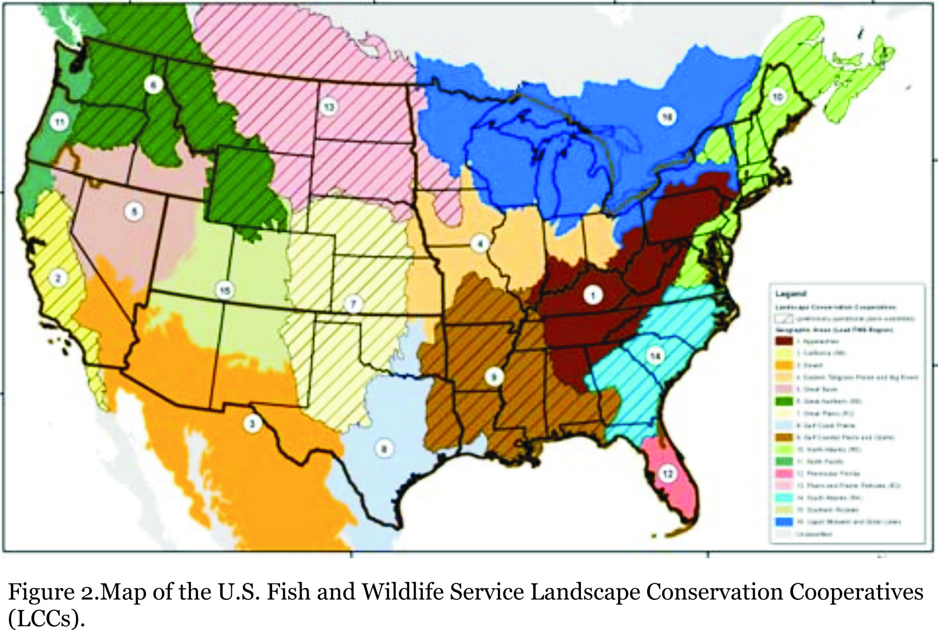
- Assess the current capability of habitats to support sustainable populations of wildlife;
- Predict the impacts of landscape-level changes (e.g., from urban growth, conservation programs, climate change, etc.) on the future capability of these habitats to support wildlife populations;
- Target conservation programs to effectively and efficiently achieve objectives in State Wildlife Action Plans and other conservation plans and evaluate progress under these plans; and
- Enhance coordination among partners during the planning, implementation and evaluation of habitat conservation through conservation design.

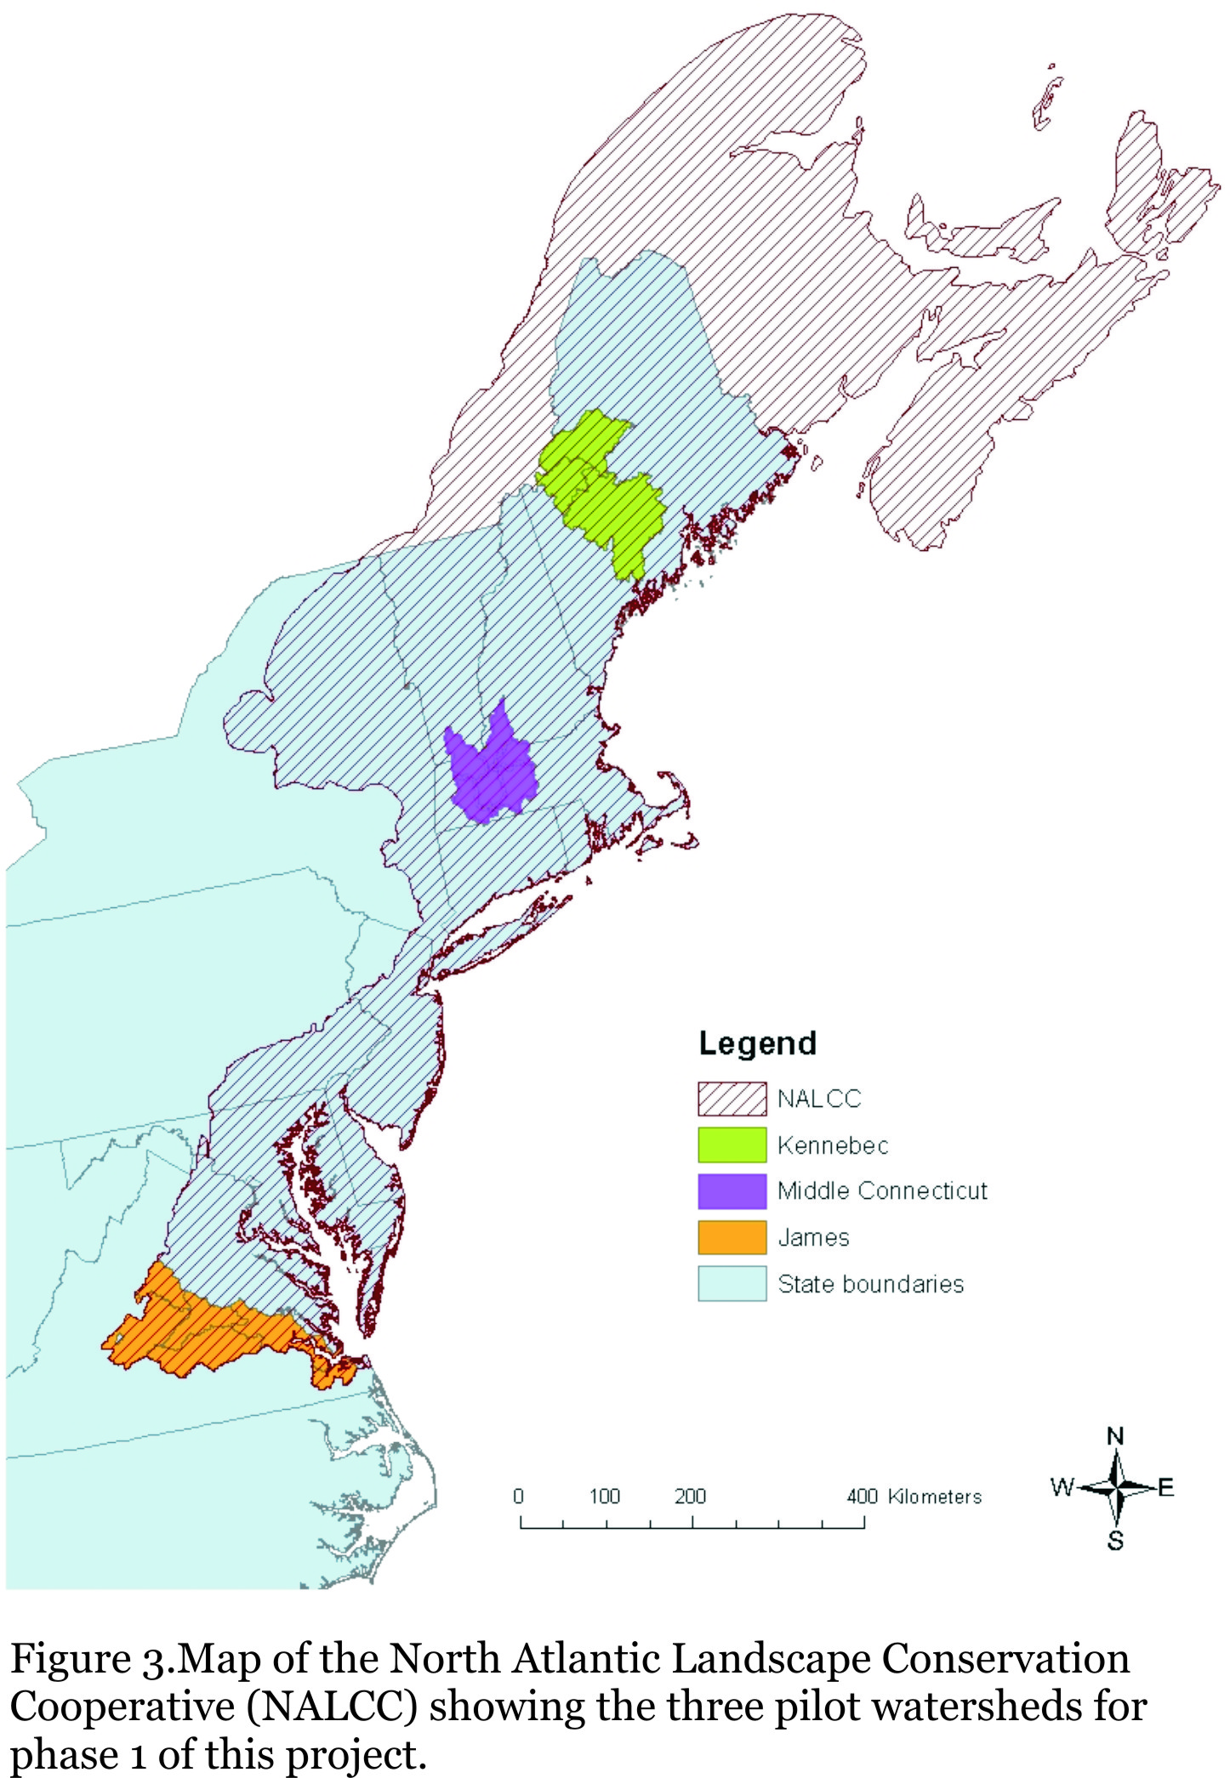
The project described in this document is one of the science-development projects of the NALCC. While the focus of this particular project is #1 and #2 above, the modeling framework being developed will provide the basis for #3 in the long term. Thus, the proposed modeling framework will allow us to assess landscape change, assess changes in ecological integrity and habitat capability for representative species, and allow us to identify priorities for land protection (i.e., what lands to protect to get the biggest bang for the buck) and conservation priorities for existing conservation lands (i.e., what should be the management priorities on each conservation tract). The specific objectives are as follows:

- ﻿ Develop a landscape change, assessment and design (LCAD) model for the NALCC that will allow us to predict changes to the landscape under a variety of alternative future scenarios (e.g., climate change, urban growth), assess affects of those changes to ecological integrity (coarse filter) and habitat capability for representative species (fine filter), and eventually (in phase 2) allow us to design conservation strategies (e.g., land protection, management and resotoration) to meet conservation objectives.
- Develop habitat capability models for a suite of representative species to be used as a fine filter for evaluating the landscape change scenarios above (#1). Note, this objective is being met in collaboration with the University of Vermont.
- Develop ecological integrity models for a suite of ecological systems to be used as a coarse filter for the evaluating landscape change scenarios above (#1).
- Pilot the LCAD model by simulating landscape change and the corresponding affects on ecological integrity and habitat capability for the representative species in three representative watersheds distributed throughout the NALCC.
- Assess the nature and magnitude of differences and similarities between areas identified as important habitat for the representative species (fine filter) and areas identified as having high ecological integrity (coarse filter) within the pilot watersheds; describe the implications for strategic habitat conservation planning and make recommendations for effectively combining fine- and coarse-filtered approaches to habitat conservation.

Note, these project objectives dovetail tightly with the first two steps of the SHC approach: (1) biological planning and (2) conservation design. Specifically, the LCAD model will provide a landscape assessment tool that can inform biological planning and a landscape design tool that can inform conservation design.

2. Model Design

The LCAD model is being designed with the following important considerations in mind:

- Computational feasibility.--The model must be practical to run given available computing resources. This will involve simplifying the model as necessary so that it is practical to run. A "good" model that we can run in days is better than a "great" model that we need a super computer and a year to run.
- Extant data.--The model input data must be based on extant data at the regional scale or data that can easily be compiled at the regional scale, and the model complexity must be scaled appropriately to match the quality of the data. We do not have the time or resources to be developing raw data, so our model will have to be limited to what already exists for the most part.
- Minimize subjective parameterization.--The model should require as few subjective parameters as possible, use empirically-derived parameter estimates wherever possible and resort to expert opinion only when necessary. This has implications in the choice of methods. For example, rather than use expert state-based transition models for vegetation development (succession), we will opt to use FIA data driven FVS models of continuous vegetation change.
- Model uncertainty.--The model must allow us to explicitly examine uncertainty in predictions (based on the uncertainty in model parameters). Note, assessing model uncertainty comes at the great cost of additional computations, so there is a real tradeoff between computational feasibility and modeling uncertainty -- we will strive to strike a balance.
- Fisheries project compatibility.--The model should strive for compatibility with the fisheries project, particularly with respect to the spatial and temporal scale of the model and the particular ecological attributes tracked in the model.
- Coarse- and fine-filter assessment capability.--The model must provide a framework for both species modeling and ecological integrity modeling.
- Start simple.--The model should be kept as simple as possible at first without compromising the ability to add complexity later as time, resources and knowledge allow. For example, while we would like to incorporate a mechanistic model of the relationship between climate and vegetation development, we will likely have to adopt a much simpler indirect approach that involves modeling the migration of ecological systems and their coupled vegetation development models.

Given the considerations above, the broad LCAD modeling framework for the combined NALCC (i.e., inclusive of the fisheries project) is illustrated in figure 4. Briefly, in addition the spatial and non-spatial database, the model is conceptually comprised of three major components (described below), including:
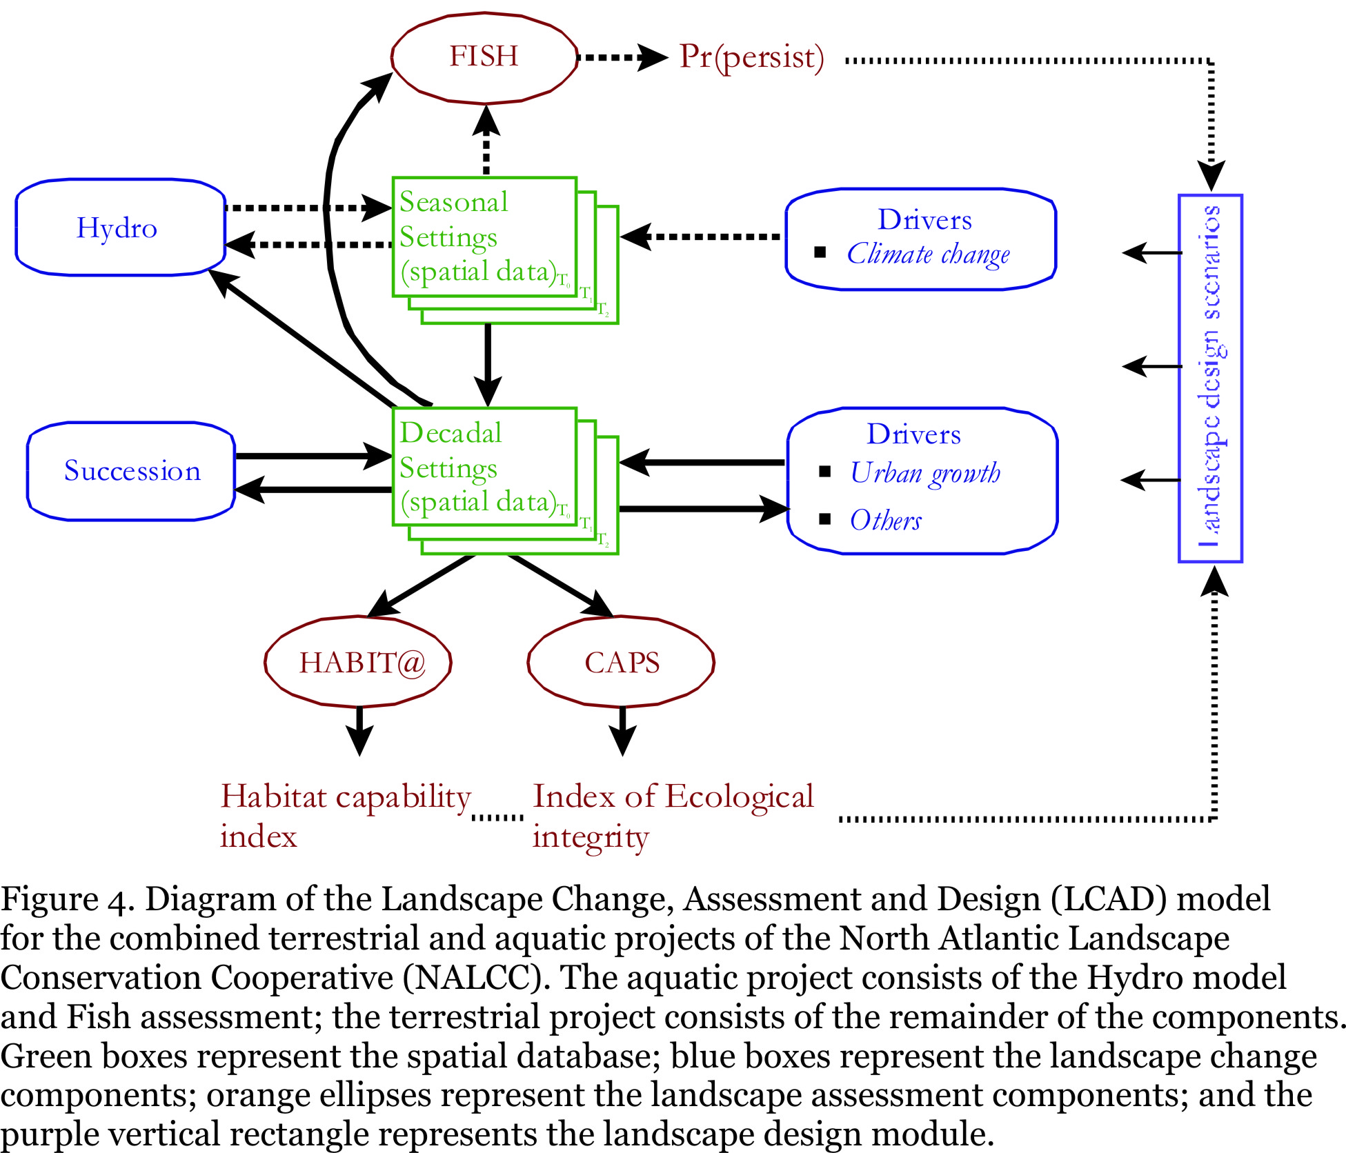

- Landscape change -- This is the core landscape change model, where the landscape drivers (e.g., urban growth) and vegetation succession processes are implemented under a user-specified scenario or set of scenarios and user-specified number of stochastic runs of each scenario. This is where the ecological setting variables (i.e., spatial data layers representing biophysical and anthropogenic attributes of the landscape) are modified over time to reflect the landscape drivers and succession.

- Landscape assessment -- This is the coarse-fine filter assessment of landscape ecological integrity (coarse filter) and habitat capability for representative species (fine filter) at each timestep and summarized for the simulation run and scenario as a whole. This assessment is used to evaluate the ecological performance of a scenario by comparison to the baseline starting condition and to each other, and is the basis for informing landscape design.

- Landscape design -- This component involves designing a land protection, land management, and/or restoration scenario to maximize ecological performance criteria such as the landscape ecological integrity indices (coarse filter) and habitat capability indices for representative species (fine filter).

The LCAD model is relatively straightforward in organization and implementation; it involves iteratively implementing landscape design, change, and assessment processes over timesteps for one or more scenarios, repeated many times to realize the stochasticity of the model processes. The raw results are a set of settings grids and an assessment of ecological integrity and habitat capability for each timestep for each stochastic run of each scenario. The summary results are a set of grids depicting ecological integrity, habitat capability and conservation priorities for each scenario and a set of tables summarizing the landscape ecological integrity and landscape capability indices for each representative species across scenarios.

The following is an outline of the modeling process; components in upper case are collections of one or more computer functions related to a common purpose and are briefly described in the following sections. Note, the outline below is for conceptual purposes only; the actual technical implementation may be somewhat different as needed for maximum computational efficiency.

1. Baseline assessment (timestep 0)

Coarse filter:
->Run INTACTNESS -- function to measure degree of freedom from human impairment
->Run RESILIENCY -- function to measure capacity to recover from disturbance and stress
->Run ADAPT -- function to measure capacity to adapt to a changing environment driven by climate change and development
->Run IRA -- function to combine intactness, resiliency and adapt metrics into a single composite metric
->Run DIVERSITY -- function to measure the diversity of ecological systems represented in the undeveloped portion of the landscape relative to the target diversity
->Run BUFFER -- function to measure the capacity for areas to help other high-valued sites retain their ecological value over time (i.e., buffer then from sources of human impairment)
->Run CONNECT -- function to measure the propensity to conduct ecological flows across the landscape
Result = suite of ecological integrity grids and numerical summaries of landscape ecological integrity

Fine filter:
->Run HABIT@ -- functions to measure habitat capability for representative species
Result = habitat capability grid for each species plus landscape capability index for each species

Development:
->Run SPRAWL --function to create new development (used here only to produce probability of each type of transition for use in SECURE in first timestep)
Result = probability of development grids (one for each transition type)

2. Simulation

Loop thru stochastic runs 1-m:

Loop thru scenarios 1-k:

Loop through timesteps 1-n:

Landscape design:
->Run SECURE -- function to protect new land under a user-specified land protection scenarios
Result = new secured land grid
->Run MANAGE -- function to actively manage vegetation under a user-specified land management scenario
Result = new vegetation settings grids
->Run RESTORE -- function to actively restore ecological integrity under a user-specified restoration scenario
Result = new ecological and anthropogenic settings grids

Landscape change:
->Run GROW -- function to produce vegetation succession
Result = new vegetation settings grids
->Run SPRAWL --function to create new development
Result = new anthropogenic settings grids
->Run other disturbance processes (to be developed in phase 2) in random order.
Result =new abiotic and/or vegetations settings grids

Landscape assessment:
Coarse filter:
->Run INTACTNESS -- as above
->Run RESILIENCE -- as above
->Run IRA -- as above
->Run DIVERSITY -- as above
->Run BUFFER -- as above
->Run CONNECT -- as above
Result = suite of integrity grids and numerical summaries of landscape ecological integrity

Fine filter:
->Run HABIT@ models -- as above
Result = habitat capability grid for each species plus landscape capability index for each species
->Run CLIMENV -- function to map climate niche envelop for each representative species
Result = binary grid depicting contemporary climate envelope for each species
->Run HABCLIM -- function to intersect habitat capability grid and climate niche envelop grid for each representative species
Result = habitat capability grid with non-zero values within the contemporary climate envelope for each species

End loop thru timesteps

End loop thru scenarios

End loop thru stochastic runs

3. Simulation summary -- suite of functions for generating tabular and graphical summaries of the simulation; by timestep, run, and scenario

The model is entirely grid-based to facilitate modeling contagious processes (e.g., disturbance) and spatial dynamism in the environment. The spatial resolution of the model is 30 m to be consistent with many of the input data sources. The temporal resolution is 10 years with a temporal extent of 80-100 years. A 10 year resolution is deemed a sufficient compromise between realistically representing processes that operate at finer temporal scales (e.g., annual variability in climate) and vegetation dynamics (e.g., seral stage changes) that are much slower, and the need for computational efficiency. Note, however, that climate data will be compiled and downscaled at a seasonal resolution for use in the hydrology and coupled fisheries model, but it will be aggregated to the decadal resolution for use in the LCAD model described here. Lastly, the model is designed to be run on sub-landscape tiles such as watersheds (HUC 6-8) to allow for parallel processing at the regional scale and to integrate well with the fisheries project, but should be flexible enough to work with any geographic extent (e.g., to accommodate application-specific conservation planning units).

3. Model Components

3.1 Input Data

The input data includes user defined scenarios comprised of both nonspatial parameters (that control the simulation and the component processes) and spatial data (maps) representing ecological settings variables and other ancillary variables.

3.1.1 Non-spatial run parameters
This represents tabular (nonspatial) input data used to control the model run, including basic control over the length of the model run (i.e., number of time steps), the number of replicate runs, and which drivers to include. Here is where the user specifies whether to run a single scenario or a range of scenarios to reflect uncertainty in the drivers. For example, multiple scenarios might represent a range of estimates of climate change, sea level rise and urban growth rates.

3.1.2 Non-spatial component parameters
This represents the tabular (nonspatial) input data used to control the individual LCAD model component processes (e.g., succession and drivers); in other words, values for the parameters that control landscape change, assessment and design. This consists of a series of tables associated with each model component. The number and structure of the parameters will vary among model components. For example, the succession component includes a suite of parameters describing the growth function for each vegetation variable (e.g., biomass) indexed by ecological system. For other components, indexing by ecological system is not useful (e.g., urban growth), and the tables are structured accordingly.

3.1.3 Spatial data (grids)
This represents the spatial (GIS) data used in the LCAD model and consists of ecological settings variables and ancillary GIS data. A detailed description of the spatial data is provided in a separate document (Spatial). Briefly, the ecological settings variables include a parsimonious suite of static as well as dynamic abiotic and biotic variables representing the natural and anthropogenic environment at each location (cell) at each time step (Table 1). Static variables are those that do not change over time (e.g., elevation, incident solar radiation). Dynamic variables are those that change over time in response to succession and the drivers (e.g., canopy cover, temperature, traffic rate). Most of the settings variables are continuous and thus represent landscape heterogeneity as continuous (e.g., temperature, soil moisture), although some are categorical and thus represent heterogeneity as discrete (e.g., ecological system, developed). Importantly, the settings variables include a broad but parsimonious suite of attributes that can be used to define the ecological system at any point in time; they are considered primary determinants of the ecosystem composition, structure and function, and determine the ecological similarity between two locations. As such, they play a key role in the coarse-filter ecological integrity assessment, they can be used in species' habitat models to represent important habitat components, and can be used in any of the landscape change model processes. Thus, the settings provide a rich, multivariate representation of important landscape attributes.

In addition to the settings variables, the spatial database includes a variety of ancillary data layers that may be used in any of the landscape change modules (e.g., the calculation of individual ecological integrity metrics, downscaling climate, predictors of urban growth, etc.), and to control the output of the analysis (e.g., to determine the spatial extent of an assessment)(Table 2). Note, all of these ancillary data layers are treated as static and thus do not change over time.

3.2 Landscape Change

The landscape change model essentially includes two separate, sequential processes that iterate over time (i.e., at each time step in the model) over the length of the model run.

3.2.1 Succession
The first process invoked in each time step is succession. Succession is modeled as a deterministic change in a variety of vegetation attributes, including biomass, quadratic mean stem diameter, stem density, and potentially canopy cover and canopy height (depending on need in wildlife habitat models) according to a set of growth functions established for each forested ecological system or group of similar forested ecological systems. A detailed description of the succession model (GROW) is provided in a separate document. Briefly, we used Forest Inventory and Analysis (FIA) plot data to compute each of the vegetation variables and stand age of each FIA plot. Pooling across all FIA plots within a forested ecological system or group of similar forested ecological systems, we treated each derived vegetation variable (e.g., biomass) as the dependent variable and stand age as the independent variable, and fit a nonlinear function (e.g., Michaelis-Menten, Monomolecular) using ordinary least squares estimation. This process fit a function to the average growth trajectory. Thus, for any given stand age, the growth function predicts the corresponding average vegetation settings value. If an ecological system did not have a sufficient sample size (i.e., >50 FIA plots) or a sufficient stand age distribution (i.e., range >50% simulation length), it was aggregated with an ecological similar system. Non-forested systems are assigned an average value for each vegetation attribute (pooled across FIA plots) and treated as static (i.e., constant over time) in phase 1 of this project.

3.2.3 Drivers
Following succession, the landscape is subject to one or more “drivers” of landscape change. Each of these drivers is modeled separately, either as a deterministic or stochastic process, and acts differently depending on the settings variables; however, they all act to modify one or more of the settings variables (table 1). Uncertainty in deterministic processes (e.g., climate change) is accounted for extrinsically by running multiple varying scenarios; uncertainty in stochastic processes (e.g., urban growth) is intrinsic to the process itself (via random variables) and is addressed by running multiple replicate simulations.

- Climate change –climate change is modeled as a deterministic process by simply downscaling the climate predictions associated with monthly temperature and annual precipitation from an ensemble of global coupled atmospheric-ocean general circulation models (AOGCMs). The uncertainty in climate change predictions stems from using a range of standard emissions scenarios set by the Intergovernmental Panel on Climate Change (IPCC) Special Report on Emissions Scenarios (SRES) representing high, medium and low levels of predicted change. A detailed description of the climate model (GCMd) is provided in a separate document. Briefly, We used publicly available AOGCM data that had been downscaled to 1/8 degree (approximately 12km) using the Bias Corrected Spatial Disaggregation (BCSD) downscaling approach. We averaged the results of 16 AOGCMs to create an ensemble average projection for each of 3 SRES scenarios, subtracted a baseline to create projected anomalies, and resampled these data at 800m cells. We then combined these data with 800m resolution, 30-year normal temperature and precipitation data (PRISM Climate Group, Oregon State University) using the “delta method”. These data were further resampled to 30m to match the other layers used in the LCAD model. Note, climate change acts principally to modify the ecological settings variables associated with temperature and precipitation, and thus causes each cell to migrate through ecological settings space over time. Thus, the principal effect of climate change in phase 1 of this project is in the landscape assessment of ecological integrity (via the adaptive capacity metrics, see below) and habitat capability for representative species (via the climate niche envelope, see below). In phase 2 of this project, climate change may also modify the succession and disturbance models applied to each cell.

- Urban growth – urban growth is modeled as a stochastic process by predicting the probability of each type of development at the cell level, determining the total amount of development based on human population projections, and allocating the development among types, all within local windows scaled to account for spatial heterogeneity in development rates and patterns. A detailed description of the urban growth model (GROW) is provided in a separate document. Briefly, urban growth is modeled statistically based on historical land use data to derive a locally-varying, relative probability of each of six types of development transitions (e.g., undeveloped to low-, medium-, and high-density development, low-density to medium- and high-density development, and medium-density to high-density development). Predictors include a variety of spatial variables, including resistant kernels based on sources of jobs (e.g., urban areas), transportation infrastructure, and suitability of land (e.g., slope, wetlands, soils, secured land). The result of this step is a surface depicting the relative probability of each type of development for each timestep. The actual amount of development at each timestep is determined by human population projections corresponding to the SRES scenarios and allocated among transition types according to observed distributions at the local scale (to be determined). The uncertainty in urban growth predictions stems from the intrinsic stochasticity of the process itself and is realized by running multiple runs of the same scenario, in addition to the variation among scenarios that vary for example in predicted human population growth. Urban growth will act principally to modify the ecological settings variables associated with human development such as impervious, traffic rates and development.

- Sea level rise – in phase 2 of this project, sea level rise will be modeled as a deterministic process in the same manner as climate change, but is contingent upon the development of broadly acceptable sea level models by third parties.

- Timber harvest – in phase 2 of this project, timber harvest will be modeled as a stochastic process. The details of this process are not clear yet and remain to be developed. However, we will probably harvest timber randomly (as opposed to a deterministic schedule) on lands deemed eligible for timber harvest and restrict consideration to even-aged silvicultural treatments only (to keep things simple). Unfortunately, harvest policies vary among ownerships (industrial, non-industrial private, state, USFS, NPS, etc.), among state agencies, among states, can change radically in short amounts of time in response to economic and political winds. Timber harvest, in terms of types of treatments and intensity of harvest, is extremely unpredictable. This suggests the need for many scenarios. Our approach will allow for complex spatial and temporal variation in management, but we will keep it simple to start. Timber harvest will act principally to modify the vegetation settings variables (e.g., biomass, canopy cover).

- Agriculture development/loss – in phase 2 of this project, agriculture development & loss will be modeled as a stochastic process. The details of this process are not clear yet and remain to be developed. Agricultural development may be important in some portions of the region. Shifting agricultural land use, for example shifting from cropland to pasture, could be included, but is highly unpredictable. Agricultural loss is more likely throughout the region and will be modeled as a probability of agricultural land reverting to early-successional natural land. Agriculture development/loss depends on the economy, soil suitability, urbanization, land costs, taxes, and distance to markets and other factors. Given the complex nature of this process, modeling agriculture development/loss is probably a low priority among the list of drivers.

- Natural disturbances – in phase 2 of this project, natural disturbances will be modeled as a suite of stochastic processes using a common algorithm that simulates initiation, spread, termination, and effects. There are several natural disturbance processes under consideration, including the following:

  - Fire – probably too rare to matter in the northeast (return intervals at the cell level much longer than simulation length of 100 yrs), but may be more important in the southern portions of the region.
  - Wind – downbursts and tornadoes may be frequent enough in some portions of the region (e.g., Adirondaks) to model; hurricanes may also be frequent enough in some portions of the region to model, perhaps separately from downbursts and tornadoes.
  - Insects/pathogens – native insects and pathogens are largely endemic and generally do not cause stand replacement; non-native invasive insects and pathogens may be worth considering on a case by case basis. Hemlock wooly adelgid may be worth modeling; spruce budworm is another possibility, but unsure whether enough stand replacement occurs to warrant inclusion. Model parameterization for any insect/pathogen disturbance is going to be extremely challenging.
  - Floods – ecologically important to riverine and riparian ecosystems, but largely doesn’t cause stand replacement in riparian systems (perhaps due to regulation of rivers via dams) and geomorphic impacts to streams and riparian areas, while important, is too difficult to model.
  - Beavers – important driver in riverine and riparian ecosystems; may be possible to model.
  - Storm surge/overwash – important geomorphic disturbance in coastal ecosystems (especially barrier beaches), but too difficult to model.
  - Others?

3.3 Landscape Assessment

The landscape assessment model includes two separate components to quantify and map the distribution of ecological integrity (coarse filter) and habitat capability for representative species (fine filter) over time under alternative landscape change scenarios. The models are coupled with the landscape change model through the use of the common ecological settings database.

3.3.1 Ecological integrity assessment (coarse filter)
Our coarse filter landscape assessment is based on the concept of landscape ecological integrity and is described in detail in a separate document (INTEGRITY). Briefly, Landscape ecological integrity refers to the ability of an area to sustain ecological functions over the long term; in particular, the ability to support biodiversity and the ecosystem processes necessary to sustain biodiversity over the long term. For our purposes, an integral landscape has a green infrastructure (i.e., undeveloped lands) containing a diversity of ecosystems with high intactness, resiliency and adaptive capacity that are well-buffered from human stressors and highly connected. Based on this definition, there are six key attributes of landscape ecological integrity; i.e., measurable attributes that confer ecological integrity either to the landscape as a whole or to the site (cell) and thus, by extension, to the landscape as a whole, that are as follows:

- ﻿Intactness...refers to the freedom from human impairment (anthropogenic stressors); it is an intrinsic attribute of a site (cell) that contributes to the ecological integrity of the site itself and thus, by extension, confers ecological integrity to the landscape as a whole. Intactness is measured using a weighted linear combination of a broad suite of stressor metrics.

- Resiliency...refers to the capacity to recover from disturbance and stress; more specifically, it refers to the amount of disturbance and stress a system can absorb and still remain within the same state or domain of attraction (i.e., resistance to permanent change in the composition, structure and function of the system) (Holling 1973, 1996). Resiliency is an intrinsic attribute of a site that contributes to the ecological integrity of the site itself and thus, by extension, confers ecological integrity to the landscape as a whole. Resiliency is measured using a weighted linear combination of two metrics: connectedness and similarity.

- Adaptive capacity...refers to the capacity to adapt to a changing environment (e.g., as driven by climate change);in the context of LCAD, adaptive capacity reflects the potential for adaptation via movement to and from a site in order to track favorable conditions as they change over time under non-equilibrium dynamics. Adaptive capacity is an intrinsic attribute of a site that reflects the ecological integrity of the site itself and thus, by extension, confers ecological integrity to the landscape as a whole. Adaptive capacity is measured using a single metric: adaptive capacity.

- Ecosystem diversity...refers to the diversity of ecological systems (or diversity of ecological settings) represented in the undeveloped areas relative to the targeted diversity, which may be user defined or a function of the proportional representation of ecosystems in the full landscape. Note, diversity is a collective property of the undeveloped lands within the landscape and is not a measurable cell attribute. Diversity is measured using a single metric: diversity.

- Buffering...refers to the capacity to help other high-valued sites retain their value over time (i.e., buffer them from sources of human impairment), or the degree to which high-valued sites are buffered by lands of low or no risk of development; it is a contingent-value attribute of a site (i.e., derives its value from its location relative to other high-valued sites) that confers integrity to the landscape as a whole. Buffering is measured using two closely related metrics, which are used in different contexts: buffer and protect.

- Connectivity...refers to the propensity to conduct ecological flows across the landscape; it is a contingent-value attribute of a site (i.e., derives its value from its location relative to other high-valued sites) that confers integrity to the landscape as a whole. Note, connectivity here refers to the ability to conduct flows locally and regionally. Connectivity is measured using a single metric: connectivity.

The ecological integrity assessment, consisting of quantifying the six attributes above, is done at each timestep of the model and summarized for the entire run and across stochastic runs for each scenario. The ecological integrity assessment is useful as a means of comparing scenarios with regards to achieving biodiversity conservation, and it is also useful as a basis for landscape design (see below).

3.3.2 Habitat capability for representative species (fine filter)
Our fine filter landscape assessment is based on the concept of habitat capability for a focal species and is described in detail in a separate document (HABIT@). Briefly, habitat capability refers to the ability of the environment to provide the local resources (e.g., food, cover, nest sites) needed for survival and reproduction in sufficient quantity, quality and arrangement to meet the life history requirements of individuals and local populations. Habitat capability for a focal species is assessed using habit@, a multi-scale GIS-based system for modeling wildlife habitat. habit@ is a spatially-explicit model: the habitat value at each cell is dependent not only on the resources available at that cell, but on resources available in the neighborhood (is there enough forage to support an individual’s homerange?), on the configuration of resources (are they juxtaposed or contiguous?), and on the accessibility of resources due to impediments to movement (are food and nesting resources across a road from each other?).
In collaboration with the University of Vermont, a HABIT@ model is being developed for each representative species. Note, the details of the model vary among species depending on the species' habitat requirements, but include an assessment of the availability of one or more local resources (e.g., nesting, cover, food) based on the ecological settings database, summarized at the home range level, and indexed for the landscape as a whole. These are largely expert models in phase 1 of this project.

Similar to the ecological integrity assessment, the habitat assessment, consisting of a habitat capability assessment for each representative species, is done at each timestep of the model and summarized for the entire run and across stochastic runs for each scenario. The habitat assessment is useful as a means of comparing scenarios with regards to achieving biodiversity conservation, and it is also useful as a basis for landscape design (see below).

3.4 Landscape Design

The landscape design model accommodates three different types of design applications, corresponding to three separate models:

- Land protection prioritization (SECURE)
- Land management prioritization (MANAGE)
- Restoration prioritization (RESTORE)

3.4.1 Secured land growth
The secured land growth model is intended to algorithmically implement different land protections scenarios. The range of scenarios has yet to be defined. However, one "smart" strategy involves first identifying and protecting high-valued core areas (based on the landscape assessment), then protecting buffers around the cores, and finally protecting areas that facilitate connectivity among cores. The details of this model are not clear yet and remains to be developed. However, we will probably build out protected land under varying scenarios representing different levels of aggressiveness. For example, we could simulate purely opportunistic (i.e., random) land protection; we could use the indices of ecological integrity and/or habitat capability to target land for protection; we could use risk of development to target cheaper lands (under the assumption that land values relate to risk of development); we could use a combination of these measures to maximize opportunity; etc.. Secured land growth will act principally to modify the secured lands setting variable and will interact strongly with the urban growth model (SPRAWL).

3.4.2 Land management
The land management model is intended (in phase 2 of this project) to algorithmically implement different land management scenarios aimed at active vegetation management. The range of scenarios has yet to be defined, but may include treatments such as timber harvest, mowing, and burning designed to create or maintain certain vegetation conditions (e.g., early successional forest), possibly limited geographically to specific ownerships (e.g., federal lands, protected lands, industrial lands). Land management activities will act principally to modify the vegetation settings variables.

3.4.3 Restoration
The restoration model is intended (in phase 2 of this project) for implementing ecological restoration activities (e.g., ecosystem conversion, wildlife passage structure, culvert removal) and modifying the settings variables accordingly based on a user-specified restoration strategy. The range of scenarios has yet to be defined, but may include activities such as culvert upgrades, dam removals, wildlife passage structures, etc., and could be limited geographically to specific ownerships (e.g., federal lands, protected lands, etc.).
Table 1. List of potential ecological settings variables. A detailed description of these variables is provided in a separate document (Spatial Data). Note, S = static variables (i.e., constant over time); D = dynamic variables (i.e., change over time). The variables are arbitrarily grouped into broad attribute classes for organizational purposes.

Biophysical attribute | Biophysical variable | Description
Temperature | Growing season degree-days [D] | Growing season degree days
 | Min. winter temperature [D] | Minimum January air temperature
 | Water temp [D] | Mean annual water temperature
Solar energy | Incident solar radiation [S] | Solar radiation
Moisture & hydrology | Topographic wetness [D] | Soil moisture, measured by a topographic wetness index
 | Flow volume [D] | Flow volume, measured as the flow accumulation or watershed size
 | Flow gradient [S] | Gradient (percent slope) of a stream
 | Tidal regime [D] | In coastal areas, the frequency, period and depth of tidal flooding
Chemical & physical substrate | Soil pH [D] | Soil pH
 | Soil depth [D] | Soil depth
 | Soil texture [D] | Soil texture (based on average grain size)
 | Water salinity [D] | Salinity
 | Substrate mobility [S] | Realized mobility of the physical substrate, due to both substrate composition and exposure to forces that transport material
 | CaCO₃ content [D] | Calcium content of the soil and water
Physical disturbance | Wind exposure [D] | Measure of exposure to sustained high winds
 | Wave exposure [D] | Measure of direct exposure to ocean waves
 | Steep slopes [D] | Percent slope
Vegetation | Dominant life form [S] | Dominant life form (unvegetated, herbaceous, shrubland, woodland, forest)
 | Canopy closure [D] | Percent tree canopy cover
 | Canopy height [D] | Height of the dominant canopy
 | Biomass [D] | Total amount of above-ground vegetation biomass
 | Mean diameter [D] | Quadratic mean tree diameter
 | Basal area snags [D] | Basal area of standing dead trees (snags)
Anthropo-genic | Traffic rate [D] | Log of the average number of vehicles per day on roads and railways
 | Imperviousness [D] | Percentage of the ground surface area that is impervious to water infiltration
 | Developed [D] | Indicator of development (0=undeveloped, 1=developed)
 | Aquatic barriers [D] | Degree to which culverts and dams may impede upstream and downstream movement of aquatic organisms
 | Terrestrial barriers [D] | Degree to which roads and railroads impede movement of terrestrial organisms
Table 2. List of potential ancillary spatial data. A detailed description of these variables is provided in a separate document (Spatial Data). Note, all of these ancillary data layers are treated as static and thus do not change over time.

Variable | Description
Ecological systems | Grid depicting TNC ecological systems
Land cover/use | Grid depicting land cover/land use classes
Elevation | Grid depicting elevation
Slope | Grid depicting raw percent slope
Aspect | Grid depicting aspect in degrees
Topographic position | Grid depicting topographic position index
Hillshade | Grid depicting classic topographic hillshade
Topographic roughness | Grid depicting topographic roughness index
Precipitation | Grid depicting downscaled precipitation (one for each SRES scenario and GCM model)
Predicted matrix system | Hexagons with predicted matrix systems from random forest
Small patch systems | Grid depicting small patch systems classes
Wetland systems | Grid depicting wetland systems classes
Hydrography | Grid depicting stream flowlines
Flow grid | Grid depicting flow direction for each cell based on FD8 algorithm
Point source pollution | Point coverage depicting point sources of pollution (such as permitted toxic discharges into streams, municipal and industrial sewage plants, and underground storage tanks, which may vary among applications)
Traffic rate | Line coverage depicting road traffic rates (log transformed) for each road segment and required input for the road traffic (traffic) metric
Dams | Coverage/grid depicting the location and size class of each recorded dam
Fine-grained imperviousness | Grid indicating impervious surface (0=pervious, 1=impervious)
Wetland polygons | Polygon coverage depicting wetland polygons
Coastal structures | Line coverage depicting jetties, groins, sea walls and any other beach-hardened coastal structure
Salt marsh ditches | Line coverage depicting salt marsh
Tidal restriction points | Point coverage depicting potential tidal restrictions (road and rail crossings on tidal streams)
Boat traffic grid | Grid depicting boat traffic rates
Beach pedestrians | Grid depicting beach pedestrian intensity
Parcels | Grid depicting ownership parcels
Census data | Grid depicting population predictions
Populated places | Polygons depicting the boundaries of urban centers of varying population sizes
Secured land | Grid depicting protected lands
Include | Grid indicating whether to calculate the index of ecological integrity or not (0=no, 1=yes)

