March 12, 2012

North Atlantic Landscape Conservation Cooperative Proposal

Project Title
Assessment of Landscape Changes in the North Atlantic Landscape Conservation Cooperative: Decision-Support Tools for Conservation (Phase 2)

Principal Investigator:
Kevin McGarigal, Professor, Department of Environmental Conservation. University of Massachusetts, Amherst, MA 01003. Phone: (413) 577-0655; email: mcgarigalk@eco.umass.edu

Project Scope and Objectives
This project is designed to support the overall goals of the Designing Sustainable Landscapes project of the North Atlantic Landscape Conservation Cooperative (NALCC), which are as follows:
- Assess the current capability of habitats in the NALCC to support sustainable populations of wildlife;
- Predict the impacts of landscape-level changes (e.g., from urban growth, conservation programs, climate change, etc.) on the future capability of these habitats to support wildlife populations;
- Target conservation programs to effectively and efficiently achieve objectives in State Wildlife Action Plans and other conservation plans and evaluate progress under these plans; and
- Enhance coordination among partners during the planning, implementation and evaluation of habitat conservation through conservation design.

The focus of work in this project is #1 and #2 above. Briefly, in phase 1 of this project (to be completed May 2012), we developed the framework for the Landscape Change, Assessment and Design (LCAD) model and implemented the landscape change and assessment portion of the model in three pilot study areas: Kennebec River watershed, middle Connecticut River watershed, and the combined Pocomoke-Nanticoke River watersheds. Specific outputs in these pilot areas from Phase I include, the overall LCAD modeling framework, urban growth models, succession models, climate-habitat capability models for representative species, and ecological integrity models. The objective of phase 2 (this proposal) is to extend the model in the following ways:

- Extend the geographic scope of the LCAD model to the extent of the USFWS/NEAFWA Northeast Region (13 states + D.C.).
- Develop climate-habitat capability models for an additional suite of representative species.
- Develop the landscape design and decision-support portion of the LCAD model; specifically, to prioritize conservation actions for land protection, management and restoration.
- Modify the succession model to incorporate spatial variability within ecological systems and multivariate trajectories in vegetation growth in concert with objectives 5-7.
- Incorporate a sea level rise model into the LCAD model; to be developed by an LCC or Climate Science Center (CSC) cooperator in coordination with the UMass team.
- Implement the regional connectivity assessment component of the landscape ecological integrity (coarse filter) assessment.

Note, additional potential objectives associated with the development of new drivers for timber harvest and natural vegetation disturbances including fire, wind, ice and insects/pathogens are included separately in the Appendix.

How project addresses LCC Criteria and Science Strategic Plan
This project is a modeling framework for conservation design in the LCC that directly addresses all 10 Action items in the Conservation Design objective of the Science Strategic Plan. This project also directly addresses the Ecological Planning objective of the NALCC Conservation Science Strategic Plan, especially action items 2 (identify representative species; 5 (conduct regional climate change vulnerability assessments for species, habitats and cultural resources) and 6 (develop and apply models that relate populations to habitat, ecological processes and other limiting factors). In addition, this project would provide information in support of action items 3(work with partners to develop additional or refine existing population objectives and other conservation targets) by relating species to habitats and 4 (compile best available information on threats and limiting factors constraining population size and distribution and management options) by assessing habitat management options.

The project matches several criteria for prioritizing projects in that plan. Specifically under the foundational needs category it addresses “organizational frameworks for science and tools to guide conservation decision-making based on current and future conditions (e.g., modeling frameworks that link predictions of future conditions to conservation decisions).” Under the addressing major threats and uncertainties to sustaining natural or cultural resources category in the North Atlantic LCC, the project will address “human impacts include land use change; climate impacts include sea level rise, impacts from changing temperature and precipitation; shifts/changes/loss of natural communities; and co-occurrence of these impacts.” The project also addresses “threats and uncertainties to multiple species or habitats; needs that will inform applied conservation decisions and actions by agencies, organizations and partnerships working in the North Atlantic LCC to sustain natural and cultural resources; and needs that are priorities for existing partnerships in the North Atlantic LCC” including the Atlantic Coast Joint Venture.

Approach

- Extend the geographic scope of the LCAD model to the extent of the USFWS/NEAFWA Northeast Region (13 states + D.C.).

- Develop the required GIS data for the entire Northeast. There are many challenging aspects to this task; chief among them are the manual editing of the NHD streams and the dams data for compliance with the model requirements. In addition, if we expand the scope of the model to coastal ecosystems, there is a good deal of work in compiling the data needed to compute the most important ecological integrity metrics for coastal ecosystems (e.g., tidal restrictions).
- Expand our existing ecological integrity models and species' habitat models to accommodate new ecological systems within the Northeast.
- Improve our current urban growth model through experimentation with key parameters that control the amount and sprawliness of development, and potentially model new roads and rails concomitant with development.
- Expand our computing capabilities to handle the greater computing requirements of the larger extent. Note, our software is custom designed to run on our computing cluster and is not easily transferable to other systems, nor is it amenable to distributed processing among different clusters.
- Improve our model software to achieve greater efficiency, in accordance with #4.
- Compile and disseminate model results (i.e., data products) to NALCC.

- Develop climate-habitat capability models for an additional suite of representative species.

In phase 1 we developed and implemented the methodological framework for quantifying habitat capability and climate suitability, and statistically assessing model performance for 11 representative species. Here, we plan to extend this modeling approach to an additional suite of representative species; the number and identity of the species to be determined by the NALCC based on funding. The current budget includes 20 additional species.

- Develop the landscape design and decision-support portion of the LCAD model; specifically, to prioritize conservation actions for land protection, management and restoration.

In phase 1 we developed the landscape change and assessment components of the LCAD model. Here, we will develop landscape design scenarios and decision-support tools related to land protection, management and restoration guided by input from managers and users in the Northeast region. Potential examples of decision-support include the following:
- Prioritizing land for protection. This could involve various overlays of the coarse- and fine-filter results of the landscape change and assessment model; for example, identifying unprotected areas that have high ecological integrity and adaptive capacity, facilitate local and/or regional connectivity, confer improved diversity of intact ecosystems, and/or provide important habitat for representative species. There are innumerable ways to combine the results of the landscape change and assessment model to provide useful guidance for land protection. Here, we will develop flexible software for integrating the results of the landscape change and assessment model in a variety of ways to prioritize lands for protection guided by the needs of land managers and users in the Northeast region.
- Prioritizing management options within focus areas. This could focus on prioritizing ecosystems and/or representative species for management within focus areas (e.g., refuge, state lands). There are innumerable ways to use the quantitative results of the landscape change and assessment model to prioritize species within focus areas; for example, based on 1) the measured vulnerability of each species to habitat loss and climate change within the focus area, 2) the proportion of each species' zone of persistence (based on vulnerability to habitat loss and climate change) within the region provided by the focus area, or 3) the proportion of each species’ current habitat within the region provided by the focus area, or 4) the proportion of each species’ current habitat that protected within the region. Here, we will explore these and other options in consultation with managers and users in the Northeast region.
- Prioritizing restoration options. This could focus on prioritizing dams for removal and culverts for upgrade to reduce hydrologic alteration and improve aquatic connectivity, or identifying locations for potential terrestrial road crossing structures to improve terrestrial connectivity. These and other restoration options will be guided by the needs of managers and users in the Northeast region.

- Modify the succession model to incorporate spatial variability within ecological systems and multivariate trajectories in vegetation growth in concert with objectives 5-7.

In phase 1 we implemented a simple vegetation growth model (statistically derived from FIA data) within each ecological system based solely on stand age as the predictor. Here, we plan to incorporate local variability in the physical environment (e.g., variability in site index) into the statistical model as spatial covariates to allow for heterogeneous growth trajectories within ecological systems. In addition, we plan to incorporate more realistic multivariate trajectories in vegetation growth to account for the interactions among individual vegetation attributes (e.g., biomass, quadratic mean diameter, stem density). Together, these improvements will provide the flexibility needed to more realistically model timber harvesting and natural vegetation disturbances and succession. Note, this approach depends on getting access to the locations of the FIA data points, which is in the works.

- Incorporate a sea level rise model into the LCAD model; to be developed by an LCC or CSC cooperator in coordination with the UMass team.

Sea level rise driven by climate change is a critically important process affecting coastal ecosystems. Here, we plan to incorporate a sea level rise model into the LCAD model contingent upon the development of a suitable model by another LCC or CSC cooperator working in coordination with the UMass team. Our role will be to ensure that the sea level rise model is compatible with the scope of the LCAD model (e.g., with respect to the spatial and temporal scale of the model and the spatial data requirements). The details of the integration are unknown at this point since the sea level rise model has not been developed, but will likely involve using the outputs from the autonomous sea level rise model to modify our ecological settings variables at each timestep, similar to the climate change driver.

- Implement the regional connectivity assessment component of the landscape ecological integrity (coarse filter) assessment.

In phase 1 we implemented the local connectivity assessment via the conductance metric. Here, we plan to implement a regional connectivity metric using a custom algorithm that we have already conceptualized (based on a combination of resistant kernels and graph matrix theory) but not implemented. Regional connectivity is considered a vital element of landscape ecological integrity and will likely play an important role in discriminating among alternative conservation design scenarios.

Products and Deliverables

- Extend the geographic scope of the LCAD model to the extent of the USFWS/NEAFWA Northeast Region (13 states + D.C.).

- LCAD modeling software and associated documentation
- Spatial data layers associated with LCAD model input, including ecological settings variables and ancillary layers, and associated documentation
- Spatial data products derived from running the LCAD model across the Northeast, including the suite of ecological integrity metrics and species' climate-habitat predictions (and conservation priorities contingent upon funding of objective 3), and associated documentation
- Given the separate year funding of this project, we will produce some of the data products after year one to show progress. In particular, we will derive the ecological integrity metrics and climate-habitat grids for a suite of new species for the current (2010) landscape

- Develop climate-habitat capability models for an additional suite of representative species.

- Climate niche envelope and habitat capability models for each species and associated documentation
- Given the separate year funding of this project, we will produce models and associated documentation for approximately 10 new species after year one to show progress.

- Develop the landscape design and decision-support portion of the LCAD model; specifically, to prioritize conservation actions for land protection, management and restoration.

- LCAD modeling software and associated documentation
- Conservation priorities for land protection mapped across the Northeast
- Conservation priorities for representative species management within a set of focus areas across the Northeast; focus areas to be determined by the NALCC (e.g., each national wildlife refuge)
- Conservation priorities for dams and culverts to restore aquatic connectivity and locations for potential terrestrial road crossing structures to improve terrestrial connectivity across the Northeast
- Given the separate year funding of this project, we will produce a demonstration of examples of landscape design and decision-support products for one or more pilot study areas after year one to show progress.

- Objectives 4-6.

- LCAD modeling software and associated documentation describing the added or modified components

Timeline

The overall timeline for this project (phase 2) is two years, as depicted in the table below. The last 6 months of the project will be dedicated to running the full model across the Northeast, summarizing the results and disseminating the data products.

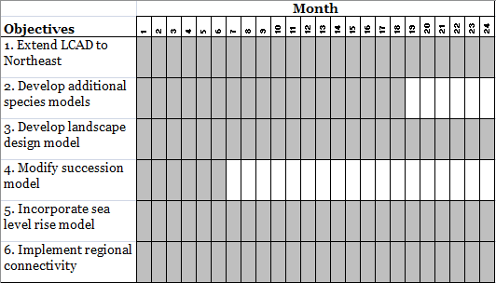

Budget including match

A summary of the budget for the entire project, including the 6 major objectives, is given in the table below. Note, the budget for additional potential objectives associated with the development of additional drivers is given separately in the Appendix. Briefly, the total cost of the entire project is $1,070,787 and this is split between two years: year 1 = $503,988; year 2 = $566,799. However, the cost is shared between the LCC and CSC (UMass in kind contributions are not shown). Specifically, the CSC will tentatively provide support for one full-time research fellow. The cost includes summer salary for the PI (McGarigal) and salary for three full-time research fellows (Compton, Plunkett and Grand) for 24 months, one full-time post-doc (DeLuca) for 18 months, and one full-time technician for 18 months. In addition, the cost includes computers and disk storage to accommodate the modeling and storage of results ($125,000), and support for computer software consulting to maintain the computing cluster and optimize computer algorithms ($60,000). Lastly, the cost includes operational expenses ($10,000) associated with purchase of data, software licenses and other miscellaneous items, and a modest amount for travel ($4,000). Importantly, this budget assumes a negotiated indirect cost rate of 15%, which has not yet been approved.

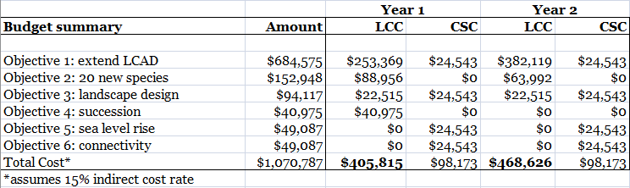

- Extend the geographic scope of the LCAD model to the extent of the USFWS/NEAFWA Northeast Region (13 states + D.C.).

This component is considered essential to phase 2; it provides the infrastructure support for all other components and thus cannot easily or meaningfully be partitioned or omitted. As shown below, the cost includes summer salary for the PI (McGarigal) and salary for three research fellows (Compton @ 0.25 FTE, Plunkett @ 0.75 FTE and Grand @ 1.0 FTE) for 24 months and one full-time GIS technician for 18 months. Compton will assume primary responsibility for expanding the existing ecological integrity and species habitat capability models to accommodate new ecological systems within the Northeast and assist Plunkett in software development and implementation. Plunkett will assume primary responsibility for software development and implementation and running the model. Grand will assume primary responsibility for developing the GIS data for the Northeast, including supervision of the GIS technician in this effort, and for compiling and disseminating the model results to NALCC. Lastly, the cost includes $40,000 in consulting support for a computer programmer to aid in the optimization of computer algorithms (which is necessary to achieve model performance needs).

The cost includes additional computers and disk storage to accommodate the expanded needs of modeling and storing results for the entire Northeast, and support for computer software consulting to maintain the computing cluster and optimize computer algorithms. Note, we currently operate our own small computing cluster and our LCAD software is customized to run on this cluster. The software currently consists of approximately 30,000 lines of code and is written in three different languages (in part owing to the legacy of our software development and in part by design). Given these intricate software dependencies, the LCAD model cannot be run on distributed processors outside of our cluster without a complete rewrite of the software. Thus, it is far more efficient and less costly to simply expand the processing capability of our cluster. Minimally, this will require roughly $100,000 in additional servers, $25,000 in disk storage to accommodate many terabytes of data. Importantly, computers and software require constant maintenance. Thus, the cost also includes $20,000 for computer maintenance (consulting). The cost of equipment is allocated to year 2 and is needed for the modeling across the Northeast region. We will work to secure partial or total funding of equipment through the CSC.

Lastly, the cost includes a modest amount for operational expenses ($10,000) associated with purchase of data (e.g., traffic data, orthophotos), software licenses and other miscellaneous items, and a modest amount for travel ($4,000). Importantly, this budget assumes a negotiated indirect cost rate of 15%, which has not yet been approved.

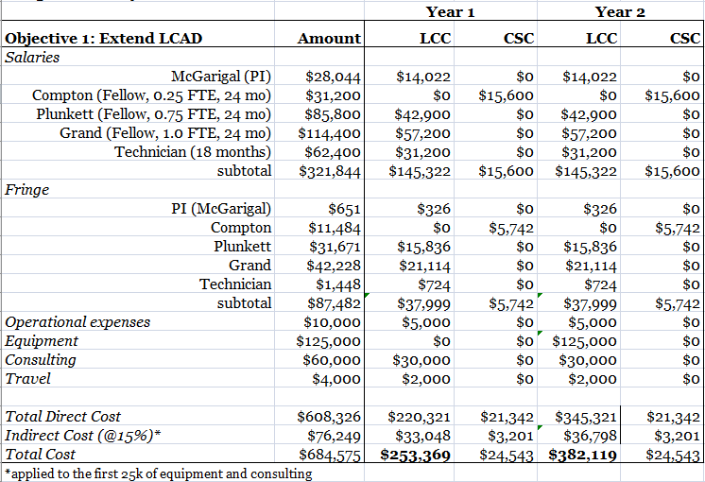

- Develop climate-habitat capability models for an additional suite of representative species.

The cost of this component includes salary for one full-time post-doc (DeLuca @ 1.0 FTE) for 18 months and one full-time GIS technician for 18 months. Note, 0.5 FTE of DeLuca's time during the first year will be devoted to objective 4 (improvement of the succession model, as described below). Thus, the budget for this objective includes 0.5 FTE for the first year and 1.0 FTE for 6 months during the second year. DeLuca will assume primary responsibility for developing, implementing and assessing all species' models, including the climate niche envelope models and habitat capability models, and supervising a full-time research technician in this effort. The technician will be responsible for conducting the background research (i.e., literature review, consultation with experts) on each species and constructing the habitat capability model. Note, the cost of this item given below is for 20 new species, which represents the maximum productivity of one experienced research fellow and one trained technician over an 18 month period. Doubling the number of species would require doubling the budget, as an additional research fellow and technician would be required.

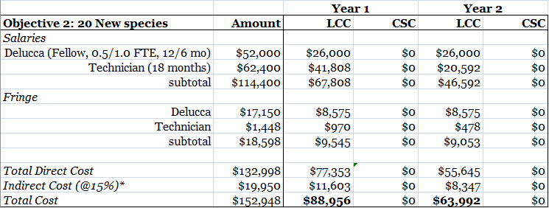

- Develop the landscape design portion of the LCAD model; specifically, to prioritize conservation actions for land protection, management and restoration.

The cost of this component includes salary for two research fellows (Compton @ 0.25 FTE, and Plunkett @ 0.25 FTE) for 24 months. Compton will assume primary responsibility for implementing the ecological restoration prioritization scheme. Plunkett will assume primary responsibility for implementing the land protection and prioritization of species for land management schemes. Note, this component is inextricably linked to component 1 above through support for Compton and Plunkett.

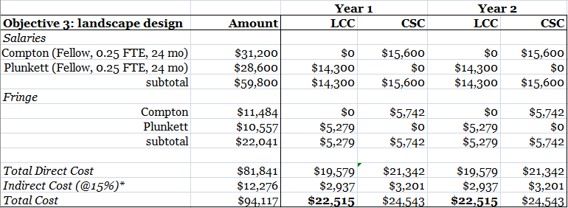

- Modify the succession model to incorporate spatial variability within ecological systems and multivariate trajectories in vegetation growth in concert with objectives 5-7.

The cost of this component includes salary for one full-time post-doc (DeLuca @ 0.5 FTE for 12 months) and is scheduled for year one of the project. DeLuca will assume primary responsibility for compiling the data and developing and implementing the statistic models associated with this objective.

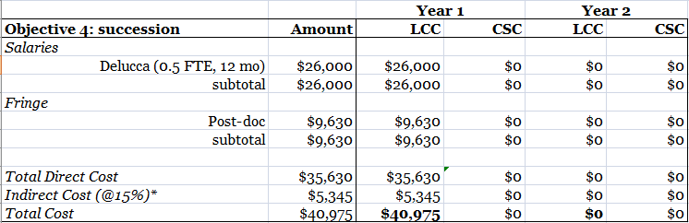

- Incorporate a sea level rise model into the LCAD model; to be developed by an LCC or CSC cooperator in coordination with the UMass team.

The cost of this component includes salary for one research fellow (Compton @ 0.25 FTE) for 24 months. Compton will assume primary responsibility for coordinating the sea level rise modeling with a third party (yet to be determined) and implementing the model within the LCAD model, as appropriate. Note, this component is inextricably linked to component 1 above through support for Compton.

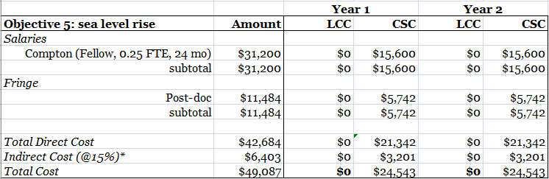

- Implement the regional connectivity assessment component of the landscape ecological integrity (coarse filter) assessment.

The cost of this component includes salary for one research fellow (Compton @ 0.25 FTE) for 24 months. Compton will assume primary responsibility for developing and implementing the regional connectivity model. Note, this component is inextricably linked to component 1 above through support for Compton.

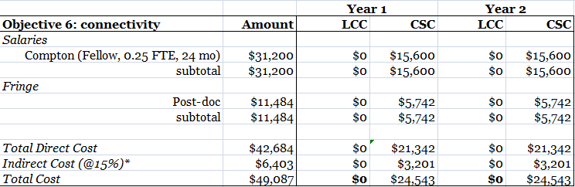

Appendix. Additional potential objectives for phase 2

In addition to the core objectives for phase 2 (listed above), there are several additional potential objectives associated with extending the disturbance drivers, as follows:

- Develop a landscape change driver for timber harvesting.
- Develop a landscape change driver for natural vegetation disturbances, including fire, wind and ice.
- Develop a landscape change driver for insect/pathogen vegetation disturbances.

Approach

- Develop a landscape change driver for timber harvesting.

In phase 1 we implemented a generic vegetation disturbance process that sought to maintain the current seral-stage distribution over time; all natural and anthropogenic vegetation disturbances were confounded in a single disturbance process. Here, we plan to develop a specific disturbance driver for timber harvesting. The details of this driver have not been worked out, but it will be fashioned after previous work done in our lab associated with the development of the Rocky Mountain Landscape Simulator (RMLands). Briefly, it will accommodate a wide variety of silvicultural treatments associated with even-aged and uneven-aged management in which treatment regimes can vary geographically and treatment units can be either spatially-fixed (where they have been defined, e.g., on industrial forestland) or stochastic (where they have not been defined, e.g., on private forestland).

- Develop a landscape change driver for natural vegetation disturbances, including fire, wind and ice.

As noted above, in phase 1 we implemented a generic vegetation disturbance process. Here, we plan to develop a specific disturbance driver for natural disturbances, including fire, wind and ice. The details of this driver have not been worked out, but it will be fashioned after previous work done in our lab associated with the development of the RMLands. Specifically, the driver will include the initiation, spread, termination and severity of stochastic disturbance events parameterized statistically to emulate contemporary nonstationary (i.e., can vary in space and time) disturbance regimes.

- Develop a landscape change driver for insect/pathogen vegetation disturbances.

The item is identical to #6 above; it is listed separately here because the challenges of parameterizing the model for insect/pathogens are much greater and thus will require a dedicated post-doc/research fellow. Consequently, this represents a separate line item in the budget (below).

Products and Deliverables

- LCAD modeling software and associated documentation describing the added or modified components

Timeline

The overall timeline for developing and implementing these drivers is 2 years; however, the actual development and testing of these drivers will take place during the first 18 months.

Budget including match

The cost of these additional components includes salary for three full-time post-docs or research fellows (to be determined) for 18 months. Each individual will assume primary responsibility for developing one of the drivers: timber harvesting, fire/wind/ice, or insects/pathogens.

