Summary of Accomplishments for Phase I of Designing Sustainable Landscapes

The Designing Sustainable Landscapes project is assessing the current capability of habitats in the North Atlantic to support sustainable populations of wildlife and predicting the impact of landscape-level changes - including those from climate change and urban growth - on the future capability of these habitats to support wildlife. It is also intended to provide decision-support tools to assist conservation managers in developing strategies to sustain wildlife populations. In phase I of the project (to be completed May 2012), the focus was to:
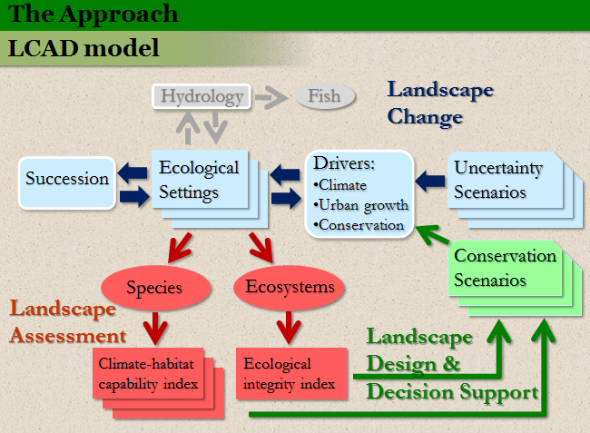
- Develop a modeling framework for simulating landscape change, assessing the ecological consequences of those changes to ecosystems and species, and providing decision-support for land protection, management and restoration. The model is referred to as the Landscape Change, Assessment and Design (LCAD) model and is fully documented. The model will potentially be extended to include sea level rise in phase II.

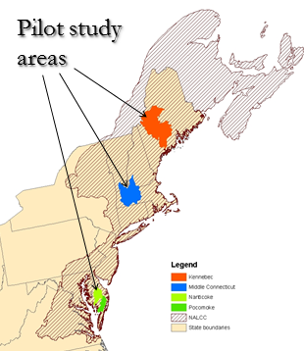

- Pilot the implementation of the landscape change and assessment portion of the LCAD model in three study areas: 1) Kennebec River watershed, 2) middle Connecticut River watershed, and 3) the combined Pocomoke-Nanticoke River watersheds. The model results in these three study areas will be presented in a final phase I report and presented and discussed with managers during a series of workshops in June 2012. The results in phase I are limited to the three study areas; the model will be extended to the entire Northeast region in phase II.

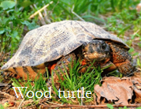
- Develop climate-habitat capability models for a suite of 10 representative species (identified as part of a separate scope of work) to be used as a fine filter for evaluating landscape change scenarios. An additional 20 species will be modeled in phase II.
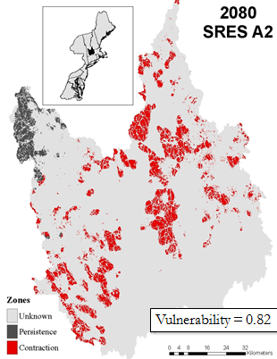

Example of current modeled habitat, and potential future contraction of suitable habitat, for a representative species under a given climate change scenario (Blackburnian Warbler in middle Connecticut River watershed)

- Develop ecological integrity models for a suite of ecological systems, including those found within the pilot watersheds (see below) to be used as a coarse filter for evaluating landscape change scenarios. The ecological integrity assessment in phase I includes a suite of landscape metrics associated with intactness and resiliency; additional metrics associated with adaptive capacity, diversity and connectivity will be included in phase II.

Example habitat capability map Example index of ecological integrity
(Blackburnian Warbler)

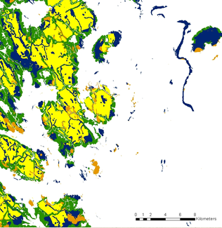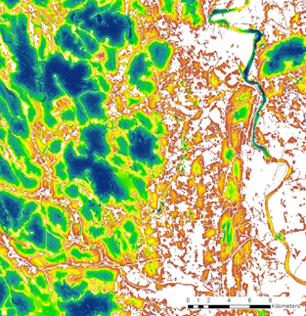

- Assess the nature and magnitude of differences and similarities between areas identified as important habitat for the representative species (fine filter) and areas identified as having high ecological integrity (coarse filter) within the pilot watersheds, and discuss the implications for strategic habitat conservation planning. The comparative assessment of coarse and fine filters in phase I is based on a limited set of 10 representative species; the coarse-fine filter comparison will be extended to an additional 20 species in phase II.

