Recommendation of Technical Review Panel to the North Atlantic Landscape Conservation Cooperative Steering Committee for funding project under RFP Topic 1:

Quantify and Map Habitats, Threats, and Current Range Distribution for Aquatic (Including Coastal) Species to Assess Species-Habitat Relationships, and Identify Priority Areas and Corridors for Conservation

Summary Recommendation

The Technical Review Panel and North Atlantic LCC Staff recommend that the Steering Committee select the Downstream Strategies proposal to receive the full $250,000 funding amount requested under the July North Atlantic LCC Request for Proposals (RFP).

Background

On April 18, 2012, the North Atlantic LCC Steering Committee approved a science need jointly developed by the aquatic and coastal subteams of the LCC Technical Committee to address distribution, status and threats of aquatic and coastal species. North Atlantic LCC staff then worked with members of the Technical Committee, the Atlantic Coastal Fish Habitat Partnership, and WMI to develop an RFP to solicit projects to address this science need. On July 6, WMI announced the RFP (full details at http://northatlanticlcc.org/rfp_2012.html). Fourteen proposals were submitted in response to the RFP, which closed on August 17.

Review Process

Scott Schwenk, North Atlantic LCC Science Coordinator, co-chaired the Technical Review Panel with Emily Greene, Coordinator of the Atlantic Coastal Fish Habitat Partnership (ACFHP). Reviewers consisted of volunteers from the LCC Technical Committee as well as the ACFHP Science and Data Working Group. To ensure a wide range of expertise, geographical perspectives, and knowledge of state agency needs, membership was supplemented with several additional state representatives. The review panel consisted of the following 15 members:

Reviewers | Organization
Ralph Abele | U.S. EPA
Dave Day | Pennsylvania Fish & Boat Commission
Julie Devers | U.S FWS, Maryland Fishery Resources Office
Emily Greene (co-chair) | Atlantic Coastal Fish Habitat Partnership
Jeff Horan | U.S. FWS, Chesapeake liaison
Callie McMunigal | U.S. FWS, Eastern Brook Trout Joint Venture
Mike Millard | U.S. FWS, Northeast Fishery Center
Andrew Milliken | U.S. FWS, North Atlantic LCC
Rachel Muir | USGS
Moe Nelson | NOAA, Center for Coastal Monitoring and Assessment
Cheri Patterson | New Hampshire Dept. of Fish and Game
Scott Schwenk (co-chair) | North Atlantic LCC
Doug Stang | New York Department of Environmental Conservation
John Sweka | U.S. FWS, Northeast Fishery Center
Marek Topolski | Maryland Department of Natural Resources

Following an initial screening by WMI, the panel co-chairs reviewed the proposals and determined that three proposals were not competitive among the group because each addressed only a single, small watershed. These three proposals were eliminated from further consideration. The remaining 11 proposals were reviewed by the full panel. The reviewers scored the proposals according to a set of criteria listed in the RFP and were encouraged to provide narratives that explained their reviews. On September 25, once the written reviews were complete, the panel discussed the proposals by teleconference.

Results of the Reviews

To ensure consistency in scoring and an informed decision, each panel member reviewed all the proposals (except for two reviewers who split the set). Thirteen reviewers submitted written scores before the teleconference (resulting in 12 complete reviews). Based on the written reviews, the proposals could clearly be divided into two groups, the top five proposals (average scores ranging from 80 to 88) and the remaining six proposals (average scores of 70 or below). None of the latter group was ranked as the best proposal by any of the reviewers. The groups could largely be distinguished on geographical scope: the top five proposals addressed most or all of the NALCC geography and five of the remaining six addressed only a portion, such as a single state or river system. Among the top five, Downstream Strategies stood out as the highest ranked proposal, being scored highest by six reviewers and second highest by another four reviewers. Four of the remaining highest rankings were given to a proposal from Penn State, ranked second highest overall. The next three proposals received one top ranking apiece: NatureServe, Michigan State, and the Massachusetts Department of Fish and Wildlife.

Eleven reviewers participated in the teleconference to discuss the proposals. Following discussion, the general consensus among reviewers was that the Downstream Strategies and Penn State proposals were the best proposals. Strengths identified for the Downstream Strategies proposal were their decision support tools, track record on similar projects for other LCCs and fish habitat partnerships, and broad coverage of both freshwater and coastal systems. Strengths identified for the Penn State proposal included species-habitat modeling, experience with Northeast data, and integration of climate change into their work. Other proposals had substantial merit but were not as complete as the top two proposals, particularly in addressing both freshwater and coastal systems. At the conclusion of the teleconference, the reviewers agreed to submit a set of written questions to both Downstream Strategies and Penn State to obtain additional information. The questions were sent on September 28.

During the week of October 1, we received written responses to the questions and held a follow-up teleconference with each of the finalists. Scott, Emily, and Jeff participated on both calls. Based on these materials and discussions, Scott and Emily recommended to the review panel that the Downstream Strategies proposal be selected, and the recommendation was accepted by reviewers. The recommendation was based on demonstration of a comprehensive framework for assessments; coverage of both freshwater and estuarine systems; and illustration of useful decision support tools. Their methodologies have been demonstrated for the Midwest and Great Plains Fish Habitat Partnerships and the Plains and Prairie Potholes LCC.

Finally, if Downstream Strategies is selected, reviewers also recommend that several issues be considered prior to finalizing the project scope of work and during performance of the project:

- Data products and tools should be consistent with guidance developed by the Science and Data Committee of the National Fish Habitat Partnership.
- Downstream Strategies should commit to making their decision support tools usable via the web (currently developed for desktop PC use but not yet over the Internet).
- To be successful, the collaborative approach proposed by Downstream Strategies will require participation by stakeholders and natural resource managers who will use the tools they will develop. ACFHP and the North Atlantic LCC should have a role in facilitating this effort. Needs will include obtaining aquatic data for most of the North Atlantic LCC area.
- Given Downstream Strategies is not experienced in coastal modeling, they will need to acquire expertise (e.g., through a subcontract) and should collaborate with ACFHP in their selection of a modeler and in development of modeling approaches.

Supplemental Information: Proposal Review Criteria

- Degree to which the project addresses the priority themes and products described in the RFP announcement.
- Scientific and technical merit.
- Programmatic capability and feasibility. Are project objectives/goals clearly defined, measurable, and connected to specific milestones/deliverables and timelines? Will/can proposed methods accomplish/produce the project’s objectives/goals, deliverables, and timelines?
- Engagement of partners.
- Demonstration that products will be accessible and useful in conservation and resource management decision-making.
- Degree to which project builds upon, rather than duplicates, existing efforts.
- Geographic scope.
- Leveraging of other resources (not required but encouraged).

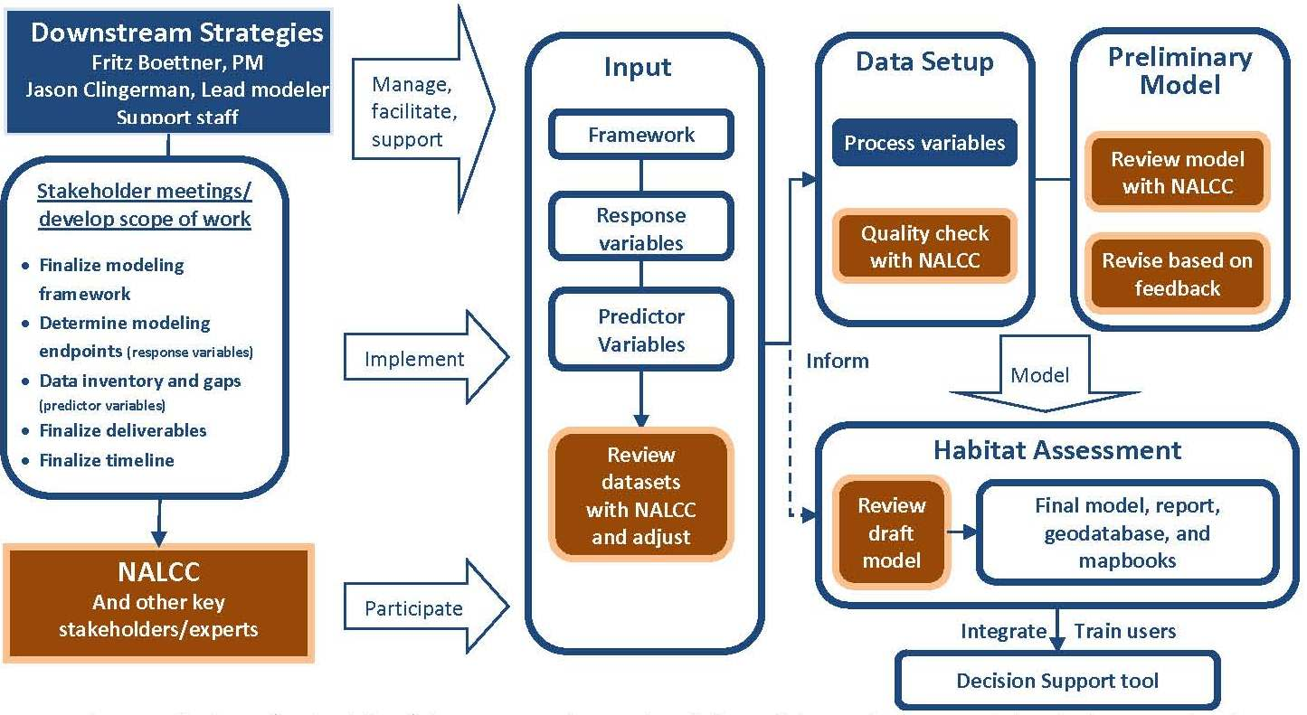
Stakeholder process and project workflow for Downstream Strategies proposal.
Supplemental Information: Proposal Abstract by Downstream Strategies

Downstream Strategies (DS) and its partners propose to create and implement a flexible and dynamic aquatic assessment process with the North Atlantic Landscape Conservation Cooperative (NALCC) and its partners. This approach has been widely accepted by aquatic and fish experts across the country and the NALCC could be the next organization to take advantage of this unique process. DS proposes to assemble data and analyze conditions to understand fish distribution, habitat, and threats to aquatic species across the NALCC region. We will engage stakeholders throughout all stages of the project to ensure compatibly of results with the specific goals of the NALCC. The central focus of this project will revolve around a flexible modeling process that has been highly refined from similar on-going and completed projects across the country. Multiple models of different species or species groups will be performed and result in expected species distribution maps, as well as identification and quantification of threats and stressors to the species modeled. The DS project team will utilize the spatially-explicit model results to populate a multi-criteria decision support tool (DST) that will integrate the components of each model developed. The DST will provide a highly functional and user-friendly mechanism for resource managers to visualize, rank, and manipulate inputs to prioritize areas for conservation action.

