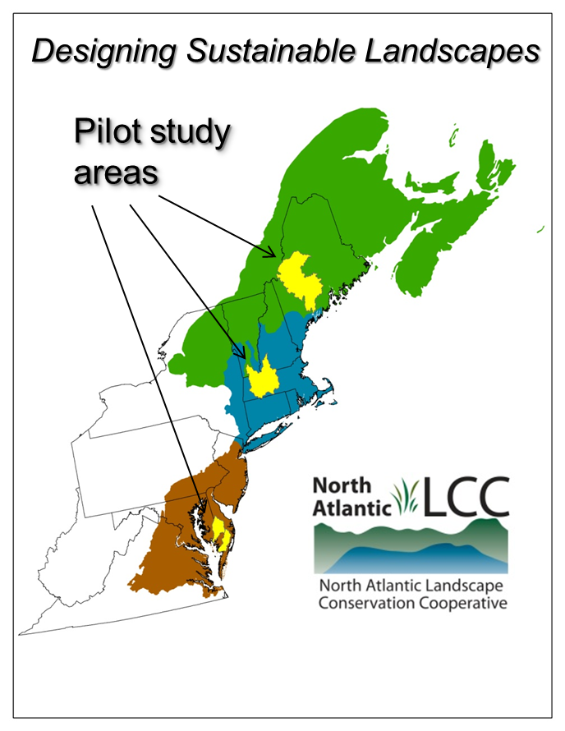
North Atlantic LCC Project Update:
Designing Sustainable Landscapes

The Designing Sustainable Landscapes project is a foundational part of a set of tools that the North Atlantic LCC is developing to guide conservation decisions in the face of regional change. The University of Massachusetts Amherst, working with a broad coalition of LCC partners, is leading the project.

During the first phase of the project, the approach was developed in three pilot study areas: the Kennebec River watershed in Maine, the middle Connecticut River in Massachusetts and adjacent states, and the Pocomoke and Nanticoke River watersheds in Delaware and Maryland.

In October 2012, LCC and U.S. FWS staff worked with UMass to conduct three one-day workshops to introduce conservation managers and other partners to the initial project results, to engage them in developing useful and relevant conservation tools, and to begin a longer-term collaboration on shared conservation goals. One workshop was held in each of the three pilot areas and over 100 conservation managers participated from a diverse array of organizations (along with others online). Examples of the organizations represented include: NOAA, National Park Service, U.S. FWS, USGS, Chesapeake Conservancy, Connecticut River Watershed Council, Ducks Unlimited, Maine Audubon, National Wildlife Federation, The Nature Conservancy, Trout Unlimited, Trust for Public Land, Maine Department of Inland Fisheries and Wildlife, Maryland Department of Natural Resources, and Massachusetts Division of Fisheries and Wildlife.

During plenary and breakout sessions, participants posed questions and offered a number of valuable suggestions as the project enters its second phase, which will include developing the landscape design portion of the project and expanding the project to the entire Northeast Region. Overall, the participants were enthusiastic about the progress of the project and envisioned using tools in conservation planning, in conjunction with state and locally available data sources. Example areas of feedback included:
- Being able to download and use regionally consistent raw and synthesized data will be useful, especially in conjunction with local data;
- Having standard products will also be useful but should be available at multiple spatial scales including Region, State, large, medium and small watershed and large, medium and small ecoregion;
- The ability to develop custom analyses (on the web) could be desirable in the future
- Packaging and marketing information in relatively simple form will be important for some audiences;
- Deciding on goals (e.g. maintain a representative species population at current levels, protect 30% of the extent of each ecological system) and how to weight various tools is both important and challenging;
- Being able to use these tools to begin answering the “how much” question will be important;
- Suggestions that tools address how to prioritize restoration of agricultural lands to wetlands and forests and other types of restoration;
- Consideration of agricultural lands as ecological systems and habitats could be important;
- Recommendations on which indices of species response to climate change would be most useful and understandable;
- Description of data sources the UMass was not aware of that could improve modeling efforts, such as expanded data on road culverts and bridges;
- Addressing coastal areas in the future will be critical.

LCC and UMass staff will be seeking, compiling and synthesizing additional input through emails, an online survey and follow-up meetings. LCC staff are also contacting participants to gauge their interest in longer-term involvement in the project and exploring how to organize that work. One possible model would be to organize standing groups focused on areas with existing regional partnerships such as the Gulf of Maine, Connecticut River watershed and Chesapeake Bay.

A key takeaway is the importance of making up front decisions about how the tools will be used in order to develop the best set of standard products. We may need a smaller group or groups that help to provide guidance on what the standard set of tools should be. They will need to address issues related to scale, format, relative weight and other factors. The conservation targets team should be able to use these tools to help think about a set of meaningful objectives for habitat capability and ecological integrity.

