Report for the Department of the Interior

Recommendations for assessing improvements in coastal resilience from projects within the DOI Hurricane Sandy Mitigation and Resiliency Program

The Department of the Interior Metrics Expert Group
October 21, 2014

Contents
Report for the Department of the Interior 1
Recommendations for assessing improvements in coastal resilience from projects within the DOI Hurricane Sandy Mitigation and Resiliency Program 1
Purpose of the DOI-Assessment: 4
The DOI Assessment Process: 5
Integration with other Federal resilience programs 6
Scoping the problem: 6
Setting the DMEG goals 8
Definitions of resilience: 8
Providing answers within the assessment timeframe 10
The DMEG strategy for sorting the DOI projects and selecting metrics 11
Defining broad systems 12
Developing sub-systems for sorting the Hurricane Sandy projects 12
Special consideration of socio- economic metrics 13
Explanation of the project metrics table 14
Assessing whole-system changes in resilience 14
Integrating projects for regional scale synthesis: 17
Recommendations for post-assessment monitoring 18
Information management 18
Next Steps 19
Appendices 22
Appendix A: Members of the DOI Metrics Experts Group 22
Appendix B: Definitions Required in Setting Metrics 22
Appendix C: Table of core metrics selected by coastal feature 23
Appendix D: Table of projects with recommended Metrics 23
Appendix E: Table of projects metadata 23
Appendix F: The Metrics Selection Process 23
Appendix G: Examples of research projects needed for preparing the assessment 25
Appendix H: Recommendations for a “Request For Proposals” in support of the DOI Resilience Assessment 31
Appendix I: Summary of the DMEG recommendations for Assessing Coastal Resilience 32
Appendix J: References 39

Introduction:
Through the Disaster Relief Appropriations Act of 2013 (P.L. 113-2), Congress appropriated $829 million ($786.7 after sequestration) for the Department of the Interior (DOI, the Department) and its bureaus to address impacts from Hurricane Sandy. With these funds, DOI initiated nearly 150 restoration, mitigation, and science projects within the coastal region of the Northeastern U.S. (Figure 1). With these funds, DOI initiated nearly 150 restoration, mitigation, and science projects within the coastal region of the Northeastern U.S(Figure 1). The goals of the DOI program were to (a) restore and rebuild national parks, national wildlife refuges, and other Federal public assets in the wake of Hurricane Sandy, (b) increase the resiliency and capacity of coastal habitat and communities to withstand storms and reduce the amount of damage caused by such storms, and (c) improve the ability of our coastal communities and ecosystems to maintain critical system functions that are valuable to stakeholders. Assessing the effectiveness of these projects, individually or as a group, at improving the resiliency of the Northeast coast was not part of the original planning for the DOI program. However, this assessment will be essential for developing best practices, determining gaps in knowledge, sustaining or enhancing the improvements in coastal resilience created by the project activity, and communicating the effective use of tax dollars to the American people. The goal of this report is to provide guidance on how DOI could establish an assessment process for both (a) assessing the effectiveness of the funded projects on building coastal resilience and (b) translating that project-based assessment into a an assessment of changes in resilience throughout the northeast coast. The assessment will include setting common measures or metrics, implementing monitoring and modeling as needed to apply those metrics as the DOI projects proceed, and synthesizing the monitoring and modeling results in a comprehensive assessment of resilience improvements in the Northeastern U.S.
The first challenge the Department faces in measuring project effectiveness is to define and establish a suite of metrics that can detect changes in ecosystem and community resilience resulting from project activity. These measurements of the effectiveness of DOI investments are needed at both the local project scale and the larger sub-regional or regional scales. Measurements are important for all DOI-sponsored projects addressing coastal resiliency, including both Bureau-based projects and the non-Federal projects funded through a DOI partnership with the National Fish and Wildlife Foundation (NFWF).
To address this challenge, in July 2014 the Department of Interior Leadership team for the Hurricane Sandy Supplemental Funding Program convened a team of physical science, ecosystem science, and socio-economic experts (the DOI Metrics Expert Group: DMEG) to garner advice on selecting metrics needed to conduct an effective assessment of the DOI efforts at improving coastal resilience. This report describes the conclusions and recommendations of the team DMEG. The resulting recommendations are highlighted in bold text throughout this report, and are summarized in an Appendix I for quick referencing in future discussions of the DOI program.

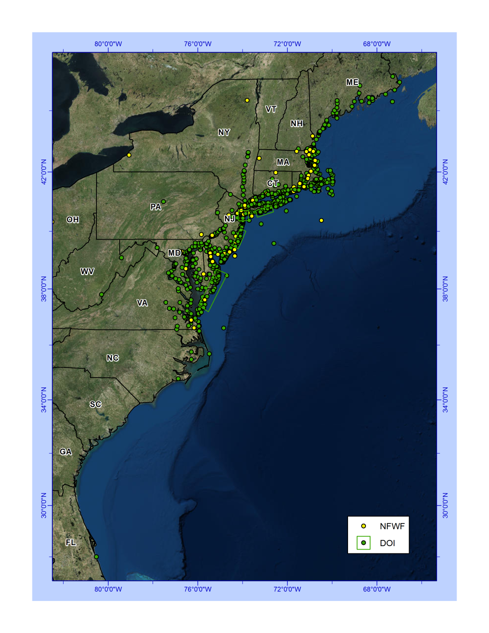
Figure 1: Map of the Northeast United States coastal region, illustrating the centroids of project footprints for the DOI Hurricane Sandy projects overseen by USGS, NPS, FWS (green dots and rectangles), and NFWF (yellow dots).

