Highlights – 2014 Science Needs Recommendations of
the North Atlantic LCC Technical Committee

From May to June 2014, the North Atlantic LCC Technical Committee deliberated about LCC conservation science needs and developed recommendations for the North Atlantic LCC Steering Committee for 2014 funding. More than 30 individuals from 18 state, federal, and NGO organizations contributed to the review process. This document summarizes the results of the review; detailed recommendations are also available from the North Atlantic LCC.

In summary, the Technical Committee concluded that North Atlantic LCC science needs would best be met this year by continued funding of two existing LCC projects: Designing Sustainable Landscapes (UMass Amherst) and Aquatic Forecasting and Brook Trout (USGS). Factors in recommending continued funding for these projects include:

- Not only are the projects addressing high priority foundational science needs in the areas of Ecological Planning and Conservation Design, they are at critical stages in the delivery of science products and decision-support tools to managers affiliated with state agencies and other organizations (which has been identified as a high priority by the Steering Committee).
- Support for the existing projects will maintain the user network and knowledge that has been accumulated during ongoing partnership activities such as the Landscape Conservation Design Pilot for the Connecticut River Watershed and planned future efforts which rely on products from both projects.
- The work of both projects will be substantially leveraged by support from entities such as the Northeast Climate Science Center.
- The substantial reduction in LCC science funds in 2014, relative to prior years, makes it difficult to simultaneously support important ongoing science projects and initiate new science projects that will have meaningful, regional-scale contributions to conservation.

Summary of Technical Committee recommendations for 2014 science project funding:

Project and Task | NALCC Budget
Designing Sustainable Landscapes (U. of Massachusetts Amherst)
1) Delivery and communication of decision-support tools and products | $160,000
2) Enhanced incorporation of habitat management and restoration | $70,000
Total | $230,000
Aquatic Forecasting and Brook Trout (USGS)
2) Expand existing tools to additional portions of LCC region | $20,000
3) Integrate models with management and policy | $90,000
Total | $110,000
Grand Total | $340,000

Designing Sustainable Landscapes

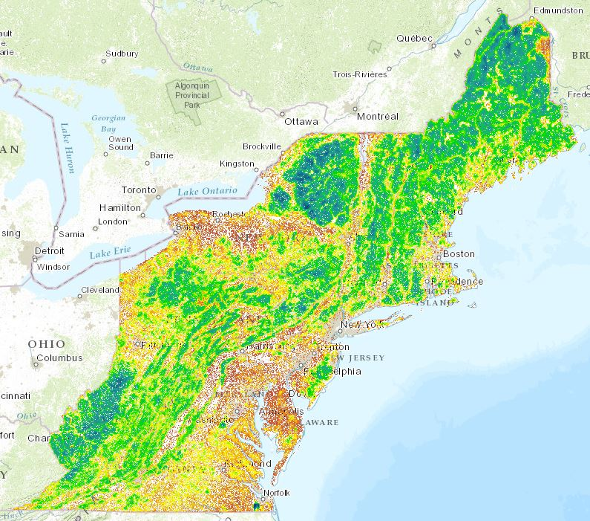
Accomplishments to Date
Black Bear Habitat Model Results

- Comprehensive modeling framework that links current environmental conditions and projected future changes in climate and development to outcomes for wildlife species and ecosystems.
- Development and release of numerous, consistent spatial datasets for the full Northeast region, such as for climate (current and future), land cover, and forest condition.
- Comprehensive species-habitat models for 30 representative wildlife species (by the completion of current phase).
- Regional assessment of ecological integrity that synthesizes factors related to resiliency, intactness, and connectedness of ecosystems throughout the Northeast.
- A landscape conservation design approach using these tools for identifying core areas, buffers and connecting corridors with a pilot in the Connecticut River watershed.

What 2014 Science Project Funding Would Support

1) Delivery and communication of decision-support tools and products – $160,000
- Work with North Atlantic LCC staff and partners to translate existing, detailed documentation into clearer, simpler documentation that is more accessible and meaningful for users and partners.
- Work with partners to help them understand and apply the tools and products (for example, in effort to identify Regional Conservation Opportunity Areas).
- Use experience in the Connecticut River Watershed Pilot to synthesize and document that conservation design approach used and to compile a partially automated process that will allow trained users to perform steps in conservation design.
- Based on satisfactory progress and usefulness to partners, lay the groundwork for a more comprehensive and automated landscape conservation design tool.

2) Habitat management and restoration – $70,000
- As a complement to the well-developed tools for prioritization of lands for protection, expand the capability of the conservation design tools to prioritize and designate forest sites for management to maintain early seral stages of forests (i.e., shrublands or young forests). This could involve compilation of locations currently managed as young forests.
- Similarly, improve the capability of the design tools to identify agricultural (or other) sites as priorities for restoration to wetlands or forests.

3) Additionally, the proposed North Atlantic LCC-supported work would be integrated with coastal resiliency and integrity work underway through an LCC-administered grant from Hurricane Sandy resiliency funding.
Aquatic Forecasting and Brook Trout
Accomplishments to Date

- Daily stream temperature and annual stream flow models for headwater streams for much of the New England and New York region.
- Projections of relative sensitivity of stream temperature to changes in air temperature.
- Brook trout occupancy models, based on current and projected future climate, for New England and New York, at the local catchment scale.
- Prototype decision-support tool to allow users to use the model results in conservation and restoration planning.

What 2014 Science Project Funding Would Support

1) Expand existing tools to additional portions of LCC region – $20,000
- Extend the stream temperature and stream flow models to the full geographic area of the North Atlantic LCC, plus the headwaters of the Atlantic-draining watersheds (e.g., Chesapeake, Delaware, Hudson).
- In coordination with the Eastern Brook Trout Joint Venture and other researchers studying brook trout, expand the brook trout occupancy models to the same region as the stream temperature and flow models.

2) Integrate models with management and policy – $90,000
Build upon recent meetings with state agencies to apply the North Atlantic LCC-supported models within the state decision-making processes, such as revisions to state water quality criteria for stream temperature. The Connecticut DEEP and Massachusetts DEP have agreed to participate in this pilot, which will be designed for adoption by interested managers across the region. Specific tasks will include: a) further adapting stream and fish models; b) customizing maps and graphics for decision support; c) modifying the existing map viewer for prioritization of watersheds; and d) exploring the potential for real-time updates of model results based on state-provided data.

Additionally, North Atlantic LCC support would leverage and help integrate the following tasks, which are fully funded through other sources:

3) Coordination with other researchers who are developing broad spatial models as well as potential users including the Eastern Brook Trout Joint Venture. This will include discussion of potential shared databases for stream and fish data. (USGS-funded)

4) Extension of the modeling approach used for brook trout to other aquatic species, in coordination with user needs and other LCC-supported projects. (USGS-funded)

